TITLE OF THE PROJECT



STUDENT NAME

SCHOOL OF STRUCTURAL AND ENVIRONMENTAL ENGINEERING
BAHRAIN POLYTECHNIC, KINGDOM OF BAHRAIN

2023

“We hereby declare that we have read this thesis and in our opinion this thesis is sufficient in term of scope and quality for the award of the degree of Bachelor of Engineering (Mechanical)”

Signature | : | ________________________________
Name of Supervisor I | : | DR. IFTIKHAR AHMAD
Date | : | 21 March 2024
Signature | : | ________________________________
Name of Supervisor II | : | ADEL AWAN
Date | : | 21 March 2024

TITLE OF THE PROJECT

STUDENT NAME

A thesis submitted in fulfilment of the
requirements for the award of the degree of
Bachelor of Engineering (Mechanical)

School of Structural and Environmental Engineering
Bahrain polytechnic, Kingdom of Bahrain

2024

DECLARATION

I declare that this thesis entitled “Hybrid vibro-acoustic energy harvesting using flexible coil and spinning spherical magnet for wireless sensor nodes” is the result of my own research except as cited in the references. The thesis has not been accepted for any degree and is not concurrently submitted in candidature of any other degree.

Signature | : | ....................................................
Name | : | Iftikhar Ahmad
Date | : | 21 March 2024

DEDICATION

To my parents

ACKNOWLEDGEMENT
First of all, I would like to thank Almighty Allah, who gave me this immense strength to accomplish this research, complete this thesis and achieve this milestone.
I am thankful to Prof. Madya Ir. Dr. Lim Meng Hee, my research supervisor whose assistance and interest have given this project much of its worth and accuracy, and whose encouragement has led it to its final completion.

I am also thankful to Prof. Ir. Dr. Mohd Salman @ Leong Yew Mun my research co-supervisor and Dr. Ahmed Mohammed Abdelrhman, research external supervisor for giving me their precious time and helpful ideas that guide us throughout the completion of this thesis.

I acknowledge the Labs of Bahrain Polytechnic, Bahrain for providing the experimental facility to this research.

ABSTRACT
Today sensors are playing an important role in worldwide networking by continuously monitoring our environment. In most cases, wireless sensor nodes (WSNs) are used as they provide a distinctive solution for remote monitoring. However, the main concern for the deployment of WSNs is the power source. Researchers have tried to harvest ambient energy, however, most of the harvesters developed have low output power and the simultaneous conversion of multiple energy sources using a single harvester is infrequent. To attain the self-sustained long-standing operation of WSNs, a novel method of hybrid vibro-acoustic energy harvester (HVA-EH) using a single flexible coil and spinning spherical magnet is presented in this work. The architecture, fabrication, and experimentation of the prototypes have been discussed. The first prototype (HVA-EH-1) comprises of three dimensional (3D) printed structure, a cantilever beam, a permanent magnet, a Helmholtz cavity, two fixed micro planar coils, and a flexible micro planar coil. At matching impedance, the maximum power generated by the HVA-EH-1 under 0.3 g vibration at zero SPL is 372 μW, and under SPL of 130 dB at zero vibration is 271 μW. While, under a hybrid environment, the HVA-EH-1 generates maximum power of 656 μW at vibration level of 0.3 g under SPL of 130 dB which is higher than the reported vibration and acoustic energy harvesters. The second prototype (HVA-EH-2) is comprised of the same components; however, a cavity is added at the tip of the cantilever beam for a spherical magnet which is used to add more resonance to the system because of its spinning and hence increases the conversion efficiency. The HVA-EH-2, when exposed to a hybrid environment of 0.3 g vibration and 130 dB SPL, a maximum root mean square voltage and power of 409 mV and 741 μW respectively were achieved at 29 Hz vibration and 1050 Hz acoustic frequency which is higher than the HVA-EH-1. By adding vibration to the standalone acoustic device, an increase of 44.72 % was observed in the output power. The spinning spherical magnet architecture in HVA-EH-2 has increased the output power by 11.47 % compared to HVA-EH-1. The HVA-EH-2, when connected to a power management circuit developed in this work, was able to produce a DC power of 5056 μW, and a 1.5 V AAA battery was also successfully charged in an hour's time duration. Furthermore, the performance of the developed prototypes was also compared with the reported vibration and acoustic energy harvesters, and it was found that the power and power density (9.2 μW/cm³) for the HVA-EH-2 are considerably better. This work paves a new way for developing hybrid environment-type energy harvesters for efficiency enhancement. This research will also help in achieving self-sustained long-term operation of WSNs in advanced technologies like the internet of things, remote condition monitoring, tele health diagnosing and monitoring, global positioning systems, and structural health monitoring.

TABLEOF CONTENTS
 | TITLE | PAGE

DECLARATION ii
DEDICATION iii
ACKNOWLEDGEMENT iv
ABSTRACT v
ABSTRAK vi
TABLEOF CONTENTS vii
LIST OF TABLES x
LIST OF FIGURES xi
LIST OF ABBREVIATIONS xvi
LIST OF SYMBOLS xvii
LIST OF APPENDICES xix
CHAPTER 1 INTRODUCTION 1
1.1 Overview 1
1.2 Applications of wireless sensor nodes 3
1.3 Problem statement 5
1.4 Research questions 7
1.5 Research hypothesis 8
1.6 Scope of the study 8
1.7 Objectives of the study 8
1.8 Significance of the study 9
1.9 Thesis structure 10
CHAPTER 2 LITERATURE REVIEW 13
2.1 Overview 13
2.2 Fundamentals of energy harvesting 13
2.3 Energy harvesting techniques 17
2.3.1 Vibration energy harvesting 18
2.3.2 Solar energy harvesting 19
2.3.3 Thermal energy harvesting 20
2.3.4 Acoustic energy harvesting 21
2.3.5 Radio frequency energy harvesting 22
2.4 Challenges to energy harvesting systems 23
2.5 Established approaches 24
2.5.1 Vibration energy harvesters 24
2.5.2 Solar energy harvesters 28
2.5.3 Thermal energy harvesters 29
2.5.4 Acoustic energy harvesters 32
2.5.5 Hybrid energy harvesters 33
2.5.6 Power management 34
2.6 Summary of the literature review 36
CHAPTER 3 RESEARCH METHODOLOGY 41
3.1 Overview 41
3.2 Introduction of research study 41
3.3 Architecture and working principles of HVA-EH-1 44
3.4 Fabrication of HVA-EH-1 48
3.5 Architecture and working principles of HVA-EH-2 52
3.5.1 Helmholtz cavity 54
3.5.2 Flexible micro planar coil 57
3.5.3 Cantilever beam with tip mass 59
3.6 Fabrication of HVA-EH-2 61
3.7 Experimental setup 63
CHAPTER 4 RESULTS AND DISCUSSION 65
4.1 Overview 65
4.2 Characterization of HVA-EH-1 under vibration energy 65
4.3 Characterization of HVA-EH-1 under acoustic energy 71
4.4 Characterization of HVA-EH-1 under hybrid environment 74
4.5 Characterization of HVA-EH-2 under vibration environment 80
4.6 Characterization of HVA-EH-2 under acoustic environment 83
4.7 Characterization of HVA-EH-2 under hybrid environment 85
4.8 Power management 91
4.9 Discussion and comparison 98
CHAPTER 5 CONCLUSION AND RECOMMENDATIONS 103
5.1 Overview 103
5.2 Conclusion 103
5.3 Proposed future work and recommendations 105
REFERENCES 107
APPENDIX 123
LIST OF PUBLICATIONS 127

LIST OF TABLES
TABLENO. | TITLE | PAGE
Table‎ 1.1 Applications of wireless sensor nodes 5
Table‎ 2.1 Ambient energies available at different locations 16
Table ‎2.2 Vibro-acoustic energy sources and their associated parameters 17
Table ‎2.3 Summary of the literature review 38
Table ‎2.3 Summary of the literature review (contd.) 39
Table‎3.1 Dimensions and parameter of HVA-EH-1 52
Table‎3.2 Dimensions and parameters of HVA-EH-2 63
Table 4.1 Comparison of acoustic and vibration energy harvesters with HVA-EH-1 and HVA-EH-2 101
Table 4.1 Comparison of acoustic and vibration energy harvesters with HVA-EH-1 and HVA-EH-2 (contd.) 102

LIST OF FIGURES
FIGURE NO. | TITLE | PAGE
Figure ‎1.1 Typical wireless sensor node architecture 3
Figure ‎2.1 General architecture of energy harvesting system 14
Figure ‎2.2 Potential energy sources, adapted from [68] 15
Figure ‎2.3 Architecture of vibration energy harvesting system 18
Figure ‎2.4 Block diagram of solar energy harvesting system. 19
Figure ‎2.5 Block diagram of thermoelectric energy harvesting system 20
Figure ‎2.6 Schematic of an acoustic energy harvesting system 21
Figure ‎2.7 A block diagram of the RF energy harvesting system 22
Figure ‎2.8 Vibration-based energy harvesters developed for WSNs sensor applications (a-f) 27
Figure ‎2.9 Solar energy harvesters developed for WSNs applications (a-b) 28
Figure ‎2.10 Thermal energy harvesters (a) schematic of thermal energy harvester (b) Photograph of the fabricated device on Kapton HN (left) and schematic of flexible thermoelectric generator (right) (c) Working principal of the thermoelectric generator in an airplane structure (d) CAD model of the developed device (e) The developed device with a hot temperature of the gearbox surface (f) the developed prototype 31
Figure ‎2.11 Acoustic energy harvesters developed for WSNs applications (a-b) 33
Figure ‎3.1 Flow chart of the reseach conducted in this work 43
Figure ‎3.2 Hybrid vibro-acoustic energy harvester-1 (a) cross-sectional view (b) exploded view 44
Figure ‎3.3 Photolithographic process of MPCs: (a) FR4 sheet (b) FR4 sheet after drilling (c) copper deposition (d) photoresist coating (e) etching (f) photoresist strip off 49
Figure ‎3.4 Micro planar coils: (a) double sided fixed MPC (b) double sided flexible MPC 49
Figure ‎3.5 Assembling process of HVA-EH: (a) 3D Printing of frame (b) fixed MPC placed in 3D printed frame (c) cantilever beam fixed to the 3D printed frame (d) magnet fixed to the free end of the cantilever beam (e) flexible MPC placed in acoustic cavity (f) the acoustic cavity attached to the 3D printed frame (g) assembled prototype. 51
Figure ‎3.6 Hybrid vibro-acoustic energy harvester-2 (a) cross-sectional view (b) exploded view 54
Figure ‎3.7 Helmholtz Cavity (a) Cross-sectional view (b) Lumped-element model 55
Figure ‎3.8 Resonant frequency of the HR Vs. neck diameter 57
Figure ‎3.9 (a) Vibration visualization of the flexible micro planar (b) flexible micro planar coil with spring, mass, and damper uncertainties 58
Figure ‎3.10 Lumped element model of the flexible micro planar coil 59
Figure ‎3.11 Schematic of the cantilever beam with lumped mass at the free end 60
Figure ‎3.12 Rate of change of the flux across the flexible MPC at various magnet orientation (a) maximum rate of change of flux (b) minimum rate of change of flux (c) absolutely no rate of change of flux 61
Figure ‎3.13 Fabrication and assembling of the HVA-EH-2 (a) 3D printing of the harvester (b) cantilever beam with a cavity at the tip (c) cantilever beam placed on 3D printed structure (d) assembled vibration part of the harvester (e) flexible MPC placed on the back of the Helmholtz cavity (f) assembled HVA-EH-2 62
Figure ‎3.14 HVA-EH’s test bench (a) block diagram (b) developed setup 64
Figure ‎4.1 Open circuit voltage versus frequency of HVA-EH-1 under vibration energy of top fixed MPC 66
Figure ‎4.2 Open circuit voltage versus frequency of HVA-EH-1 under vibration energy of bottom fixed MPC 66
Figure ‎4.3 Open circuit voltage versus frequency of HVA-EH-1 under vibration energy of flexible MPC 67
Figure ‎4.4 Open circuit voltage versus frequency of HVA-EH-1 under vibration energy of combined coils 67
Figure ‎4.5 Load voltage and power versus load resistance of top fixed MPC 69
Figure ‎4.6 Load voltage and power versus load resistance of bottom fixed MPC 69
Figure ‎4.7 Load voltage and power versus load resistance of flexible MPC 70
Figure ‎4.8 Load voltage and power versus load resistance of combined coils 70
Figure ‎4.9 Open circuit voltage versus frequency of flexible MPC under acoustic energy 71
Figure ‎4.10 Load voltage and power as a function of load resistance under acoustic energy at SPL of 115 dB 72
Figure ‎4.11 Load voltage and power as a function of load resistance under acoustic energy at SPL of 120 dB 73
Figure ‎4.12 Load voltage and power as a function of load resistance under acoustic energy at SPL of 125 dB 73
Figure ‎4.13 Load voltage and power as a function of load resistance under acoustic energy at SPL of 130 dB 74
Figure ‎4.14 Open circuit voltage versus frequency of HVA-EH-1 under both vibration and acoustic energy at vibration level of 0.1 g 75
Figure ‎4.15 Open circuit voltage versus frequency of HVA-EH-1 under both vibration and acoustic energy at vibration level of 0.2 g 75
Figure ‎4.16 Open circuit voltage versus frequency of HVA-EH-1 under both vibration and acoustic energy at vibration level of 0.3 g 76
Figure ‎4.17 Load voltage as a function of load resistance of the HVA-EH-1 at 0.1 g 77
Figure ‎4.18 Load voltage as a function of load resistance of the HVA-EH-1 at 0.2 g 77
Figure ‎4.19 Load voltage as a function of load resistance of the HVA-EH-1 at 0.3 g 78
Figure ‎4.20 Output power as a function of load resistance of the HVA-EH-1 at 0.1 g 79
Figure ‎4.21 Output power as a function of load resistance of the HVA-EH-1 at 0.2 g 79
Figure ‎4.22 Output power as a function of load resistance of the HVA-EH-1 at 0.3 g 80
Figure ‎4.23 RMS Open circuit volatage versus frequency of HVA-EH-2 under vibration environment 81
Figure ‎4.24 RMS load volatage versus load resistanceof HVA-EH-2 under vibration environment 82
Figure ‎4.25 Calculated power versus load resistanceof HVA-EH-2 under vibration environment 82
Figure ‎4.26 RMS Open circuit volatage versus frequency of HVA-EH-2 under acoustic environment 84
Figure ‎4.27 RMS load volatage versus load resistanceof HVA-EH-2 under acoustic environment 84
Figure ‎4.28 Calculated power versus load resistanceof HVA-EH-2 under acoustic environment 85
Figure ‎4.29 RMS OCV versus freqeuncy of the HVA-EH-2 under the hybrid environment at 110 dB SPL 86
Figure ‎4.30 RMS OCV versus freqeuncy of the HVA-EH-2 under the hybrid environment at 120 dB SPL 86
Figure ‎4.31 RMS OCV versus freqeuncy of the HVA-EH-2 under the hybrid environment at 130 dB SPL 87
Figure ‎4.32 Load voltage versus load resistance of HVA-EH-2 under hybrid environment 110 dB SPL 88
Figure ‎4.33 Load voltage versus load resistance of HVA-EH-2 under hybrid environment 120 dB SPL 88
Figure ‎4.34 Load voltage versus load resistance of HVA-EH-2 under hybrid environment 130 dB SPL 89
Figure ‎4.35 Power versus load resistance of HVA-EH-2 under hybrid environment 110 dB SPL 90
Figure ‎4.36 Power versus load resistance of HVA-EH-2 under hybrid environment 120 dB SPL 90
Figure ‎4.37 Power versus load resistance of HVA-EH-2 under hybrid environment 130 dB SPL 91
Figure ‎4.38 (a) Six stage Cockcroft Walton converter (b) MATLAB Simulation of Cockcroft Walton converter 92
Figure ‎4.39 Characterization of HVA-EH-2 with power management circuit: DC load voltage versus load resistance at SPLs 110 dB 93
Figure ‎4.40 Characterization of HVA-EH-2 with power management circuit: DC load voltage versus load resistance at SPLs 120 dB 94
Figure ‎4.41 Characterization of HVA-EH-2 with power management circuit: DC load voltage versus load resistance at SPLs 130 dB 94
Figure ‎4.42 Characterization of HVA-EH-2 with power management circuit: DC power versus load resistance at SPLs 110 dB 95
Figure ‎4.43 Characterization of HVA-EH-2 with power management circuit: DC power versus load resistance at SPLs 120 dB 96
Figure ‎4.44 Characterization of HVA-EH-2 with power management circuit: DC power versus load resistance at SPLs 130 dB 96
Figure ‎4.45 Block diagram of battery charging 97
Figure ‎4.46 Battery charging at 0.3 g, 130 dB SPL under both resonances 97

LIST OF ABBREVIATIONS
WSN | - | Wireless Sensor Nodes
CMS | - | Condition Monitoring System
RCM | - | Remote Condition Monitoring
EH | - | Energy Harvesting
HVA-EH | - | Hybrid Vibro-Acoustic Energy Harvester
RF | - | Radio Frequency
RPM | - | Revolution Per Minute
VEH | - | Vibration Energy Harvesting
TEH | - | Thermal Energy Harvester
ABS | - | Acrylonitrile Butadiene Styrene
AEH | - | Acoustic Energy Harvesting
DC | - | Direct Current
PCB | - | Printed Circuit Board
MPC  FMPC | - | Micro Planar Coil  Flexible Micro Planar Coil
OCV | - | Open Circuit Voltage
RMS | - | Root Mean Square
PVC | - | Polyvinyl Chloride
SPL | - | Sound Pressure Level

LIST OF SYMBOLS
$$m$$ | - | Seismic Mass
$$x (t)$$ | - | Velocity
$$y (t)$$ | - | Input Vibration
$$z (t)$$ | - | Relative Displacement
$$k$$ | - | Spring Constant
$$d$$ | - | Damping
$$Y$$ | - | Amplitude of Vibration
$$ω_{n}$$ | - | Natural Frequency of the Cantilever Beam
$$ω$$ | - | Excitation Frequency
$$m_{air}$$ | - | Lumped Mass of the Air
$$k_{air}$$ | - | Spring Constant of Air
$$ρ$$ | - | Density of Air
$$L_{n}$$ | - | Length of the Neck
$$A$$ | - | Cross Sectional Area of the Neck
$$D_{n}$$ | - | Diameter of the Neck
$$H_{c}$$ | - | Height of Cavity
$$W_{c}$$ | - | Width of the Cavity
$$L_{c}$$ | - | Length of the Cavity
$$V$$ | - | Volume of the Cavity
$$ζ_{eq}$$ | - | Equivalent Damping
$$C$$ | - | Speed of sound
$$p$$ | - | Sound Pressure
λ | - | Wavelength
$$f$$ | - | Frequency
$$m_{a}$$ | - | Acoustic Mass
$$µ_{a}$$ | - | Viscosity of Air
$$b_{a}$$ | - | Viscus Damping
$$x$$ | - | Displacement Vector
$$\dot{x}$$ | - | Velocity Vector
$$\ddot{x}$$ | - | Acceleration Vector
$$F$$ | - | Force Vector
$$c$$ | - | Damping Coefficient
$$F_{0}$$ | - | Amplitude of the Excitation Force
$$y(t)$$ | - | Displacement at the Free End

LIST OF APPENDICES
APPENDIX | TITLE | PAGE
Appendix A. Simulink block diagram of the power management circuit 123
Appendix B. Article 1 124
Appendix C. Article 2 125
Appendix D. Article 3 126

INTRODUCTION

Overview
In today’s smart world, countless numbers of sensors continuously monitor and manipulate our environment [1]. Sensors are an irreplaceable link in the chain of worldwide networking today. Usually, they convert the physical occurrences into voltage or current signals [2]. There are sensors in almost every sector of our life like health, smart homes, military surveillance, agriculture and food processing, civil infrastructure, research laboratories, structural health monitoring, condition monitoring, and traffic management [3][4][5]. There is almost no zone of human pursuit where the sensors are still not in use.
For instance, companies capitalize an enormous amount of budget to build their industrial equipment. To keep these equipment’s up and healthy running, companies use condition monitoring systems (CMS), and hence it is very difficult without any suitable monitoring system in position to forecast the reliability of the equipment and predicting the potential failure mode of the same become nearly impossible. Poor monitoring systems in place can be unfavourable and leads to catastrophic failure which may cause substantial damage to life and property [6]. CMS is a part of measurement systems where the performance of the machine is monitored continuously [7]. A machine in its appropriate state produces certain sounds and vibrations [8]. As time passes the machine wears out and starts unwanted vibrations, makes noise, and reduces its efficiency. After some time, the machine fails and stops working. To overcome this problem, regular measurement of parameters such as temperature, strain, pressure, vibration, rotating speed, displacement, current, voltage, and acoustics level, is required [9]–[11].
Various types of sensors are used for CMS [12], [13], and the deployment of these sensors need large quantities of cables for data and power transmission. For example, in Germany irrespective of the installation charges, only changing the connection wires for switches and sensors in new and renovated buildings can save upto10,000 tons of copper wire per year [14]. The deployment of wired sensors makes it difficult to measure these parameters in inaccessible and hard-to-reach positions. Nowadays mostly wireless sensor nodes (WSNs) are used for the above applications. Research on WSNs started back in the 1980s, and it gains huge attention from research and industrial perspectives since 2001 [15]. This is due to the advancement in the fabrication of low-power-driven and miniature parts like radios, sensors, and processors that were put together on a single chip.
A wireless sensor node (WSN) can make the process more robust and autonomous [16]–[18]. It avoids cable usage and eases system deployment on-site, which leads to substantial savings. WSN is one of the convenient sensor nodes which is used for monitoring and transmitting data continuously [19]. A WSN comprises a sensing element, a processing element, a communication element and a power element [4]. The block diagram of a typical WSN is shown in Figure 1.1.
- Sensing Element: It comprises various types of sensors like temperature, vibration, voltage, light, acoustic, magnetic, humidity, current, etc. The sensing element measures the external phenomenon with the help of sensors and pass it to the processing element.
- Processing Element: This element processes the data as per the pre-defined instructions using micro-controller. The processing involves various tasks including control of other elements. Different micro-controllers will provide different performance criteria based on memory, data rate, speed, and exterior requirements of the system.
- Communication Element: The ready information from the processing element is sent to the base server using communication element. It comprises of radio frequency (RF) transceiver and antenna for transmitting and receiving data. The communication element has an extra feature of idle and sleep mode in addition with transceiving mode to save the power.
- Power Management Element: This element is responsible for providing power to all other elements of the WSN as per their requirements. Power management element uses battery to perform its tasks.
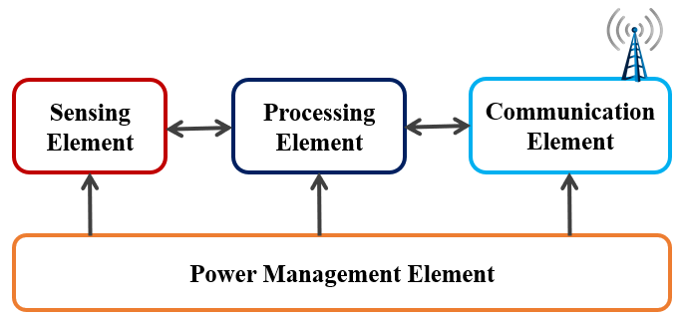
Figure ‎1.1 Typical wireless sensor node architecture
Moreover, the size of integrated circuit is becoming smaller than its previous version due to transistors doubling. Due to the smaller size of these integrated circuits, the power requirements of WSNs are substantially reduced and recently developed ultra-low power sensors (acceleration, pressure and temperature) consume less power in the range of 1.8 to 324 μW [20][21]. Usually, WSNs with multiple sensors consumed more power because of the multiple data transmission which tends to decrease in sleep mode while increases when sending or receiving data. However, WSNs are responsible for a verity of standard wireless communications and are always facing problems with low battery which can only be solved with a continuous battery charging or an uninterrupted power supply.

Applications of wireless sensor nodes
Applications of WSNs can be seen in two main categories: tracking and monitoring. Tracking applications comprised of animals, humans, vehicles, and object tracking. Monitoring applications include structural health and seismic monitoring, condition monitoring, indoor or outdoor environmental monitoring, inventory location monitoring, power monitoring, health and wellness monitoring and factory and process automation. While there are many different applications, below we describe a few example applications that have been deployed and tested in the real environment.
WSNs have been broadly applied in the field of medical health, including patient monitoring, disease diagnosis, hospital drug management, remote monitoring of human physiological data, tracking and monitoring of hospital doctors and the patient's activities. In the medical field, because of the small size of the WSNs and wireless communication technology, they can provide new solutions and techniques for telemonitoring, first aid, etiological diagnosis, and medical equipment tracing and medication management. WSNs in agricultural and environmental applications include: the monitoring of environmental conditions that affects crops, precision agriculture monitoring, to track the movement of birds, insects and other small animals, the detection of oceans, soil, and atmospheric composition, forest fire monitoring, pollution monitoring, rainfall monitoring, river water level monitoring, flood monitoring and so on.
Condition monitoring has been practiced in the manufacturing sector for years [22]. However, new advances in sensor technology that assimilate cloud-based data delivery have changed the conventional condition monitoring to remote condition monitoring (RCM) [23]. RCM is a practice in which software’s and sensors are used to monitor the performance irregularities in machines [24]. A single mobile app and software environment allows facility managers to position wireless sensors on or near the assets they are measuring, and then link sensors to a secured cloud that is accessible via mobile device app or desktop computer.
Apart from these, WSNs are used in different sectors such as (smart homes [25], military surveillance [26], health [25], civil infrastructure [27], agriculture and food processing [28] and traffic management [29]). Furthermore, various types of WSNs are now available in the market. These WSNs includes, acoustic sensors, light sensors, wind speed sensors, solar radiation sensors, temperature sensors, humidity sensors, pyroelectric sensors, Infrared occupancy detectors, barometric pressure sensors, rainfall meters, accelerometers, magnetic RPM sensors, GPS modules, soil moisture sensors, soil temperature sensors, magnetometers, and seismic sensors. Some applications of WSNs are listed in Table1.1.
Table ‎1.1 Applications of wireless sensor nodes
Field | Applications
Healthcare | Monitor vital signs  Blood glucose monitoring  Tele-health diagnosing and monitoring  Tele-surgical system
Smart homes and offices | Energy saving systems  Security system  Automated lighting system
Military | Enemy troops tracking  Communication devices  Global positioning system
Traffic management | Traffic flow control
Industry | Condition monitoring  Industrial automation  Inventory and assets tracking  Radio frequency identification (RFID) system
Civil infrastructure | Bridges, flyovers health monitoring  Building health monitoring

Problem statement
Today we are living in an intelligent world where uncountable numbers of sensors mostly WSNs continuously monitor and manipulate our environments [30][21][31]. Unlike wired sensors, WSNs provide a distinctive solution, avoid cable usage, and ease system deployment, which leads to substantial savings. However, the deployment of WSNs is facing a lot of problems and a continuous power source is one of the main concerns. Currently, WSNs use the battery as the sole power source which has a lot of malfunctions [32][33], like deep discharge, limited longevity, cannot be placed in a remote places, sensitivity to temperature, and essential charging point [34]. Due to these concerns, batteries need periodic replacement which leads to downtime in the industry and can also interrupt the monitoring and tracking system [35][36]. Moreover, the process is not practical when we are talking of hundreds of sensors per user. For a reliable monitoring and tracking system, the battery needs to be replaced with a continuous power source, or it should be recharged continuously.
Increasing the battery’s life or to change it with some alternative is a big challenge of the 21st century. Researchers have tried to harvest the ambient energy available in the vicinity of WSNs to increase the shelf life of the battery. Numerous kinds of energies comprising; solar [37], thermal [38], acoustic [39], and vibration [20] present in the surrounding of WSNs have been converted into useful electrical energy using energy harvesters. However, the output power of the developed energy harvesters is low (2.4 μW to 210 μW) [40][34][41][42][43][44][45][46][47] [48] and despite the advantages of these energy harvesters, there are a lot of challenges which needs to be overcome before the commercialization of such systems for the power requirement of WSNs.
Furthermore, the developed harvesters are not suitable for the real environment, for instance: solar energy harvesters cannot be placed in indoor environments, thermal energy harvesters are limited to thermal gradient only, vibration energy harvesters have high natural frequencies, [34][42][44] and acoustic energy harvesters have low output power [46][48][47][49]. Vibration and acoustic energies have dominancy over the other sources as they are widely available in the real environment [50][51][49][52][53][54][55][56]. One way to increase the efficiency of the harvesters is to consider the size but increasing the size will decrease the power density. Another way is to develop a device that can harvest multiple sources simultaneously, but limited work is available on this idea because of the unavailability of multiple sources at the same time. However, vibration and acoustic are the only two sources which are available at the same time in the real environment [50][51][49][52][53][54][55][56] but rarely we can see the devices considering both the sources simultaneously.
Thus, a new type of harvester is inevitable to simultaneously convert vibration and acoustic energies in a more efficient manner. Furthermore, the output voltage produced by most of the energy harvesters is relatively low and of an alternating current (AC) nature. The WSNs can only be operated continuously if the supplied energy is equal to or more than the consumption, which is challenging for most of the energy harvesters, and hence ultra-low power management approaches are required to supply a reliable direct current (DC) power. The simultaneous conversion of two sources along with a power management circuit will yield an energy harvester with a decent output power for WSNs applications.

Research questions
This research will be carried out to address the following research questions.

- Does enough vibration and acoustic energy available in the environment of the WSNs that can be harvested for their power requirement?
- Is it possible to develop a hybrid environment-based vibro-acoustic energy harvester with enhanced output power?
- Is it possible to develop a single coil based electromagnetic type hybrid vibro-acoustic energy harvester?
- How multiple resonances can be incorporated in a hybrid vibro-acoustic energy harvester?
- Does the in-lab characterization of hybrid vibro-acoustic energy harvester under both vibration and acoustic environment possible?
- How the ultra-low power management will be performed?

Research hypothesis
The available sound and vibration energy in the in the surrounding of WSNs can produce enough electrical power for their requirements (1.8 - 3.4 μW) using hybrid environment-based energy harvesters through simultaneous conversion of multiple sources.

Scope of the study
This research is limited to experimental work and mainly focuses on the design, development, and characterization of energy harvesters for WSNs. A novel hybrid vibro-acoustic energy harvester (HVA-EH) using a flexible coil and a spinning spherical magnet is conceptualized, designed, developed, and tested. The developed device can scavenge vibration and acoustic energy simultaneously using a single flexible coil for WSNs. The power management of the electrical energy produced by the HVA-EH was performed to charge a battery. The characterization of the HVA-EH was limited to sinusoidal vibration only. The detailed mathematical modelling of the developed prototype under a hybrid environment was not considered in this research. The fatigue analysis of the cantilever beam can be investigated in the future for endurance limits. The research can be extended by developing hybrid transaction type (electromagnetic with piezoelectric or electrostatic with piezoelectric) energy harvesters for the hybrid environment to enhance the output power.

Objectives of the study
The main novelty of the research work is the development of a hybrid vibro-acoustic energy harvester (HVA-EH) using a flexible coil and spinning spherical magnet. The presented method is able to harvest power from both vibration and acoustic sources simultaneously through electromagnetic transduction for WSNs. The objectives of the research are listed below.

- To design and develop HVA-EH for simultaneous harvesting of vibration and acoustic energies
- To characterize the developed HVA-EH for open circuit voltage, load voltage, and output power responses
- To enhance and manage the output of HVA-EH to maximize the conversion efficiency

Significance of the study
Despite their many problems, WSNs have gained more attention in the last two decades. Currently, majority of the WSNs depend on a single power supply (battery) which has numerous problems like limited longevity, deep discharge, and required charging points. The periodic replacement of batteries causes downtime and stops production. Thus, many studies have been conducted to increase the shelf life of the battery or to change it with some alternatives. Researchers have tried to harvest ambient energies for the power requirement of WSNs, and despite the advantages of these energy harvesters, there are a lot of challenges that need to be overcome before the commercialization of such systems. The contribution of this research is to provide information to fellow researchers on the development of a hybrid environment-type energy harvester that can be used to enhance output power with multiple ambient sources. The developed harvester with enhanced output power will be used to increase the longevity of batteries which will have an impact on the performance of WSNs by providing a continuous power supply. Furthermore, this study is intended to develop a hybrid vibro-acoustic energy harvester using a flexible coil and spinning spherical magnet to scavenge both vibration and acoustic energy simultaneously through electromagnetic transduction. This research will also help in achieving self-sustained long-term operation of WSNs which will eventually make the deployment of WSNs easy for advanced technologies like the internet of things, remote condition monitoring, tele health diagnosing and monitoring, global positioning systems, and structural health monitoring.

Thesis structure
The overall goal of the research conducted in this thesis is to develop a hybrid vibro-acoustic energy harvester (HVA-EH) using a flexible coil and spinning spherical magnet to harvest vibration and acoustic energies simultaneously through electromagnetic transduction. The thesis has been written in the conventional format as specified by the School of Graduate Studies, Universiti Teknologi Malaysia.
Chapter 1 introduces the background of the study, the formulation of the problem, the objectives to be met, and its scope and significance.
Chapter 2 outlines the fundamental of energy harvesting and various techniques used for harvesting ambient energies. It also provides a review of the available ambient energies in the surrounding of WSNs and various types of vibration and acoustic energy harvesters developed for WSNs.
Chapter 3 addresses the research methodology and the fabrication approach of the developed prototypes. The fabrication steps involved in the development of HVA-EH-1 and HVA-EH-2 are discussed. The materials and methods used in the fabrication of different parts like a flexible coil of the developed prototypes are discussed in detail. The assembly steps of each of the developed prototypes have also been illustrated in chapter 3. Moreover, a detailed description of the development of the experimental setup is also provided in this chapter.
In chapter 4 the experimentation of the developed prototypes is discussed. Characterization of the HVA-EH-1 and HVA-EH-2 under vibration, acoustic and hybrid environments is reported. The OCV, load voltage and output power responses of the developed prototypes are shown and discussed in detail. Chapter 4 also includes the response of the HVA-EH-2 after connecting it to the power management circuit in terms of output direct current (DC) power and charging capabilities are discussed. Finally, a discussion on the results of the prototypes and a comparison of the prototypes with the recent state-of-the-art vibration and acoustic energy harvesters have been discussed in chapter 4.
Chapter 5 presents the conclusion and the proposed future recommendations of this research.
The references summarized in the bibliography, a list of research papers published from this work, and the appendices associated with the chapters are presented at the end of the thesis.

LITERATURE REVIEW

Overview
This chapter outlines the fundamental of energy harvesting (EH) and various techniques used for harvesting ambient energies. It also provides a review on the available ambient energies in the surrounding of WSNs and various types of vibration and acoustic energy harvesters developed for WSNs. Moreover, the challenges faced by the energy harvesters are also summarized in this chapter.

Fundamentals of energy harvesting
Energy harvesting or energy scavenging is the process in which ambient energy from the environment is transformed into useful electrical energy on small scale [57][58]. The energy can either be used immediately or can be stored for future usage. This process is like the large scale renewable energy generation, however, the energy produced is much smaller (micro watts to few watts) [59]. It is used to provide an alternative or to enhance batteries which contain a finite amount of energy and require periodic recharging or replacement. In addition to that, the disposal of batteries is a huge concern to the environment [60]. Energy harvesting works by scavenging small amount of ambient energy, which is otherwise dissipated or wasted in the form of heat, noise, solar radiations, vibration, RF waves, etc. Various types of energy harvesting systems have been illustrated by the researchers [61][62][63][64][65][66][67], however, it could be said that, summarized form of those systems consist of three main elements (listed below) in addition to energy source. The general architecture of the energy harvesting system is shown in Figure 2.1.
- Harvester Element: This is the main element of energy harvesting system which converts ambient energy of the environment into useful electrical energy by various transduction mechanisms.
- Power Management Element: This element manages the harvested electrical energy by conditioning it into most suitable form for the desired application. This element mainly involves voltage rectification and regulations. Moreover, it is also responsible for energy storage.
- Load Element: This element comprises of the electronic system such as a WSN, actuators, etc. to consume the output electrical energy.

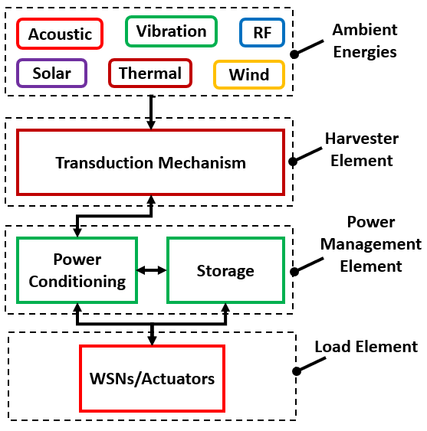
Figure ‎2.1 General architecture of energy harvesting system

Various forms of energies are available in the environment of WSNs. These energy resources have been classified into external and internal sources by A. D. Ball [68]. Air and fluid flow generate force which is an effective kinetic energy and can be converted into useful electrical energy for the power requirement of WSNs. Solar energy is abundantly available outside the set up and can be utilized by WSNs. Artificial light is also available inside the facility which can also play its part in making the WSNs system autonomous. The solar energy is also affected mostly by the weather, region, and length of the day. Electromagnetic waves in the form of RF are available all around us and can be harvested. However, the environment affects the external energy sources, and their harvesters are difficult to be adopted. The potential EH resources available around the WSNs are shown in Figure 2.2.
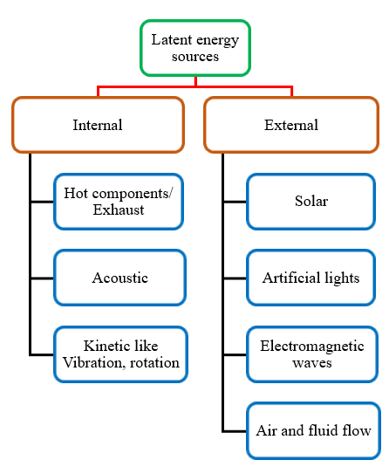
Figure ‎2.2 Potential energy sources, adapted from [68]

Alternatively, internal energy in the closed environment has great potential. Most of the industrial machine has efficiency less than 50 %, the remaining energy is wasted and is available in the nearby vicinity of different machines [68]. This wasted energy is available in three different forms i.e. acoustic, vibration and heat. In mechanical system, the components that are in close contact with each other causes friction and loss in energy occur in the form of heat and sound. The thermoelectric [69] and acoustic [70] energy harvesting techniques can be used to scavenge this energy. Moreover, vibration is abundantly available in machines and structures like bridges and high risers which is a good source of kinetic energy [71]. In short, the energy available in the surrounding of WSNs can be harvested separately or can be combined with other sources to form a hybrid energy harvesting system like vibration and acoustic. Because of the significant amount of wasted energy in the form of heat, sound and vibration, the energy harvesting has an inordinate potential to develop an autonomous WSNs system. Furthermore, the power densities of various types of ambient energies available in the surrounding of WSNs are summarized in Table 2.1. Different types of energy harvesters have power densities in μW/cm³ and μW/cm², and the reason is that sometime volume of the devices is given and sometime area. The different sizes of the devices make it challenging for the researchers to compare different energy harvesting systems, however, power density is one of the normalized parameters which is used to compare various energy harvesting systems. From Table 2.1, it could be observed that, vibration and acoustic energy is lavishly available in industrial environment and have the highest power densities among the reported energy sources.
Table ‎2.1 Ambient energies available at different locations
Energy type | Location | Power Density | Ref.
Acoustic | Ambient noise | 0.96 µW/cm³ @ 100 dB | Rabaey et.al.[50]
Acoustic | Ambient noise | 191.4 µW/cm³ @ 120 dB | Khan et.al. [51]
Acoustic | Open speaker | 32.7 µW/cm³ @ 130 dB | Iftikhar et.al. [49]
Vibration | Industrial Machines | 800 µW/cm³ | Bhatanagar et.al. [52]
Vibration | Car tire | 160 µW | Renaud et.al. [53]
Vibration | Industrial | 100 µW/cm² | Vullers et.al. [54]
Vibration | Vibration shaker | 2.3 µW/cm³ | Iftikhar et.al. [55]
Vibration | Jet Engine | 78.81 mW | Wang et.al. [56]
RF | Urban area | 180 µW/cm² | Singh et.al. [72]
RF | Wi-Fi | 1 µW/cm² | Based et.al. [73]
RF | GSM | 0.1 µW/cm² | Based et.al. [73]
Thermal | Industrial | 60 µW/cm³ | Bhatanagar et.al. [52]
Thermal | Human body | 25 µW/cm² | Based et.al. [73]
Thermal | Industrial | 10 µW/cm² | Based et.al. [73]
Solar | Indoor | 10 µW/cm² | Vullers et.al. [74]
Solar | Outdoor | 10 mW/cm² | Vullers et.al. [74]

Moreover, the associated parameters of vibration and acoustic energy are summarized in Table 2.2. The range of vibration amplitude and frequency is from 0.09 g to 4 g and 43 Hz to 307 Hz respectively, while the range of available sound pressure level (SPL) and acoustic frequency is 90 dB to 190 dB and 1 Hz to 20 kHz respectively.
Table ‎2.2 Vibro-acoustic energy sources and their associated parameters
Vibro-acoustic energy source | Vibration amplitude (g) | Vibration frequency (Hz) | Sound pressure level (dB) | Acoustic Frequency (Hz) | Ref.
Turbine compartment | 0.5 | 154 | 131.9 | 30-8k | [43][75]
HVAC vents | 1.5 | 60 | -- | -- | [76]
Drilling operation | 0.09 | 178 | 190 | 10-10k | [71][75]
Centrifugal fan (2000 rpm) | 1.5 | 307 | -- | -- | [71]
Turbofan engine | -- | -- | 150 | 20-20k | [77]
Electric generator | 4 | 132 |  |  | [47]
3 axis machine tool (Base) | 1.02 | 70 | -- | -- | [76]
Oil production activities in ocean | -- | -- | 135 | 40-100 | [78]
Air-compressor | 2 | 43 | -- | -- | [79]
Automobile surrounding | 1.2 | 200 | 90 | 1-100 | [76][80]
Small power Boat | -- | -- | 150 | 350-1200 | [81]
Marine dredging operations | -- | -- | 180 | 50-500 | [80]

Energy harvesting techniques
Energy harvesting is a promising solution to the challenges faced by the WSNs. Various types of potential energies are available in the surrounding of WSNs which can be scavenged through different techniques. Energy harvesting techniques with their corresponding block diagrams, advantages and disadvantages have been illustrated in this section.

Vibration energy harvesting
Vibration energy harvesting is a process in which ambient mechanical vibration is converted into useful electrical energy [19]. Ambient vibration energy is abundantly available; structures like bridges vibrate due to vehicle movement and strong wind, car vibrates due to bumpy road and running of engines, moreover, almost every industrial machine possesses vibrations. Various types of transduction mechanisms have been used to convert vibration energy into electrical energy for different WSNs and actuators. Piezoelectric [82][64], electrostatic [83], triboelectric [84][85], and electromagnetic [86][34] transduction mechanisms are most common types of techniques used to convert vibration energy into electrical energy. Piezoelectric vibration energy harvesters (VEHs) mainly use piezoelectric material which produces voltage when subjected to force or deformation [87]. Electrostatic VEHs work on the changing capacitance between two plates, the capacitance between two plates changes because of the gap varying due to vibration and thus voltage is produced in the plates [88]. Triboelectric VEHs use two materials of different polarities which have the capabilities to lose and gain electrons. Due to their combined contact electrification and electrostatic induction, electrical energy (alternating current) is produced [89][90]. Electromagnetic VEHs are based on Faraday’s law of electromagnetic induction, where the magnetic flux density changes across the coil due to the relative motion between the magnet and coil and hence voltage is induced in the coil [91]. Moreover, a power management system is used for the rectification and storage purposes. The basic architecture of VEH system is shown in Figure 2.3.
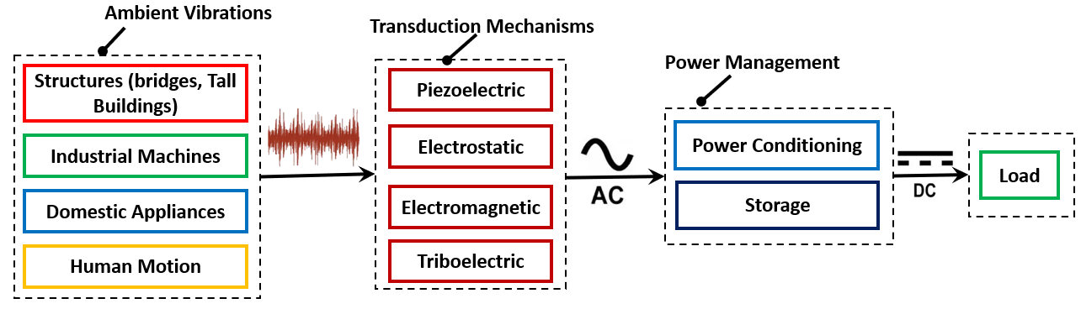
Figure ‎2.3 Architecture of vibration energy harvesting system
All four types of transduction mechanism have their own advantages and disadvantages. The piezoelectric VEHs has the maximum output voltage and high energy density, however, because of the high impedance it has low output current and power [19][92]. The resonant frequency can be easily tuned, while the need of specific piezoelectric material is always there [93], moreover, the piezoelectric materials degrade overtime [94]. Similarly, the electrostatic VEHs have high output voltage but low output power [19]. The resonant frequency is basically high, and it always require an initial pulse to start. The triboelectric VEHs has low operation frequency and high-power density, however, the mechanism is not fully understood and it is difficult to integrate [95]. Finally, the electromagnetic VEHs have low output voltage but high output power because of the low internal resistance of the device [96][92]. The electromagnetic VEHs have complications to miniature device size [97].

Solar energy harvesting
Whether indoors or outdoors, light is a rich energy source that can be used to power an extensive variety of applications including WSNs and devices of the emerging internet of things (IoT) industry. The conversion and storing of radiated energy from the sun is known as solar energy harvesting [98]. In this process, the solar energy in the form of light or heat is converted into useful electrical energy through photovoltaic cells or solar collectors [99][100]. When solar energy strikes on photovoltaic cells, the electrons of the semiconductor material are knocked loose. If electrodes are connected to the positive and negative terminals, making an electrical circuit, the electrons can be captured in the form of an electric current which is electrical energy. The block diagram of solar energy harvesting system is shown in Figure 2.4.
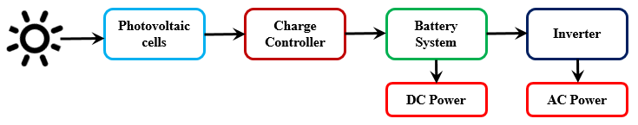
Figure ‎2.4 Block diagram of solar energy harvesting system.
The solar energy harvester has some benefits over other energy harvesting techniques but at the same time it has some limitations. The solar energy is unlimitedly available in the environment but indoors sensors charging is a big challenge for it [101]. The entire solar energy generation process is noiseless but it cannot be harvested at the cloudy and rainy climates [102]. Also, the availability during night-time is big concern. The efficiency of solar cells also degrades because of the polluting environment.

Thermal energy harvesting
Thermal energy harvesting is a process in which the ambient heat available in our environment or given off by various industrial machines is converted into useful electrical energy [103]. The phenomenon by which the ambient heat is converted into useful electrical energy known as seebeck effect. The devices used for thermal energy harvesting are known as thermoelectric generators [65]. The seebeck effect occurs when there is a change in temperature between two conductors connected at two junctions. Due to thermal diffusion, the motion of charge carriers (P and N type materials) occurs in the conductors. Block diagram of thermoelectric energy harvesting system is shown in Figure 2.5.
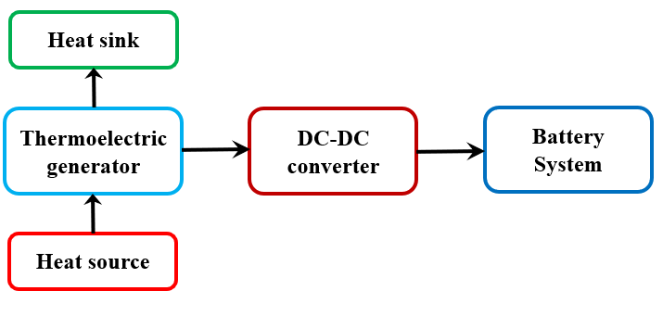
Figure ‎2.5 Block diagram of thermoelectric energy harvesting system

Thermoelectric energy harvesters are maintenance free because of the uses of compact solid-state device and easy to integrate with the existing setup [104][105]. It does not require additional power source but the uneven temperature distribution on the plate can make it inefficient. Because of the higher temperature gradient, there is a limited usage of thermoelectric energy harvesters [106]. It has low output power and high cost is associated with it. Another disadvantage is that they are bulky and also requires heat sinks to keep the spatial gradient [107]. The heat is harvested from the waste heat that is why it is highly efficient in the environmental terms.

Acoustic energy harvesting
The undesired sound waves are considered as noise and the most common noise sources are high speed train, airplanes, loudspeakers, and industrial machines; however, these sources are now the necessities of life. Acoustic waves are mechanical waves that have energy which is an indispensable environmental source of energy. The acoustic energy can be converted into electrical energy using acoustic energy harvesters (AEHs) [49]. AEHs mostly uses a Helmholtz resonator which comprises of an orifice, cavity and a transduction mechanism (piezoelectric or electromagnetic) [108]. Sound energy is converted to mechanical energy when sound strikes on the orifice generates an oscillatory pressure in the cavity. The oscillatory pressure vibrates the piezoelectric material or magnet and coil deepening on the transduction mechanism and a voltage is induced accordingly. The schematic of AEH system is shown in Figure 2.6.
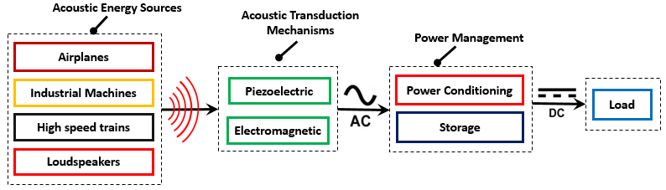
Figure ‎2.6 Schematic of an acoustic energy harvesting system
The transduction mechanisms of AEHs are same as vibration so most of the advantages and disadvantages are already discussed in VEH section [19][92][94][96]. However, the thermoacoustic energy harvester promises many additional advantages compared to other energy harvesters, like long shelf life, low heat input requirement, less maintenance cost and simplicity in design [109].

Radio frequency energy harvesting
Radio frequency energy harvesting is the conversion of energy from the electromagnetic fields into useful electrical energy [110]. RF energy harvesting system mainly comprises of an antenna to receive electromagnetic waves, matching impedance circuit to amplify signals, peak detector to convert signal into voltage values and voltage booster to adjust output voltage. The receiving antenna, matching impedance circuit and rectification unit are collectively known as rectenna [111]. A power management system with storage unit is also integrated into the RF energy harvesting system to provide a constant output voltage. The block diagram of the RF energy harvesting system is shown in Figure 2.7.

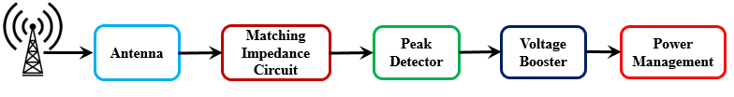

Figure ‎2.7 A block diagram of the RF energy harvesting system

Compared to other energy harvesting techniques like vibration, thermal, acoustic and solar the power density of RF energy harvester is low, but the harvested power is adequate to power up some sensors [112]. The main advantage of the RF energy harvesting systems is that unlimited spectrum of sources is available and it can wirelessly power up the sensors and other devices [113]. However, extracting energy from the RF source and development of matching impedance circuit are among the big challenges [101].

Challenges to energy harvesting systems
Various types of energy harvesting techniques have been developed for different WSNs. However, there are a lot of challenges which needs to be overcome before the commercialization of such systems. The challenges faced by the energy harvesting system to power up WSNs are summarized below:
- Power management is one of the challenges that energy harvesters are currently facing. Most of the kinetic energy harvesters produce AC voltage with low amplitude which needs ultra-low voltage rectification.
- The energy harvesting devices are costly, and its high production and implementation cost is another challenge in its way of commercialization. For the power autonomy of distributed sensors network, a large quantity of energy harvesting devices is needed which is only possible with a reduced cost.
- Most of the time WSNs are used in high temperature environment, and the conventional silicon based devices are not able to work above 80 ºC [114]. The experts have suggested the use of high temperature devices; however, this approach is again expensive, and the high temperature challenge is still there for the energy harvesting system.
- Regardless of the various scavenging power techniques, it is important to match the internal resistance of the generator with the internal resistance of power management circuit to achieve the maximum output power for WSNs.
- There is no international standard for energy harvesters and the nonexistence of standardization is the main challenge in their commercialization. The lack of precise measurement delays the innovation, development, and market acceptance of these devices. The standardization of energy harvesters will increase its efficiency, reduce its cost, and improve market sustainability.
- The need of a versatile harvester which can harvest power from multiples sources is always a challenge in this field. This type of harvester will continuously power the WSN and can skip the energy storage.
- Miniaturization of the energy harvester devices is another challenge which can help in the cost reduction, mass production of the devices and can be best fit in WSNs.
- Although tremendous research has been done in the past decade on the energy harvesting, however, there is no simulation environment which can evaluate the energy harvesting system before the deployment in WSNs.

Established approaches
Various studies have investigated energy harvesting mechanisms for WSNs. In this section of the thesis, different types of the energy harvesters developed for WSNs applications are illustrated. Established approaches include vibration, acoustic, radio frequency, thermal, and solar energy harvesting mechanisms.

Vibration energy harvesters
Vibration energy is abundantly available in industrial environment and various attempt have been made to power up the WSNs with this energy. A vibration based electromagnetic type energy harvester was designed, build and tested by Waterbury et. al. [115], the device comprises of a permanent magnet, coil and planar spring. The internal resistance of the coil was measured to be 76 Ω, while the total number of turns in the coil were 660. The device uses a planar spring to tune the frequency accordingly. The developed device could produce a root mean square (RMS) voltage of 601 mV with a maximum power output of 1800 µW when tested on a face milling machine and water pump. However, the device was not used to power any real WSN. The developed prototype along with its components is shown in Figure 2.8 (a).
Torah et. al in [40], has designed and developed an electromagnetic generator to power up CMS sensors. The generator comprises of a cantilever beam, neodymium magnet and copper coil. Tungsten masses have been added to the tip of the cantilever beam to reduce the resonant frequencies of the device. All these components contribute to the total volume of the device (0.15 cm³). The characterization process reveals that the generator can produce an OCV of 1141 mV with a maximum power of 58 μW at 0.06 g. At higher acceleration level the power management system used have boosted the output power to 120 μW at a resonance frequency of 52 Hz. The developed prototype was successfully tested on industrial air compressor and on an office air conditioning unit; however, the output power of the device was too low to power up any WSN. The 3D model of the electromagnetic generator is depicted in Figure 2.8 (b).
Another attempt of autonomous condition monitoring was carried out in by Discenzo et al. [116], the oil pump was considered as an example using self-powered sensors. A cantilever beam type piezoelectric generator was used to extract electrical power from mechanical vibration with a resonant frequency of 130 Hz. Bimorph piezoelectric (T220-A4 from Piezo Systems Inc.) material was used to construct the energy harvester. The developed energy harvester is shown in Figure 2.8 (c), however, the output voltage and the generated power are not clearly shown in the paper.
Another attempt was made to convert the rail track vibrations into electrical energy to power the rail side sensors for condition monitoring using electromagnetic energy harvester by Gao et. al. [117]. The developed prototype consists of two fixed magnets, a movable magnet, and a coil. Mathematical modelling of the device is also described in the paper. When the train passes the track vibrates which move the magnets and the coil experiences a variation in magnetic flux density and as a result voltage is induced in the coil. The device can generate a maximum voltage of 695 mV with a calculated power of 550000 µW. Moreover, a DC-DC booster is used to charge a lithium battery of autonomous sensors node which was used in CMS. Illustration of hardware prototype of self-sustaining sensor nodes is shown in Figure 2.8 (d).
A wireless sensor network for CMS is developed by Jang et. al. [118], to reduce the power consumption of WSN and its associated sensors. The system was powered by a piezoelectric energy harvester. The harvester could generate a maximum power of 100 µW with an overall volume of the 4.03 cm³ at 40.8 Hz. The system was tested at a vibration level of 0.45 g on a vibration shaker. The developed piezoelectric energy harvester along with the measurement setup is shown in Figure 2.8 (e).
Furthermore, a multi-mode vibration-based energy harvester was designed using piezoelectric beams with a unique architecture of pre-stretched hosting beams and multiple micro beams. The broad band vibration data of an underground train bogie was observed and collected [45]. The prototype was tested under random condition and shows a broad band feature between 10 – 130 Hz with several peaks which can be used for condition monitoring sensors in railways. The harvester clamped in a holder for testing is shown in Figure 2.8 (f).

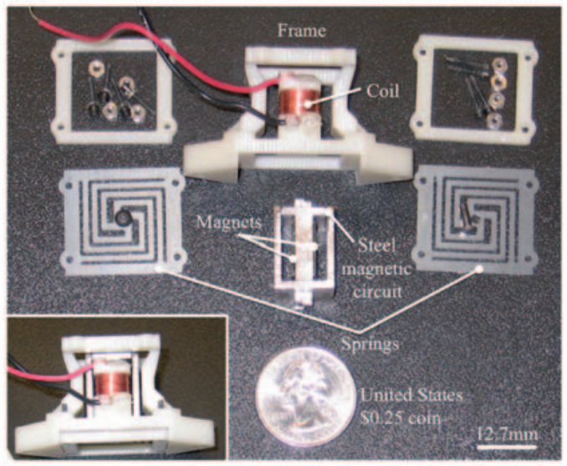 | 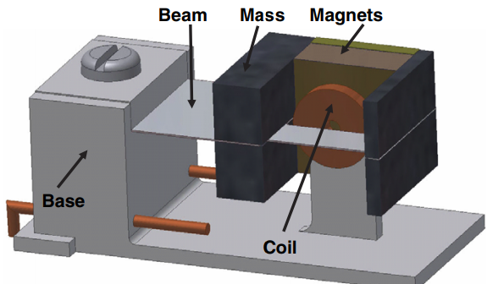
(a) [115] | (b) [40]
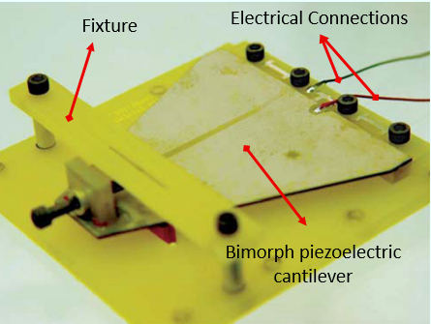 | 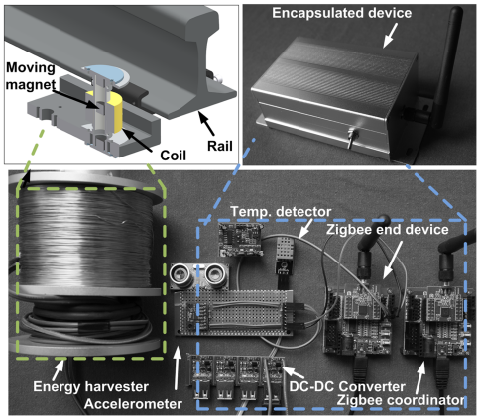
(c) [116] | (d) [117]
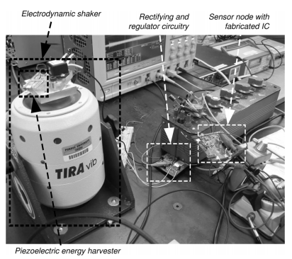 | 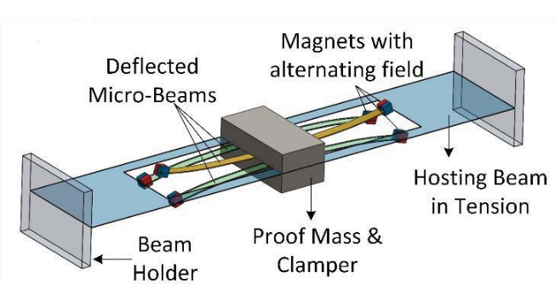
(e) [118] | (f) [45]

Figure ‎2.8 Vibration-based energy harvesters developed for WSNs sensor applications (a-f), reprinted from [115][40][116][117][118][45]

Solar energy harvesters
Solar energy harvesting also has the potential to power the WSNs. An attempt has been made by Ibrahim et. al. [119] by developing a solar EH system for wirelessHART sensor node. The characterization of the proposed system showed a potential to power up the wirelessHART node. The wirelessHART was analysed by connecting it to the network. The system could generate a voltage of 8400 mV. Solar EH system developed is shown in Figure 2.9 (a).
Another solar energy harvester was developed by Pozo et. al. [120], using photovoltaic module. A direct current (DC)/DC converter was also used to optimize the output power. Different parameters such as voltage, efficiency and power were considered at various environmental conditions such as temperature and illumination. It was concluded from the experimentation that the harvesting system can generate a voltage of 3760 mV and output power of 283180 µW. The real test setup of the solar EH system is shown in Figure 2.9 (b).
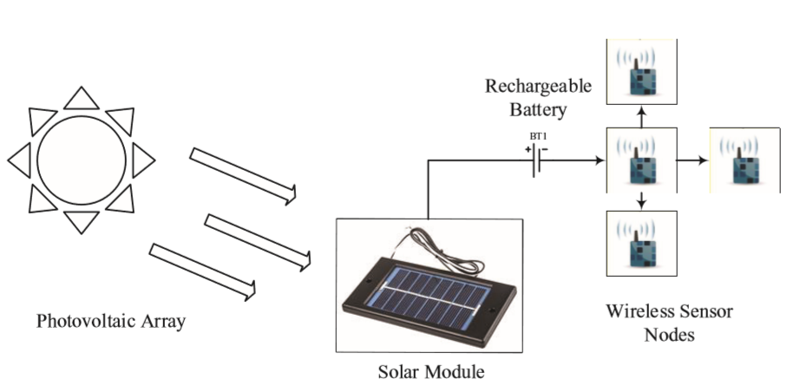
      - [119]
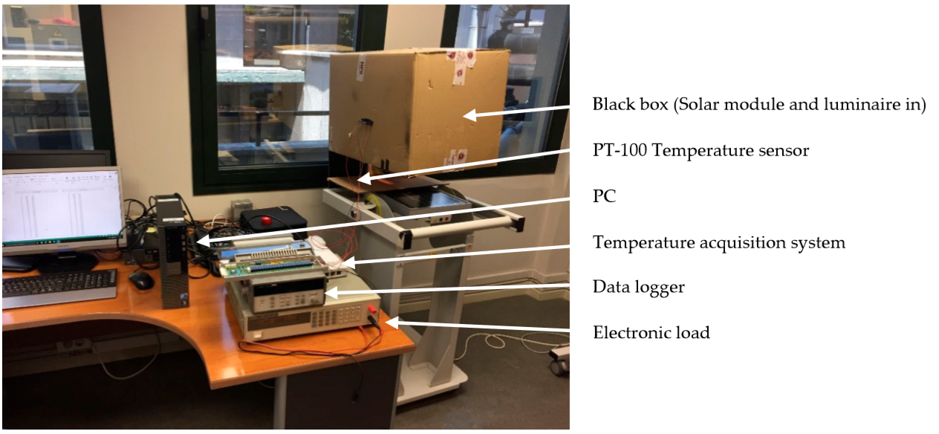
      - [120]
Figure ‎2.9 Solar energy harvesters developed for WSNs applications (a-b), reprinted from [119][120]

Thermal energy harvesters
Thermal energy harvesters convert waste heat into useful electrical energy using seebeck effect. A series of PN junction connected end to end makes thermoelectric generator. A schematic of thermal energy harvester is shown in Figure 2.10 (a) [121]. Because of the excess temperature gradient in industrial environment, thermal energy harvesters can play vital role in CMS. Francioso et al. developed a miniaturized thermoelectric generator by integrating an array of 100 thin- film thermocouples on flexible substrate with an area of about 7 x 3 cm² [122]. A maximum OCV of 430 mV and an electrical output power up to 0.032 µW was achieved at matching impedance and at 40 °C temperature gradient. The established device can be used for healthcare, biometric parameters monitoring and condition monitoring. Photograph of the fabricated device on Kapton HN (left) and schematic of flexible thermoelectric generator (right) is shown in Figure 2.10 (b).
To power up WSNs in the airlines a TEH was developed by Dilhac et. al. [123]. The prototype was tested in three major zones (pressurize and temperature controlled, non-pressurized and non-temperature controlled and very harsh environment around the engine) of the airlines. For a simulated flight environment, a maximum power of 30000 µW was generated and the total scavenged energy is close to 35 joules. The energy generated by the device can be used to power up the WSNs used for the aircraft structure health monitoring. Another thermoelectric generator for the aircraft environment is discussed by Le et. al. [107]. The developed device could control three strain gauges. The necessary power can be produced from the temperature gradient of 30 to 50 ºC. The working principle of the proposed thermoelectric generator is shown in the Figure 2.10 (c). For the gas turbine monitoring system, a compact TEH was developed by Zhang et. al. [38]. The prototype was experimentally tested, and mathematical validation were also carried out. It was observed from the characterization of the device that it can produce a maximum power of 920 µW from a source temperature of 325 ºC.
A thermoelectric generator was developed by Schirrmacher et. al. [124], based on SK464 passive heat sink for WSNs in marine gearbox. The device was successfully tested to power vibration, rotational speed, and torque sensors. A continuous power of 14000 µW was achieved with the temperature gradient between the heat sink and ambient air. The developed device with a hot temperature of the gearbox surface is shown in Figure 2.10 (e). The modification of mechanical system is one of the limitations of the developed system. Furthermore, a low voltage thermoelectric generator is presented by Guan et. al. [33]. The device can power up a microcontroller and a WSN under low voltage and high efficiency. With a self-starting mechanism, the device can generate an OCV of 62 mV and a maximum power of 48 µW. the developed prototype is shown in Figure 2.10 (f).

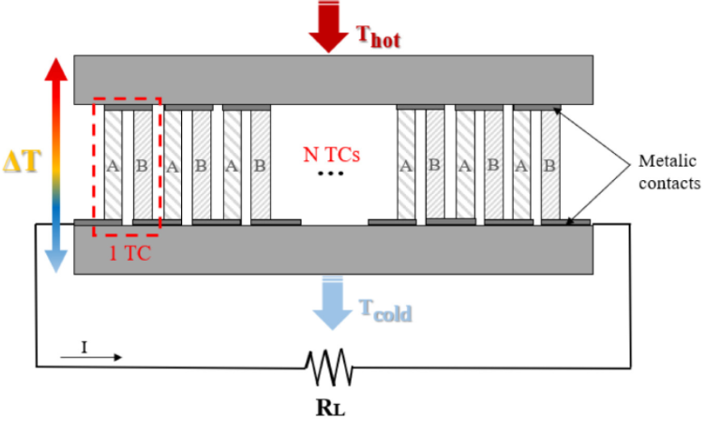 | 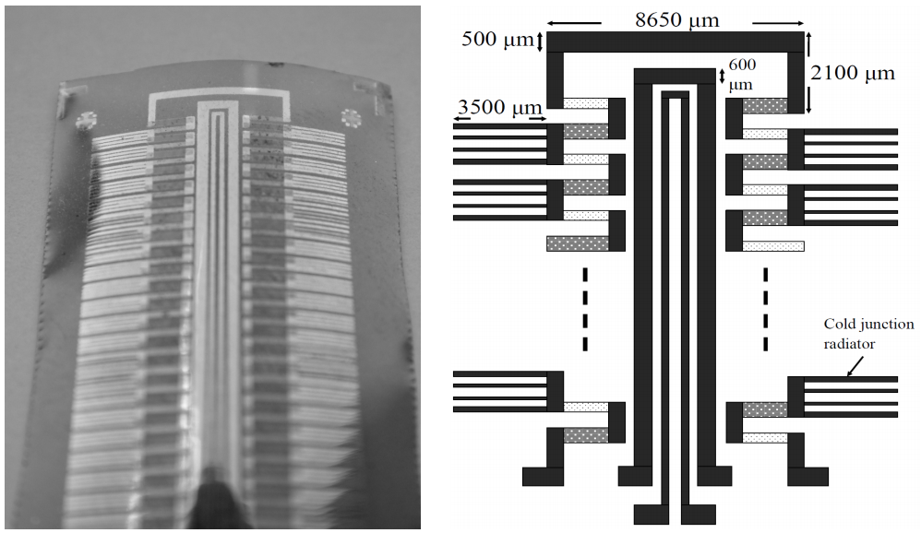
(a) [121] | (b) [122]
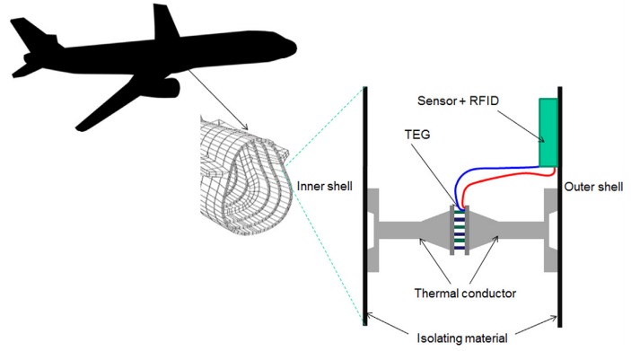 | 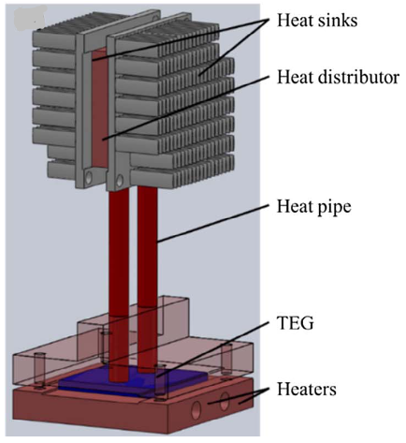
(c) [107] | (d) [38]
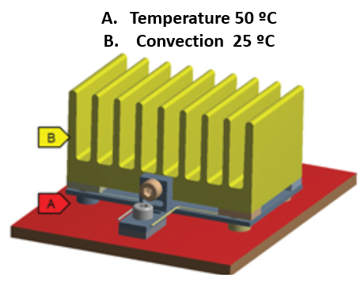 | 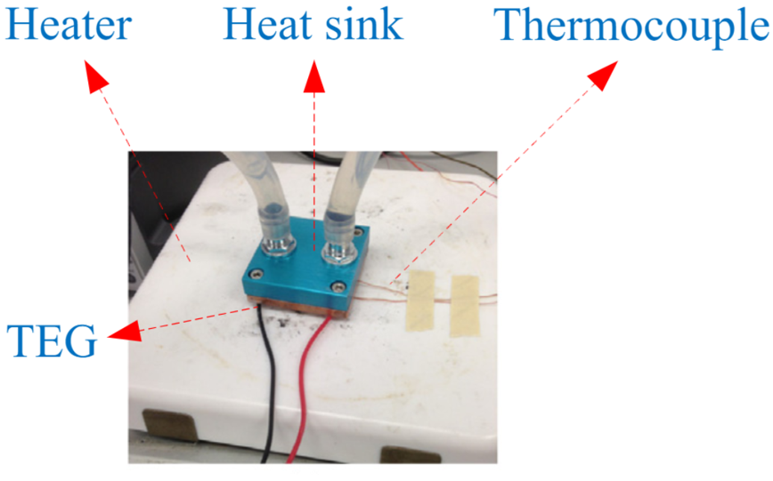
(e) [124] | (f) [33]
Figure ‎2.10 Thermal energy harvesters (a) schematic of thermal energy harvester (b) Photograph of the fabricated device on Kapton HN (left) and schematic of flexible thermoelectric generator (right) (c) Working principal of the thermoelectric generator in an airplane structure (d) CAD model of the developed device (e) The developed device with a hot temperature of the gearbox surface (f) the developed prototype, reprinted from [121][122] [107][38][33]

Acoustic energy harvesters
An acoustic based piezoelectric type energy harvester was developed by Iizumi et al. in [125], the device comprises of dual top electrodes with three different parts. The peripheral, central, and connected energy harvester generate power of 5.28×10⁻⁵ µW, 4.25×10⁻⁵ µW, and 8.28×10⁻⁵ µW under the sound pressure level (SPL) of 100 dB at resonance frequency of 4.92 kHz, respectively. The device was compared to the other acoustic energy harvesters with similar diaphragm, and it was observed that the proposed device can generate two times more power with its unique architecture. The proposed device can be easily adopted for high noise environment like manufacturing workshop and can be used for CMS sensors. The cross-sectional view of the prototype is shown in Figure 2.11 (a).
Another attempt with an improved AEH has been made by Khan et. al. [126]. The device comprises of a piezoelectric material with Helmholtz resonator. The design, fabrication and characterization of the prototype is shown in the paper. The prototype was tested both in lab and in real environment. The output power achieved in the experimentation was 90.6 µW at 130 dB. Further, the device was optimized with cylindrical shape Helmholtz resonator and proof mass. The power output was increase by 103 % to 184.18 µW. The device was also tested near a motorbike and a domestic generator, and this proves that the proposed device is suitable for CMS sensors.
Moreover, an acoustic energy harvester was developed for low frequency environment by Yuan et. al. [48]. The design, fabrication and characterization of the prototype have been discussed in the paper. From the experimentation, it is clearly shown that the device is suitable for broad band environment. At SPL of 100 dB the device can generate an output power of 2.4 µW. From the SPL, it is clear that this type of device can be used for condition monitoring sensors keeping in mind the SPL at manufacturing environment [50]. Experimental test setup of the proposed harvester is shown in the Figure 2.11 (b).
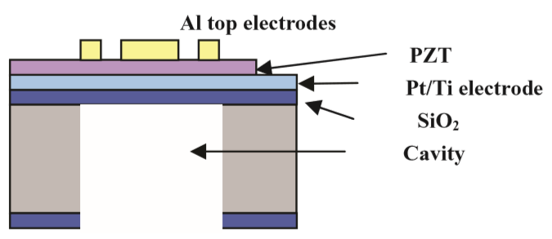 | 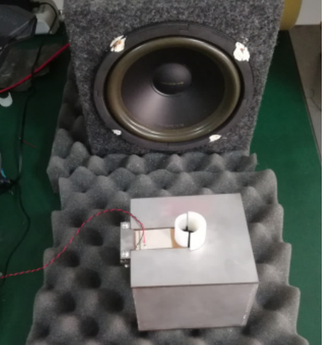
(a) [125] | (b) [48]
Figure ‎2.11 Acoustic energy harvesters developed for WSNs applications (a-b), reprinted from [125][48]

Hybrid energy harvesters
To overcome the insufficient energy generation problem of a single energy harvester, hybrid energy harvesting is becoming an emerging technology [127]. Hybrid energy harvesters converts energy from multiple sources into useful electrical energy. In various WSN’s environment, more than one types of energies are available like vibration and acoustic, thermal and vibration, solar and thermal, etc. which can be simultaneously converted into useful electrical energy [128]. Furthermore, hybrid energy harvesters also use more than one type of transduction mechanisms in which different structures and materials can improve the energy conversion performance. As a result, hybrid energy harvesters can be divided into two categories: multi-source hybrid harvesters, and single source harvesters with hybrid mechanisms Various energy harvesting system have been integrated to yield a hybrid system for the power requirement of low power electronics like WSNs [129][130][131][132][133]. Hybrid energy harvesting system can be of hybrid environment-based like vibration-thermal [134], vibration-solar [135] and thermal-solar [121] or hybrid transduction mechanism based like electromagnetic-piezoelectric [129][136][137] and piezoelectric-electrostatic [138].
A hybrid system of energy harvesting has been developed by Feng et. al in [44] to power up CMS sensors. The system comprises vibration, magnetic and thermoelectric energy harvesting schemes. Conventional magnetic, thermoelectric, and piezoelectric energy harvester were used to develop the hybrid system. The system was developed to energize the condition monitoring sensors in power grids. The developed system was tested in the lab and a maximum power output achieved were 1980000 µW, 366000 µW and 630 µW for thermoelectric, magnetic and vibration energy harvesters, respectively. However, the developed prototype was not tested in real environment. Another hybrid system with two subsystems has been demonstrated to operate a WSN without battery [139]. The system was hybrid environment-based exploiting solar and vibration ambient sources. A WSN was completely managed including controlling and monitoring by the proposed system.
Another condition monitoring system (acoustic emission monitoring) has been discussed by Wang et. al. [140]. The acoustic emission monitoring with WSN was proposed in this work. A subsystem of energy harvesting was introduced to power the WSN. The energy harvesting system was hybrid based, comprised of solar, thermal and vibration. The system was tested on an air compressor and the result shows that the developed system can harvest 3370 µW from wasted heat and 1560 µW from machine vibration, then store the energy in supercapacitor type energy storage unit. The output power of the developed system was enough to perform the acoustic emission monitoring with power autonomy. It is clear from this work that the hybrid system can play a vital role in the power requirement of WSNs.

Power management
Power management is a crucial and complex research area that aims to optimize the efficiency of the power obtained from harvesting sources and to provide solutions for minimizing energy losses. The optimal way to convert the harvested power is to design a power management component that considers the characteristics of the harvesting source. Various types of power management circuits have been developed in in the past to rectify and amplify the output voltage of energy harvesters.
Shi-Jun et al. [141] proposed a novel method to manage the energy in a system that collects thermal energy efficiently. The method uses the bus voltage intervals to control the threshold for the maximum power point tracking and the load power tracking. The load power tracking is based on fuzzy logic, and it helps to keep the bus voltage stable when the DC load power demand is low. The experiments show that the method can adjust to the changes in DC load power with an average error of 3.5 % and that the energy management works well under different load power and battery state of charge conditions. Another paper published by Zhang et.al. [142] illustrates a design that can collect and store energy from a dc power source using PV cells. The design is suitable for applications such as wearable devices, home automation, and geolocation. The maximum power that can be harvested is 50 mW. The design also includes a boost converter that can transfer power from the source to another storage element. To protect the device from damage, the design has over-discharge and over-voltage protection features.

Furthermore, a power management instigated circuit developed by Kadirvel et. al. [143] can collect energy from sources like thermoelectric generators and solar cells and are specially made for wireless sensor nodes. They can work with up to 400 mW of power, which makes them very effective for power management. They have a feature called maximum power point tracker that allows them to get the most amount of energy from the sources. They can also adjust to different types of batteries, such as NiCd, supercapacitor, thin-film solid-state, and lithium-ion/polymer. They can be used for smart-lighting, smart-homes, fitness devices, and wearable devices. Another work is reported in [144], which explain the operation of two practical IoT sensor nodes, continuously powered by the vibrations of a standard industrial compressor, using a multi-modal EM-VEH device, integrated with customized power management. The power management enabled the system to send and receive the data with an interval of less than a minute. Reseli et. al. [145] compares different power management techniques for energy harvesting. It suggests an improvement on the adaptive circuit to achieve higher efficiency. The paper uses a comparator circuit as an adaptive method for the DC-DC step-down converter to reduce the power consumption and losses of the circuit. The simulation results show that the output voltage of the energy harvesting power management circuit is 3.0 V and the output power is 30 mW. The paper reports an efficiency of 80 % and a total power loss of 7.5 mW.

Summary of the literature review
Energy harvesting technologies reported in this work have been deeply investigated based on the important parameters such as size of the prototype, output voltage, output power, internal resistance, input acceleration/SPL, and frequency. Despite the advantages of these energy harvesters there are a lot of challenges which needs to be overcome before the commercialization of such systems for the power requirement of WSNs. Furthermore, the developed harvesters are not suitable for the real environment, for instance: solar energy harvesters cannot be placed in indoor environment, thermal energy harvesters are limited to thermal gradient only, vibration energy harvesters have high natural frequencies, [34][42][44] and acoustic energy harvesters have low output power [46][48][47][49]. Vibration and acoustic energies have dominancy over the other sources as they are widely available in the real environment [50][51][49][52][53][54][55][56]. Though vibration and acoustic energies are abundantly available but individually they are not producing a decent output power.
It has been observed that the average individual output power of available vibration and acoustic energy harvesters is ranges from 2.4 μW to 212 μW except [44] which was characterized at higher acceleration level, and [146] which has large volume. The piezoelectric devices give high OCV but because of the high internal impedance the power output is very low, while the electromagnetic devices have low internal resistance and that is why they have higher output power even with smaller device size. The reported vibration energy harvesters were operated at higher acceleration level of up to 2.5 g. The resonance frequencies of the reported vibration harvesters are high and are not suitable for real environment. As far as the acoustic energy harvesters is concern, mostly researchers have used piezoelectric transduction, however, because of the high internal impedance of piezoelectric materials, the output power is very low.
From the literature it can be seen that the efficiency of the harvesters can be increased by considering their sizes but increasing the size decreases the power density [146]. Another way is to develop a device which can harvest multiple sources simultaneously, but limited work is available on this idea because of the unavailability of multiple sources at the same time. However, vibration and acoustic are the only two sources which are available at the same time in real environment [50][51][49][52][53][54][55][56] but rarely we can see the devices considering both the sources simultaneously. Thus, a new type of harvester is inevitable to simultaneously convert vibration and acoustic energies in a more efficient manner. Furthermore, the development of devices with low frequency range (<100 Hz) and low acceleration (<0.3 g) and sound pressure level (< 130 dB) is the need of the day for continuous power supply of WSNs in real environment. The simultaneous conversion of the two sources will yield an energy harvester with a decent output power, while the resonant frequencies, acceleration and SPLs of the energy harvesters can be lowered with the development of new architectures like flexible coil and spinning spherical magnet type. The development of devices with low frequency range and low acceleration and SPL can be used for uninterrupted power supply of WSNs in real environment. Summary of the literature review is available in Table 2.3.

Table ‎2.3 Summary of the literature review

Type | Transduction Mechanism | Device volume (cm³) | Resistance (Ω) | Input Acceleration (g)/SPL (dB) | Frequency (Hz) | Voltage (mV) | Power (μW) | Power density(μW/cm³) | Ref./Year
Vibration | Electromagnetic | 0.15 | 2323 | 0.06 g | 52 | 1141 | 58 | ¯¯¯ | [40] 2008
Vibration | Electromagnetic | 29.03 | ¯¯¯ | 2 g | 82 | 33 | 68.4 | 2.35 | [34] 2018
Vibration | Piezoelectric | ¯¯¯ | 900000 | ¯¯¯ | 20 | 25000 | 60–131 | ¯¯¯ | [41] 2022
Vibration | Piezoelectric | ¯¯¯ | ¯¯¯ | 0.5 g | 100 | 4500 | 170 | ¯¯¯ | [42] 2016
Vibration | Piezoelectric | 4.03 | ¯¯¯ | 0.45 g | 40.8 | 4800^{b} | 100ª | ¯¯¯ | [43] 2013
Vibration | Piezoelectric | ¯¯¯ | 100000 | 1 g | 100 | 8000 | 630 | ¯¯¯ | [44] 2017
Vibration | Piezoelectric | ¯¯¯ | 1000000 | 2.5 g | 50 | ¯¯¯ | 16 | ¯¯¯ | [45] 2020
Acoustic | Piezoelectric | ¯¯¯ | ¯¯¯ | 100 dB | 138 |  | 15.3 | ¯¯¯ | [46] 2020
Acoustic | Electromagnetic | ¯¯¯ | ¯¯¯ | 100 dB | <1332 | 110 | 212 | ¯¯¯ | [147] 2018
Table ‎2.3 Summary of the literature review (Continued)
Type | Transduction Mechanism | Device volume (cm³) | Resistance (Ω) | Input Acceleration (g)/SPL (dB) | Frequency (Hz) | Voltage (mV) | Power (μW) | Power density(μW/cm³) | Ref./Year
Acoustic | Electromagnetic | 6141.3 | 160000 | 110 dB | 140 | 1365 | 625 | 0.10 | [146] 2020
Acoustic | Electromagnetic | 21.20 | 114 | 130 dB | 2100 | 38 | 3.16 | 2.45 | [47] 2016
Acoustic | Piezoelectric | ¯¯¯ | 22000 | 100 dB | ¯¯¯ | ¯¯¯ | 2.4 | ¯¯¯ | [48] 2018
Acoustic | Piezoelectric | 1.22 | 12000 | 130 dB | 1350 | 558 | 40 | 32.70 | [49] 2019
Acoustic | Piezoelectric | ¯¯¯ | ¯¯¯ | 123.8 dB | 391 | 3200 | 130 | ¯¯¯ | [148] 2021
Acoustic | Piezoelectric | ¯¯¯ | 10000 | 114 dB | 155 |  | 210 | ¯¯¯ | [149] 2018
ªAverage power ^{c}Rotary frequency
^{b}Rectified voltage ^{d}calculated value

RESEARCH METHODOLOGY

Overview
This chapter addresses the research methodology and the fabrication approach of the developed prototypes. The fabrication steps involved in the development of HVA-EHs using flexible coil and spinning spherical magnet are discussed. The materials and methods used in the fabrication of different parts of the developed prototypes are discussed in detail. The assembly steps of each of the developed prototypes have also been illustrated in this chapter. Moreover, a detail description of the development of experimental setup is also provided in this chapter.

Introduction of research study
To address the research objectives of hybrid vibro-acoustic energy harvesting using flexible coil and spinning spherical magnet for WSNs, design, development, and experimental work is required. The research therefore involved the following main steps to achieve the objectives:
- A thorough literature review was conducted to study the available sound and vibration energy in the surrounding of WSNs and the developed approaches were also summarized to set a reference for the current study
- From the literature review, a clear problem was identified and formulated
- Design and development of the novel prototype which is able to harvest sound and vibration energy simultaneously using flexible coil and spinning spherical magnet was carried out in the third stage of this research
- Characterization along with the power management of the developed prototypes was carried out to see the output responses
- Results achieved during characterization was analyzed, discussed, and compared with the reported results, the result were analyzed based on the required power set in the research hypothesis. If the output power of the developed prototype is equal or greater than the required one, then the result is said to be acceptable.
The flow chart of the research conducted this study is shown in Figure 3.1.
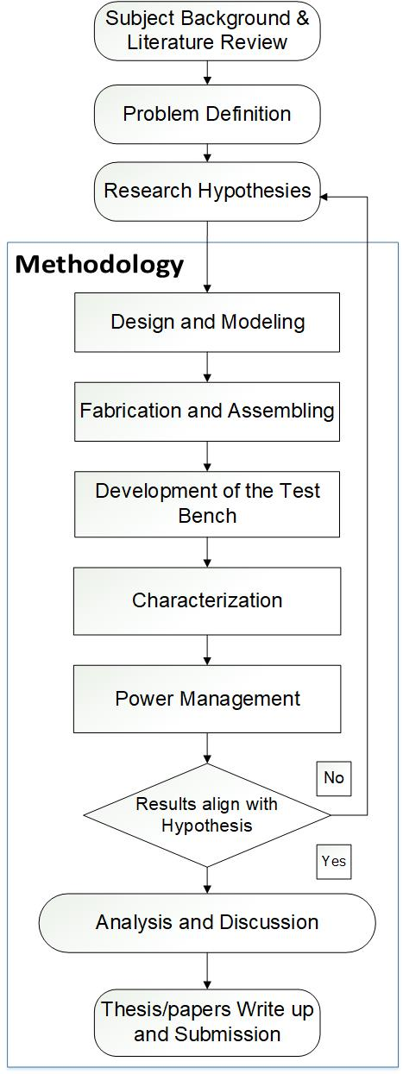
Figure ‎3.1 Flow chart of the reseach conducted in this work

Architecture and working principles of HVA-EH-1
The HVA-EH-1 comprises of two fixed and one flexible printed circuit board (PCB) based micro planar coils (MPCs), a Helmholtz cavity, a permanent Neodymium (NdFeB) magnet residing on a cantilever beam and 3D printed frame. The flexible MPC is fixed between the Helmholtz cavity and the 3D printed frame, while the two fixed MPCs are placed on the top and bottom sides of the 3D printed frame. The cantilever beam with the NdFeB magnet fixed to its end is placed at the centre of the 3D printed frame. The cross-sectional and exploded view of the HVA-EH-1 developed in this work is displayed in Figure 3.2 (a) and (b) respectively.
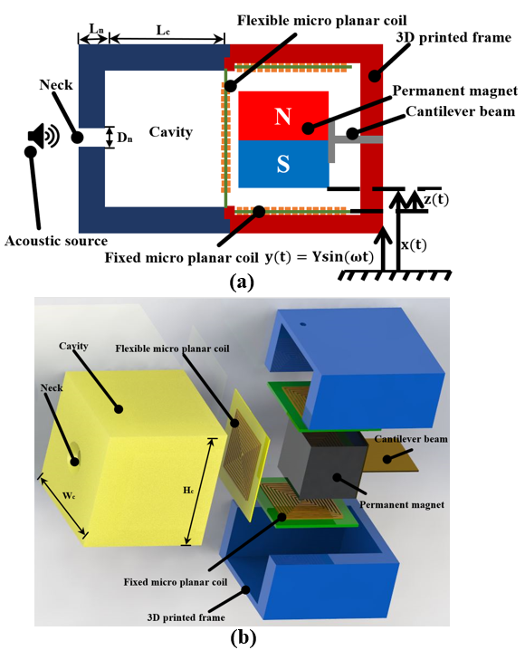
Figure ‎3.2 Hybrid vibro-acoustic energy harvester-1 (a) cross-sectional view (b) exploded view

The cantilever beam along with the magnet vibrates with velocity $x(t)$ due to input vibration $y(t$). Because of the relative motion $z(t)$ between magnet and MPCs, voltage is produced in the MPCs as per Faraday’s law of electromagnetic induction. The voltage produced in the MPCs depends on the rate of change of magnetic flux density, number of turns in each MPCs and the gap between MPCs and magnet. When the magnet and beam assembly is subjected to vibration and the system is considered as a discrete system where mass of the beam is less than the tip mass and the whole mass is concentrated at the free end of the beam. The governing equation of motion for such system will be as Equation (3.1) [150][151][152].
$m\ddot{z}\left(t\right)+d\dot{z}\left(t\right)+kz\left(t\right)= -m\ddot{y}(t)$ (3.1)
Where $m$ is the concentrated mass at the free end, $k$ is the spring constant of the system and $d$ is the damping constant. The stiffness $k$, of the beam is given by Equation (3.2) [150].
$k=\frac{3EI}{l^{3}}$ (3.2)
Where $l$ is the length of the cantilever beam (0.038 m including magnet length),$I$ is the moment of inertia of the cross section of the beam and $E$ is the young modulus (97 GPa for Brass) of the beam material. The beam has rectangular cross section, and its moment of inertia can be calculated using Equation (3.3).
$I=\frac{bh^{3}}{12}$ (3.3)
Where $b$ is the breadth (0.019 m) and $h$ is the height (0.0005 m) of the beam cross sectional area. The fundamental undamped natural frequency $ω_{n}$ of the system is given by Equation (3.4).
$ω_{n}= \sqrt{\frac{k}{m}}$ (3.4)
Where $m$ is the equivalent mass placed at the tip of the beam (0.051 kg, mass of the magnet). Substituting the value of $k$, we get Equation (3.5)
$ω_{n}= \sqrt{\frac{3EI}{ml^{3}}}$ (3.5)
Using the Equation 3.5 and using the given values for the HVA-EH-1 as specified in table 3.1, the natural frequency of the cantilever beam was calculated to be 22.74 Hz as shown in Equation 3.6.
$ω_{n}= \sqrt{\frac{3×97×{10}^{9}×({0.019 ×{0.0005}^{3}}/{12})}{0.051 × {0.038}^{3}}}$ = $142.84 Rad/$sec = 22.74 Hz (3.6)
If the input vibration is assumed to be a function of amplitude $Y$and frequency, $ω$ then it can be written as Equation (3.6).
$y\left(t\right)=Y\sin{ (ωt)}$ (3.6)

Furthermore, the amplitude of the relative velocity can be expressed as Equation (3.7) [153]:
$\dot{z}\left(t\right)= \frac{{{(ω}/{ω_{n})}}^{2}ωY}{\sqrt{{\left(1-{ω/{ω_{n}}}^{2}\right)}^{2}+{(2ζ_{eq}ω/ω_{n})}^{2}}}$ (3.7)
Where $ω$ is the excitation frequency, $Y$ is the amplitude of vibration and $ζ_{eq}$ is the total damping ratio of the system. The total damping ratio $ζ_{eq},$ can be expressed as Equation (3.8) [151][152]:
$ζ_{eq}= \frac{d}{2mω_{n}}$ (3.8)
On the other side, the acoustic wave enters through the neck of the augmented by the cavity. In the air, sound is propagated in a longitudinal wave format and the mathematical equation of the sound propagation in plane wave tube is given as Equation (3.9) [154]
$\frac{∂^{2}p}{∂x^{2}}- \frac{1}{C^{2}}\frac{∂^{2}p}{∂t^{2}}=0$ (3.9)
Where $C$ is the speed of sound $(343 m/s at 20 ºC)$ and$p$ is the sound pressure. The relationship between sound pressure and wavelength $(λ),$ and frequency $(f)$is expressed by Equation (3.10).
$C= λ.f$ (3.10)
The accumulated waves in the cavity causes the flexible MPCs to oscillate about its mean position close to the NdFeB magnet. Due to this vibratory motion, the flexible MPC experiences a change in magnetic flux density and emf is induced in the flexible coil based on electromagnetic transduction. The acoustic waves push the air mass at the neck to the cavity and hence increases the pressure inside the cavity. The increased pressure inside the cavity pushes the mass back to the neck which create negative pressure in the cavity. Due to the acoustic wave pressure at the neck and the negative pressure in the cavity, the air confined in the cavity behaves like a spring while the air at the neck act as a lumped mass. The lumped mass ($m_{air})$ and the stiffness of the spring $(k_{air})$ can be expressed as Equation (3.11) and Equation (3.12) respectively [47]:
$m_{air}= ρL_{n}A$ (3.11)
$k_{air}= \frac{ρ {(CA)}^{2}}{V}$ (3.12)
The acoustic part of the HVA-EH-1 shown in Figure 3.2 can also be modelled as a spring mass damper system and its undamped natural frequency $ω_{a}$ can be expressed as Equation (3.13) [155]:
$ω_{a}= \frac{C}{2π} \sqrt{\frac{3A}{4VL_{n}}}$ (3.13)

Where $ρ$ is the density of air, $L_{n}$ is the length of the neck, $A$ is the neck cross-sectional area, $C$ is the speed of sound, $D_{n}$ is the diameter of the neck, $H_{c}$ is the hight of the cavity, $W_{c}$is the width of the cavity, $L_{c}$ is the length of the cavity and $V$ is the volume of the cavity.

Fabrication of HVA-EH-1
Various fabrication techniques were used to fabricate the components of HVA-EH-1. The fixed and flexible double sided MPCs were fabricated through photolithography. The main aim behind the design of these coils was to have more number of turns in a small area so that maximum voltage can be generated. The stepwise fabrication process for the coils is shown in Figure 3.3. A clean FR4 shown in Figure 3.3 (a) is used as a base material and was drilled for the electrical connections as shown in Figure 3.3 (b). Layers of copper were deposited on both sides of the FR4 material as depicted in Figure 3.3 (c). After copper deposition, photoresist material which alters its chemical properties when exposed to ultraviolet (UV) light is applied to both sides of the sheet as shown in Figure 3.3 (d). In etching, a liquid chemical gets rid of the uppermost layer of the copper in the areas that are not covered by photoresist as shown in Figure 3.3 (e). A specific solution called as “developer” is used to remove the photoresist because of the chemical changes that occurs when the photoresist is exposed to UV light. The section view of the coil when the photoresist is stripped off is shown in Figure 3.3 (f). The fabricated fixed and flexible double sided MPCs are shown in Figure 3.4 (a) and (b) respectively.
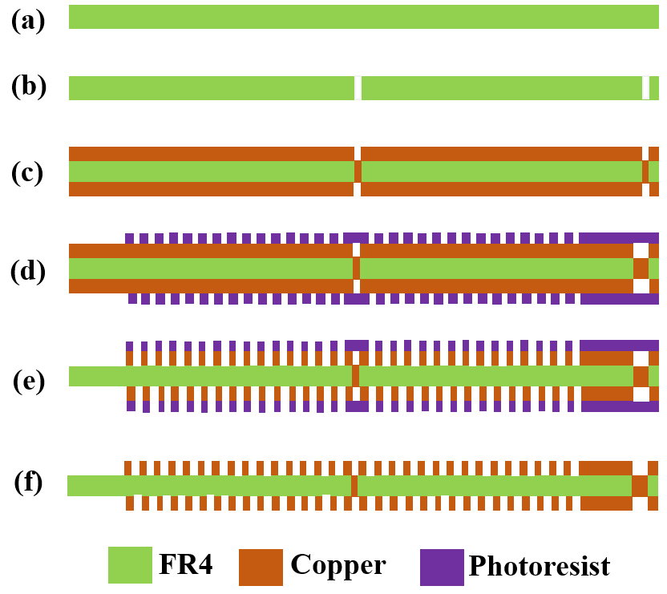
Figure ‎3.3 Photolithographic process of MPCs: (a) FR4 sheet (b) FR4 sheet after drilling (c) copper deposition (d) photoresist coating (e) etching (f) photoresist strip off

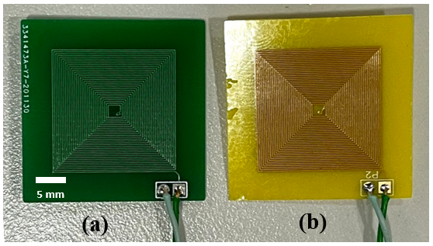
Figure ‎3.4 Micro planar coils: (a) double sided fixed MPC (b) double sided flexible MPC
The frame and the acoustic cavity were 3D printed from Acrylonitrile butadiene styrene (ABS) material. The 3D printing process of the frame is shown in Figure 3.5 (a). The microfabricated fixed MPC was then placed in the 3D printed frame is shown in Figure 3.5 (b). A brass sheet was cut as per the dimensions of the cantilever beam using milling machine. The cantilever beam fixed to the 3D printed frame is shown in the Figure 3.5 (c). To the free end of the cantilever beam the NdFeB magnet was attached as shown in Figure 3.5 (d). The flexible coil was placed at one end of the 3D printed acoustic cavity as shown in the Figure 3.5 (e). The acoustic cavity along with the flexible MPC was then fixed to the 3D printed frame which already have the cantilever beam with a magnet at its free end as shown in Figure 3.5 (f). The top 3D printed frame with another fixed MPC in its ceiling was then placed to complete the assembling process. All the components were fixed with each other with an adhesive epoxy. The final prototype is shown in Figure 3.5 (g). Dimensions and parameters of the developed device are shown in Table 3.1.

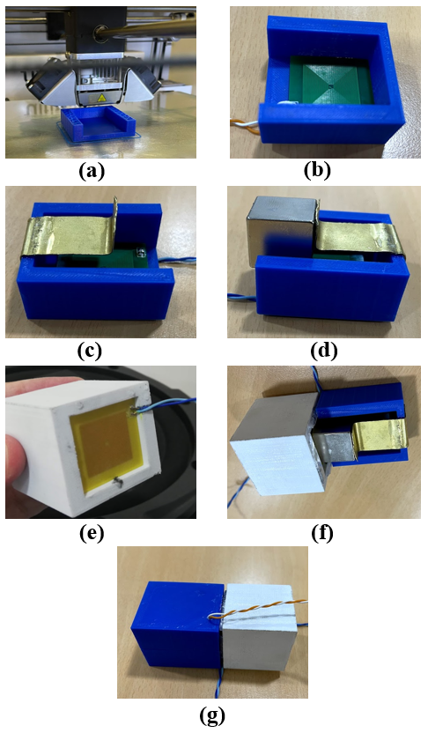
Figure ‎3.5 Assembling process of HVA-EH: (a) 3D Printing of frame (b) fixed MPC placed in 3D printed frame (c) cantilever beam fixed to the 3D printed frame (d) magnet fixed to the free end of the cantilever beam (e) flexible MPC placed in acoustic cavity (f) the acoustic cavity attached to the 3D printed frame (g) assembled prototype.

Table ‎3.1 Dimensions and parameter of HVA-EH-1
Description | Values | Unit
Overall volume of the prototype | 131.20 | cm³
Acoustic Cavity (inner) | 28.00 x 28.00 x 28.00 | mm
Acoustic Cavity (Outer) | - 40.00 x 40.00 | mm
Neck Diameter | 5.00 | mm
Flexible MPC | - 30.00 | mm
Thickness of the Fixable MPC | 0.30 | mm
Resistance of Fixable MPC | 9 | Ω
Fixed MPC | - 28.00 | mm
Thickness of Fixed MPC | 1.50 | mm
Resistance of Fixed MPC | 8 | Ω
Length of cantilever beam | 19.00 | mm
Width of cantilever beam | 19.00 | mm
Young’s modulus of the cantilever beam (Brass) | 97 | GPa
Calculated natural frequency of the cantilever beam | 22.74 | Hz
Density of the magnet (NdFeB) | 7500 | Kg/m³
Height of cantilever beam | 0.50 | mm
Magnet size | - x 19.05 x 19.05 | mm
Remanence (Br) | 1.44 | T

Architecture and working principles of HVA-EH-2
Electromagnetic-type energy harvesters work based on faraday’s law of electromagnetic induction. Whenever, there is a change in magnetic flux across the conducting coil, an emf will be generated in the coil. Usually, the change in magnetic flux in energy harvesters is generated by the relative motion amid the coils and the permanent magnets. Herein, we placed forward another novel prototype (HVA-EH-2) utilizing flexible coil and spinning spherical magnet which has the unique advantage of causing relative motion by both base excitation and acoustic waves. The HVA-EH-2 comprises of a spinning spherical permanent magnet covered in its cavity at the free side of the cantilever beam, a flexible coil to the base of the cavity close to the spherical magnet. The cantilever beam vibrates due to the base excitation, and as a result the flexible coil experience a change in magnetic flux, on the other side, the acoustic waves enter the cavity through its neck and oscillate the flexible coil which experiences a variation in magnetic flux. The difference of the device from most of energy harvesters is that other devices are constructed only for vibration or acoustic only, while in the proposed device, an emf is produced in the flexible coil because of the change in magnetic flux due to both base excitation and acoustic waves. The base excitation and acoustic waves simultaneously oscillate the flexible MPC and hence voltage is generated because of the coil oscillation, vibration of cantilever beam and the spinning of the spherical magnet. The cross-sectional and exploded views of the HVA-EH-2 are shown in Figure 3.6 (a) and (b) respectively. The detailed working principles of each component are given in the below subheadings.
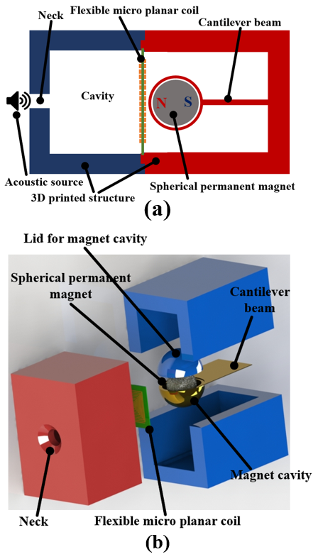
Figure ‎3.6 Hybrid vibro-acoustic energy harvester-2 (a) cross-sectional view (b) exploded view

Helmholtz cavity
The cross-sectional view along with the simplified lumped-element model of the Helmholtz Cavity (HC) are illustrated in Figure 3.7 (a) and (b) respectively, where, H_{C} is the height of the HC, H_{N} is the height of the cavity neck, W_{C} is the cavity width and D_{N} is the diameter of the cavity neck. The acoustic pressure (𝑃₁) in the locality of the HC’s neck pushes the air mass at the cavity neck into the cavity and as a result, the cavity pressure is increased to 𝑃₂. The pressure 𝑃₂ then pushes the air mass at the cavity neck in the upward direction. The inertia of the air mass pushes it above the mean position and thus reduces the pressure to lesser than 𝑃₁ in the cavity. The acoustic pressure 𝑃₁ and the reduced pressure in the cavity again pushes the air at the neck in the downward direction. Throughout this oscillation, the air in the cavity acts like a spring, which pulls and pushes the lumped air at the resonator’s neck. The simplified model of the HC can be represented as a spring-mass-damper system as shown in Figure 3.7 (b). The neck of the HC can be considered a round pipe that opposes the air moving in it. The oscillating air at the neck possesses kinetic energy because of its definite mass. The neck of the HC has two elements, inertial and resistive which act as mass and damper respectively. Because of the compressibility and storing potential energy the acoustic mass in the HC can be modelled as a spring.
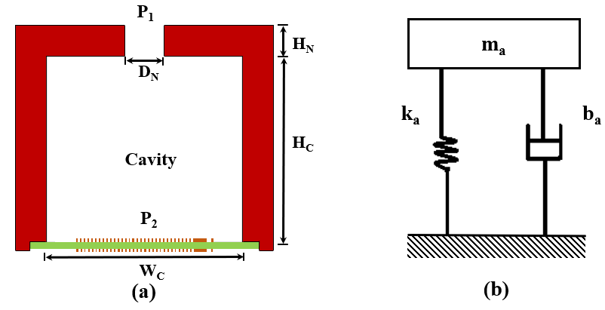
Figure ‎3.7 Helmholtz Cavity (a) Cross-sectional view (b) Lumped-element model

The acoustic mass $(m_{a})$ in the neck of the HC depends on flow area (A) at the neck, the height (H_{N}) of the neck and the air density (𝜌), this is given by Equation (3.14).

$m_{a}=AH_{N}ρ$ (3.14)

However, the viscus damping exhibits a non-uniform axial velocity profile at the neck of the HC and that is why an additional factor of 4/3 is used in Equation (3.15), for a better approximation of the acoustic mass as given in Equation (3.15) [156].
$m_{a}=\frac{4}{3}AH_{N}ρ$ (3.15)

The neck of the HC can be modelled as a pipe with laminar flow. The friction losses in such a pipe pay to the viscous damping in the cavity [157], which is given by Equation (3.16).
$b_{a}=8πμ_{A}H_{N}$ (3.16)

Where $μ_{A}$ is the viscosity of the air. The stiffness of the acoustic spring $(k_{a})$ depend on the density of the air ($ρ)$, cross-sectional area ($A)$ of the neck, speed of sound ($C)$ and volume of the cavity ($V_{c}$). The stiffness is given by Equation (3.17) [157].

$k_{a}=\frac{ρ{\left(CA\right)}^{2}}{V_{c}}$ (3.17)

Furthermore, the undamped natural frequency of the HC is given by Equation (3.18) [49].

$F_{undamped}=\frac{C}{2π}\sqrt{\frac{3A}{4V_{C}H_{N}}}$ (3.18)

Equation (3.18) can be used to tune the resonant frequency of the HC. Figure 3.8 shows the resonant frequency as a function of the neck diameter of the HC at various neck heights at constant cavity volume V_{C} of 91125 mm³. It can be seen from Figure 3.8, that increasing neck diameter will increase the resonant frequency of the HC. The dimensions in the figure 3.8 were chosen based on fixed volume of the HC which was fixed according to the dimensions of the flexible coil.for the fixed volume of the HC, various neck heights and neck diameters were tried to achieve the resonance frequency of the HC. A HC with specific resonant frequency can be designed from Figure 3.8 based on neck diameter.
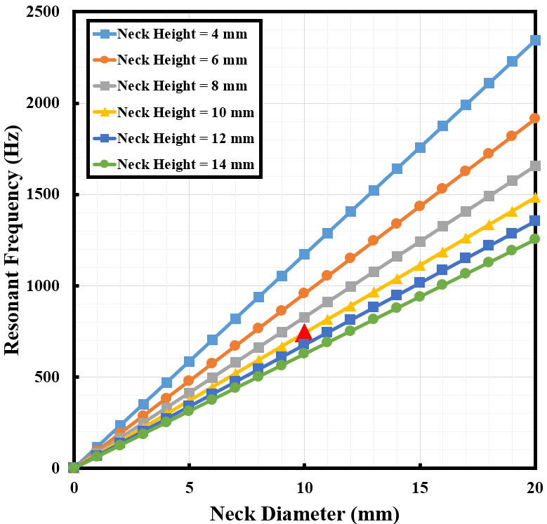
Figure ‎3.8 Resonant frequency of the HR Vs. neck diameter

Flexible micro planar coil
The flexible MPC vibrates because of the oscillation of the air in the HC. The acoustic pressure (𝑃₁) in the locality of the HC’s neck pushes the air mass at the cavity neck into the cavity and as a result the cavity pressure is increased to 𝑃₂. The pressure 𝑃₂ then pushes the air mass at the cavity neck in the upward direction. The inertia of the air mass pushes it above the mean position and thus reduces the pressure to lesser than 𝑃₁ in the cavity. The acoustic pressure 𝑃₁ and the reduced pressure in the cavity again pushes the air at the neck in the downward direction. Throughout this oscillation, the lumped air is pushed and pulled and hence vibrates the flexible MPC. Because of the permanent magnet available close to the flexible MPC, it experiences a change in the magnetic field and hence voltage is generated in the flexible MPC. The schematic of the flexible MPC vibration is shown in Figure 3.9 (a). The flexible MPC can be modelled as a plate with all edges fixed condition. The analysis of this type of model required geometrical and physical properties such as modulus of elasticity, Poisson’s ratio, length, cross-sectional area, and density. However, these parameters do not have certain values because of the non-homogeneity of mass distribution, as well as differences are found due to the fabrication and assembling processes. Here we consider the FMPC as all edges-fixed plate with spring, mass and damper uncertainties as shown in Figure 3.9 (b) [158].
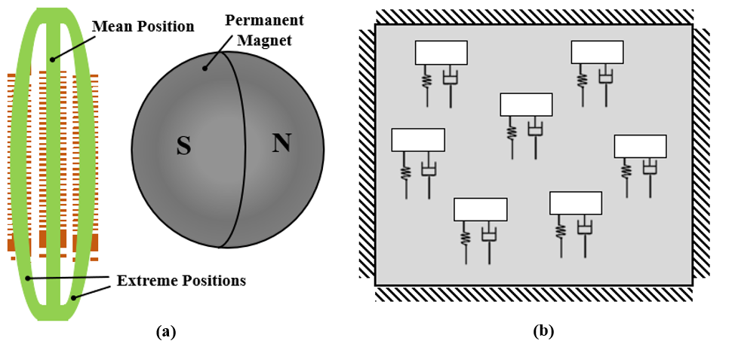
Figure ‎3.9 (a) Vibration visualization of the flexible micro planar (b) flexible micro planar coil with spring, mass, and damper uncertainties

With all these uncertainties the system can be considered as multi-degree-of-freedom system and lumped element model of the same is shown in Figure 3.10. [159].
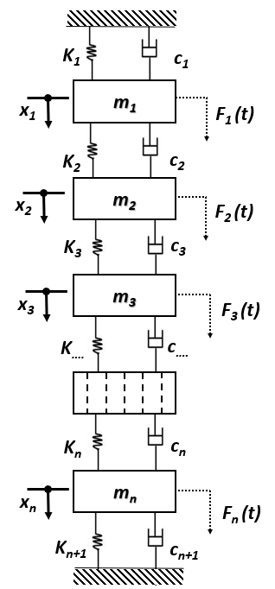
Figure ‎3.10 Lumped element model of the flexible micro planar coil

Cantilever beam with tip mass
The spherical magnet enclosed in its cavity is attached to the free side of the cantilever beam. The cantilever beam with lumped mass is exposed to the sinusoidal base excitation. The system can be modelled as a single-degree-of-freedom system considering the negligible mass of the beam as compared to the lumped mass of the spherical magnet. If the base excitation motion is $m\ddot{y}(t)$ then the equation of motion of the equivalent system as a single-degree-of-freedom will be given as Equation (3.19) [160]. The schematic of the cantilever beam with lumped mass at the free side is depicted in Figure 3.11.
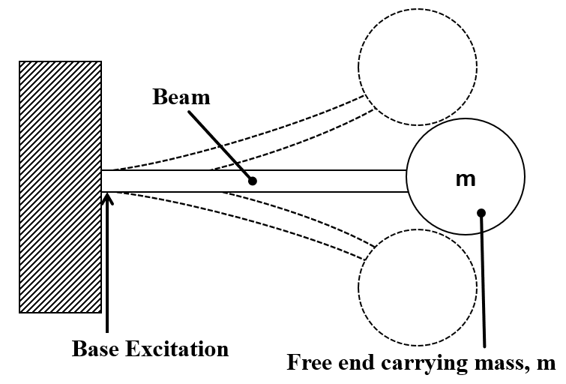
Figure ‎3.11 Schematic of the cantilever beam with lumped mass at the free end

$m\ddot{x} \left(t\right)+c\dot{x} \left(t\right)+kx \left(t\right)= -m\ddot{y}(t)$ (3.19)

Where $m$ is the concentrated mass at the free end, $k$ is the spring constant of the system and $d$ is the damping constant. The stiffness $k$, of the beam is given by Equation (3.2). The natural frequency of the system can be calculated using Equation 3.5. the calculation for the natural frequency was done using the dimensions given in table 3.2.
$ω_{n}= \sqrt{\frac{3×97×{10}^{9}×({0.025 ×{0.001}^{3}}/{12})}{0.244 × {0.045}^{3}}}$ = 165.12$Rad/$sec = 26.29 Hz (3.20)
The forced response of the system is given by Equation (3.21).
$y=Y \sin\left(ωt-φ\right)$ (3.21)
Where, $Y$ is the amplitude of vibration given by Equation (3.22), and $φ$ is the phase difference of the displacement with respect to the exciting force which is given by Equation (3.23).
$Y=\frac{F_{o}}{\sqrt{{(k-mω^{2})}^{2}}+ {(cω)}^{2}}$ (3.22)

$\tan{φ}= \frac{cω}{k-mω^{2}}$ (3.23)
In the HVA-EH-2, the rate of change of the magnetic flux across the flexible MPC is also subjected to the orientation of the spinning spherical magnet. The spinning of the spherical magnet enables another resonance and hence increases the output. Various orientations of the spinning spherical magnet with regard to the flexible MPC are presented in Figure 3.12. The rate of change of magnetic flux will be maximum when the axis of the rotation of the spinning spherical magnet is parallel to the axis of the flexible MPC as shown in Figure 3.12 (a), However, a moderate rate of change of the magnetic flux is expected when the axis of rotation of the spinning spherical magnet is partially inclined to the flexible MPC’s axis as shown in Figure 3.12 (b). The flexible MPC will experience absolutely no rate of change of magnetic flux, when the axis of the rotation of the spherical magnet is perpendicular to the flexible MPC’s axis, as shown in Figure 3.12 (c).
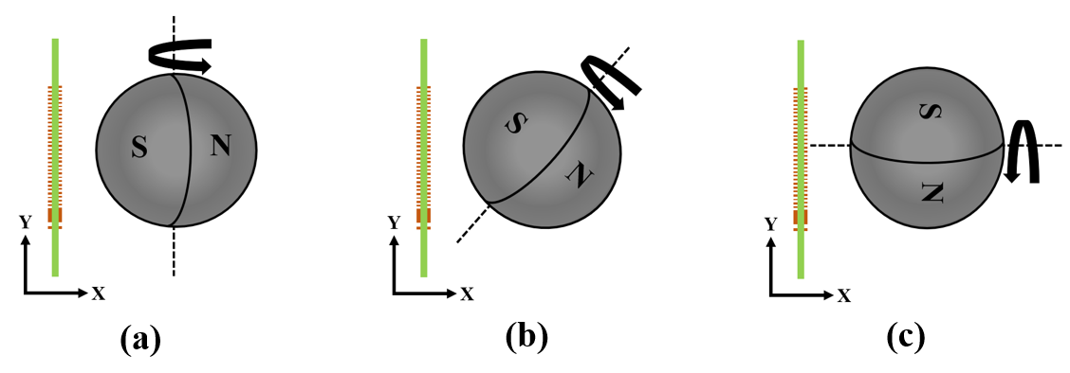
Figure ‎3.12 Rate of change of the flux across the flexible MPC at various magnet orientation (a) maximum rate of change of flux (b) minimum rate of change of flux (c) absolutely no rate of change of flux

Fabrication of HVA-EH-2
The prototype of HVA-EH-2 was fabricated using fuse deposition modelling (3D printing) and conventional machining. The main structure was first 3D printed from Polylactic acid (PLA) material as shown in Figure 3.13 (a). Brass material was used to manufacture the cantilever beam. A thin sheet of brass was first cut into the desired dimension using a milling machine. To create a cavity for the spherical magnet at the tip of the cantilever beam, a manual hammering process was performed. The cantilever beam with cavity at its free end is shown in Figure 3.13 (b). The cantilever beam was then fixed to the 3D printed structure as shown in Figure 3.13 (c). The spherical neodymium (NdFeB) magnet was placed in the cavity at the free side of the cantilever beam and the other 3D printed part was used to cover the structure as shown in Figure 3.13 (d). The flexible MPC was fabricated using the same techniques as presented in HVA-EH-1 [161], the flexible MPC was then fixed to the HC which was printed with the same PLA material as shown in Figure 3.13 (e). Finally, the main structure and the HC were assembled using an adhesive material as shown in Figure 3.13 (f). The parameters along with the dimensions of the developed prototype are available in Table 3.2.
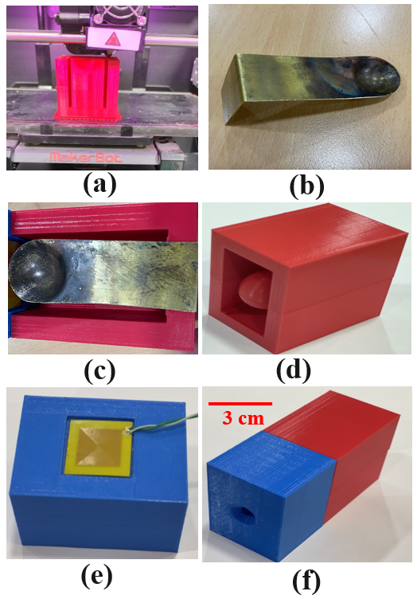
Figure ‎3.13 Fabrication and assembling of the HVA-EH-2 (a) 3D printing of the harvester (b) cantilever beam with a cavity at the tip (c) cantilever beam placed on 3D printed structure (d) assembled vibration part of the harvester (e) flexible MPC placed on the back of the Helmholtz cavity (f) assembled HVA-EH-2
Table ‎3.2 Dimensions and parameters of HVA-EH-2
Description | Values | Unit
Total volume of the HVA-EH | 550 | cm³
Internal volume of the Helmholtz cavity | 91.12 | cm³
External volume of the Helmholtz cavity | 220 | cm³
Neck Diameter | 10 | mm
Area of the FMPC | - 30.0 | mm
Thickness of the FMPC | 0.30 | mm
Resistance of FMPC | 9 | Ω
Length of cantilever beam with magnet cavity | 64 | mm
Cantilever beam (Width) | 25 | mm
Cantilever beam (Height) | 1 | mm
Young’s modulus of the cantilever beam (Brass) | 97 | GPa
Calculated natural frequency of the cantilever beam | 26.29 | Hz
Spherical magnet diameter | 19 | mm
Density of the magnet (NdFeB) | 7500 | Kg/m³
Remanence of the magnet (Br) | 1.44 | T

Experimental setup
Indigenous vibro-acoustic energy harvester’s test bench was developed for the characterization of both prototypes. A desktop speaker (KENWOOD, KFC-W3010) with a frequency response of 25Hz-800 Hz, nominal resistance of 4 Ω and peak power of 1000 W was used to produce vibrations. A Teflon material was installed on the speaker diaphragm with an adhesive material to isolate the developed prototypes from permanent magnet of the speaker. Accelerometer (ADXL335) was attached with the Teflon to constantly measure acceleration level. Another speaker as a sound source was used at one end of a polyvinyl chloride (PVC) pipe which was used as a plane wave tube to ensure smooth sinusoidal acoustic wave. The plane wave tube was left open from the other side to make sure that the developed prototypes can harvest acoustic energy in an open environment. A sound level meter (TENMA-72-947) was used at the end of the plane wave tube to continuously measure the sound pressure level (SPL). The developed protypes were positioned with an adhesive material on the Teflon. Two Function generators Agilent (33220A) with frequency range of 20 MHz were used to regulate the frequency and amplitude of acoustic and vibration signals. These signals were further amplified by two single input power amplifiers. Digital multi meter Agilent (U1252A) was used to test the connectivity of the coils and the voltage produced was analysed using Agilent (DSO1012A), 100 MHz oscilloscope. The experimental setup is shown in Figure 3.6.
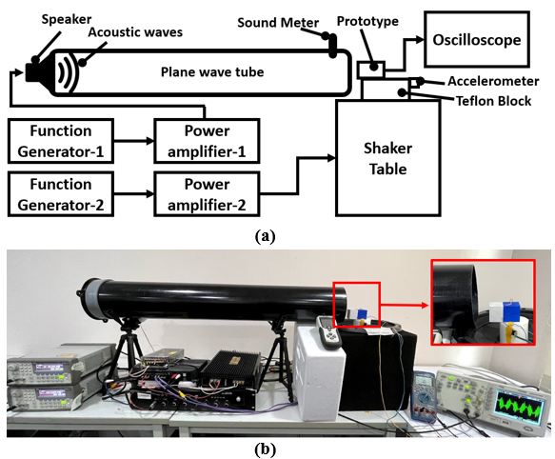
Figure ‎3.14 HVA-EH’s test bench (a) block diagram (b) developed setup

RESULTS AND DISCUSSION

Overview
In this chapter, the experimentation of the developed prototypes is discussed. Characterization of the HVA-EH-1 and HVA-EH-2 under vibration, acoustic and hybrid environment (simultaneous vibration and acoustic) are reported. The open circuit voltage (OCV), load voltage and output power responses of the developed prototypes are shown and discussed in detail. Finally, at the end of this chapter, the response of the HVA-EH-2 after connecting it to the developed power management circuit in term of output DC power and charging capabilities are discussed.

Characterization of HVA-EH-1 under vibration energy
To record the responses under vibration energy, The HVA-EH-1 was excited at acceleration level of 0.1 g, 0.2 g and 0.3 g with a frequency sweep of 0-80 Hz. It was noticed that the prototype of HVA-EH-1 has a vibration resonant frequency of 26 Hz. The open circuit peak-to-peak voltage of top fixed MPC, bottom fixed MPC, flexible MPC and combined coils where all the coils were connected in series are shown in Figure 4.1, 4.2, 4.3 and 4.4 respectively. For vibration level of 0.3 g, the OCVs generated by top fixed MPC, bottom fixed MPC, flexible MPC and combined coils are 184 mV, 195 mV, 569 mV and 852 mV respectively at resonant frequency. The output voltage of the top and bottom coil is different because of the gravity effect, which bring the magnet closer to the bottom coil and hence the output voltage is more compared to the top coil. To confirm the resonant frequency of the HVA-EH-1, the characterization was carried out at reverse frequency sweep as well. It was also observed that with increase in vibration level the output voltage increases.
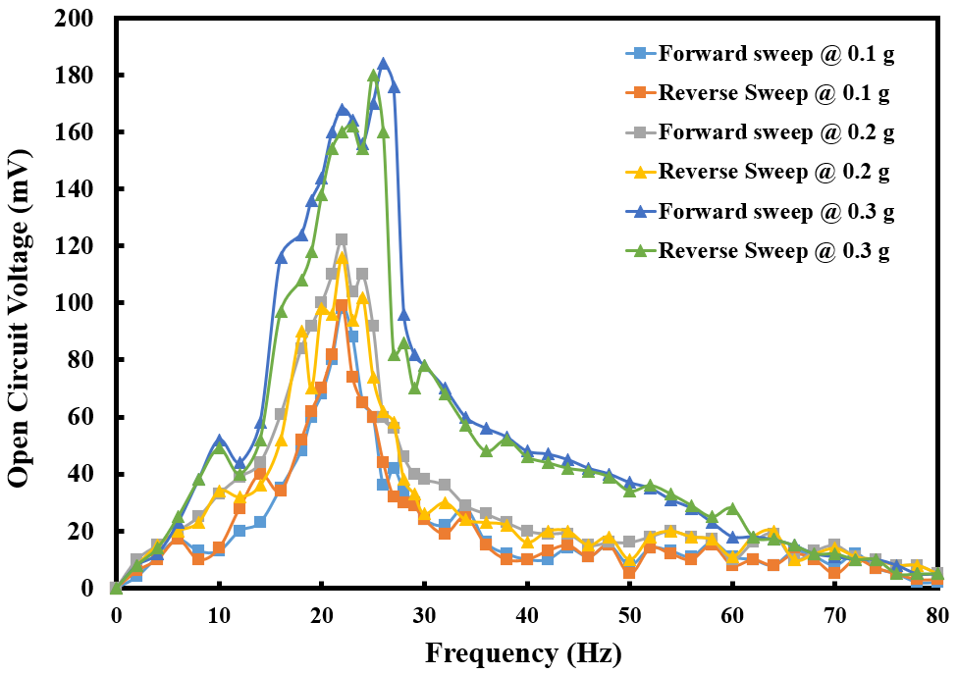
Figure ‎4.1 Open circuit voltage versus frequency of HVA-EH-1 under vibration energy of top fixed MPC
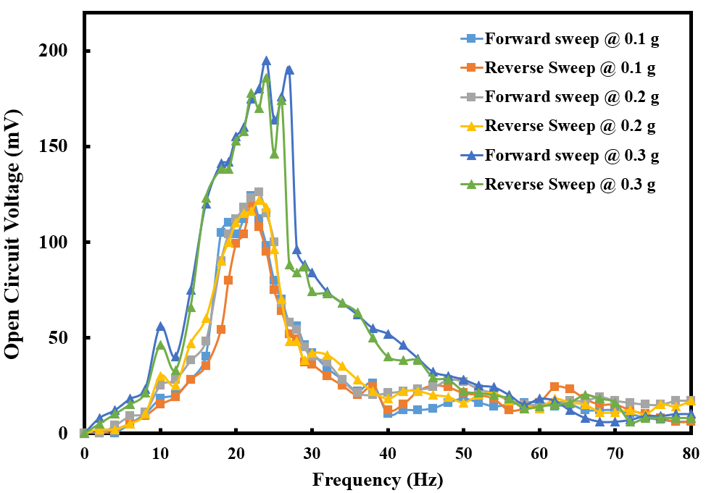
Figure ‎4.2 Open circuit voltage versus frequency of HVA-EH-1 under vibration energy of bottom fixed MPC
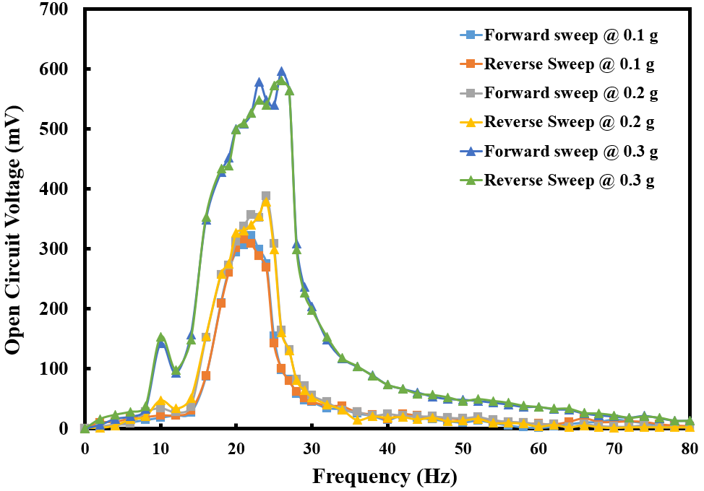
Figure ‎4.3 Open circuit voltage versus frequency of HVA-EH-1 under vibration energy of flexible MPC
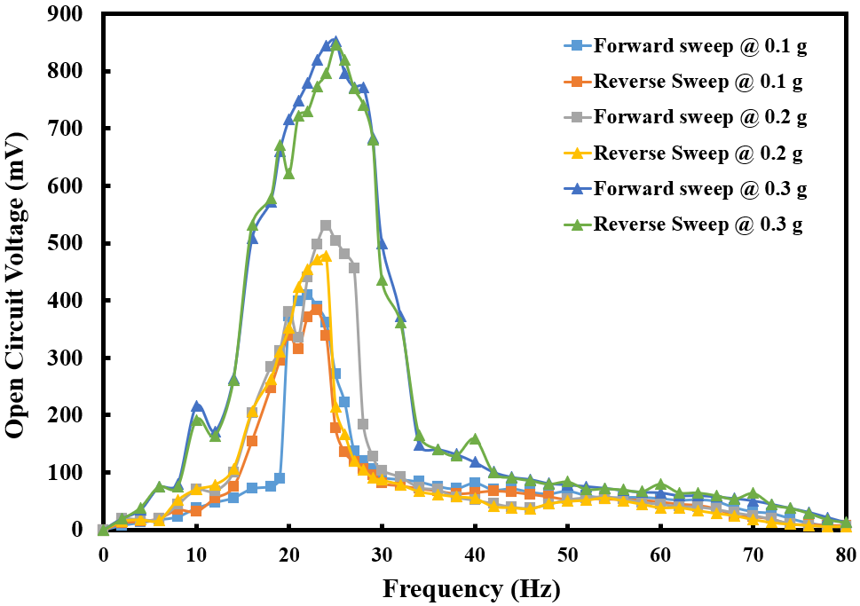
Figure ‎4.4 Open circuit voltage versus frequency of HVA-EH-1 under vibration energy of combined coils

Figure 4.5, 4.6,4.7 and 4.8 compares the output load voltage of top fixed MPC, bottom fixed MPC, flexible MPC and combined coils respectively with varying resistive load. For base acceleration of 0.3 g, a maximum of 101 mV, 104 mV, 195 mV and 356 mV output load voltages are produced by top fixed MPC, bottom fixed MPC, flexible MPC and combined coils respectively at resonant frequency. For top fixed MPC, bottom fixed MPC and flexible MPC, the load resistance was varied up to 30 Ω using linear variable resistor. However, for the combined coils it was varied till 50 Ω because of its high resistance when connected in series. Above 30 Ω and 50 Ω the changes in load voltages were noted to be very small.
The output root mean square (RMS) power under vibration energy of the HVA-EH-1 was calculated using Equation (4.1) [162].
$P= \frac{({V_{pp})}^{2}}{{(2\sqrt{2})}^{2} R_{L}}$ (4.1)
Where $V_{pp}$is the peak-to-peak voltage and $R_{L}$ is the load resistance. From Figure 4.5, 4.6,4.7 and 4.8, it can be seen that at vibration level of 0.3 g, the top fixed MPC, bottom fixed MPC and flexible MPC generate an output power of 67 μW, 81 μW and 234 μW respectively at resonant frequency of 26 Hz and matching impedance of 10 Ω. The coils are generating maximum power at 10 Ω because the internal resistance of each coil is 9 Ω and because of the maximum power transfer theorem, the output power is maximum around that resistance. The combined coils generate an output power of 372 μW at matching impedance of 24 Ω with the same vibration level (0.3 g) and resonant frequency (26 Hz). For the combined coil, the total internal resistance is 27 Ω therefore the output power is maximum around that value.
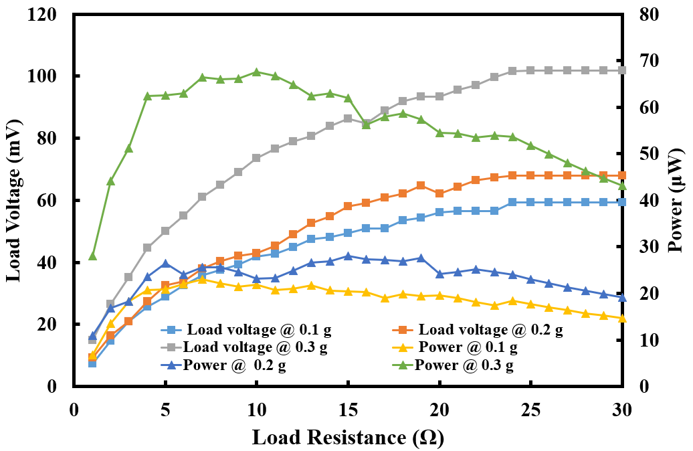
Figure ‎4.5 Load voltage and power versus load resistance of top fixed MPC
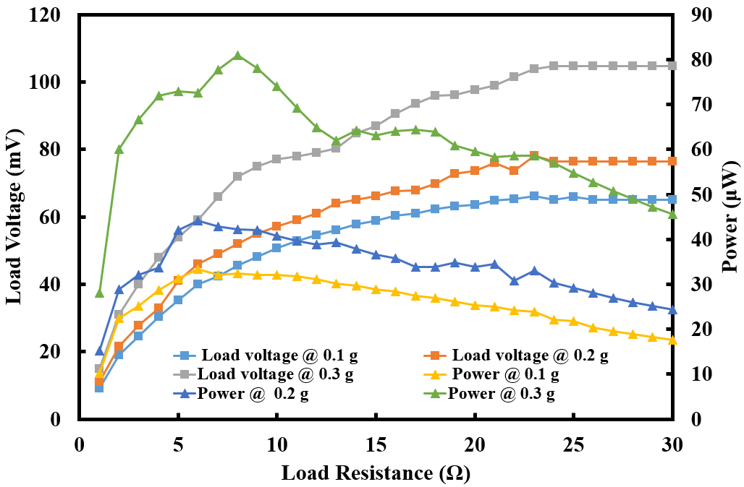
Figure ‎4.6 Load voltage and power versus load resistance of bottom fixed MPC
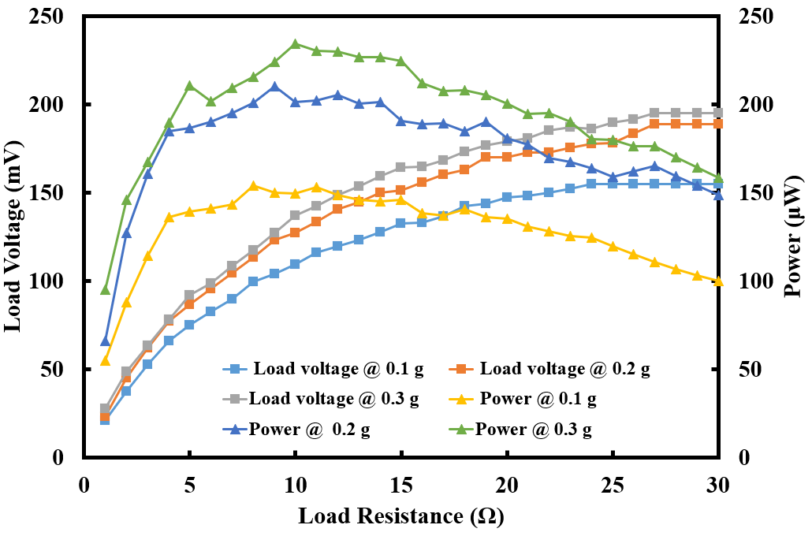
Figure ‎4.7 Load voltage and power versus load resistance of flexible MPC
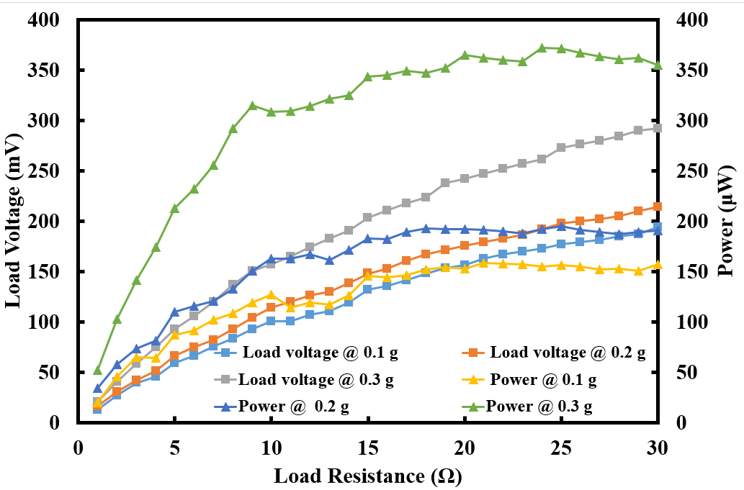
Figure ‎4.8 Load voltage and power versus load resistance of combined coils

Characterization of HVA-EH-1 under acoustic energy
The HVA-EH-1 was characterized under different SPLs (115 dB, 120 dB, 125 dB, 130 dB) at a frequency sweep of 0-1000 Hz of sinusoidal acoustic waves. The developed harvester was tested at SPL of 115 dB and above because the output was significantly low below 115 dB. Under acoustic energy, only the flexible MPC oscillates and experiences a change in magnetic flux density. The OCV versus frequency response of the flexible MPC at various SPLs is depicted in Figure 4.9. The HVA-EH-1 produces an OCV at multiple frequencies (340 Hz, 495 Hz, 660 Hz and 820 Hz) under different SPLs. The multiple frequencies were observed because of the flexibility in the flexible MPC and resonance of the cavity. When the device is subjected to SPL of 130 dB, it generates a maximum OCV of 203 mV at 340 Hz, 405 mV at 495 Hz, 448 mV at 660 Hz, and 360 mV at 820 Hz. It was also observed that the output voltage of HVA-EH-1 increases with the increase in SPL.
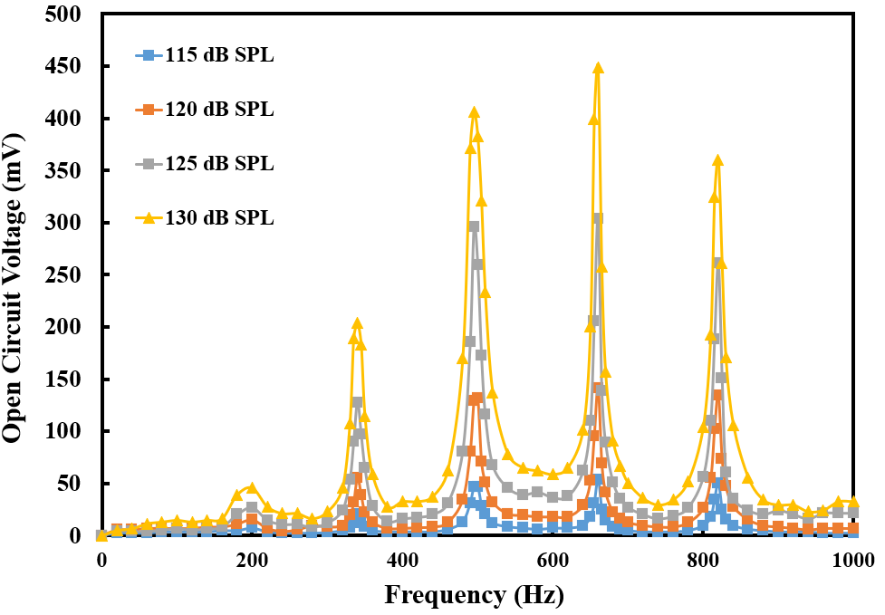
Figure ‎4.9 Open circuit voltage versus frequency of flexible MPC under acoustic energy
Figure 4.10, 4.11, 4.12 and 4.13 shows the load voltage and power as a function of load resistance for the flexible MPC under SPLs of 115 dB, 120 dB, 125 dB and 130 dB respectively. The load voltage data was recorded at four dominant frequencies (340 Hz, 495 Hz, 660 Hz and 820 Hz) and different SPLs. By changing the load resistance, the load voltage increases at the expense of decrease in the current through the load. When the HVA-EH-1 was excited at 2nd mode (495 Hz), the maximum load voltages produce was 152 mV, 162 mV, 125 mV and 178 mV at 115 dB, 120 dB, 125 dB and 130 dB respectively.
The output power for the flexible MPC under acoustic energy was also calculated using Equation (4.1). It was observed that at 2nd mode the device can generate a maximum output power of 207 μW, 254 μW, 248 μW and 271 μW under SPLs of 115 dB, 120 dB, 125 dB and 130 dB respectively at matching impedance.
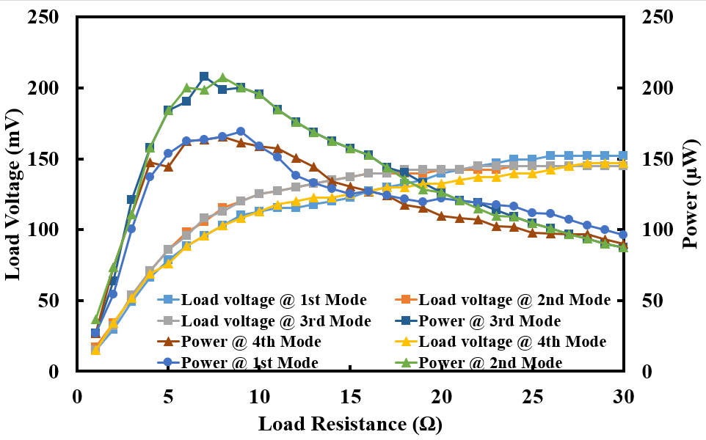
Figure ‎4.10 Load voltage and power as a function of load resistance under acoustic energy at SPL of 115 dB
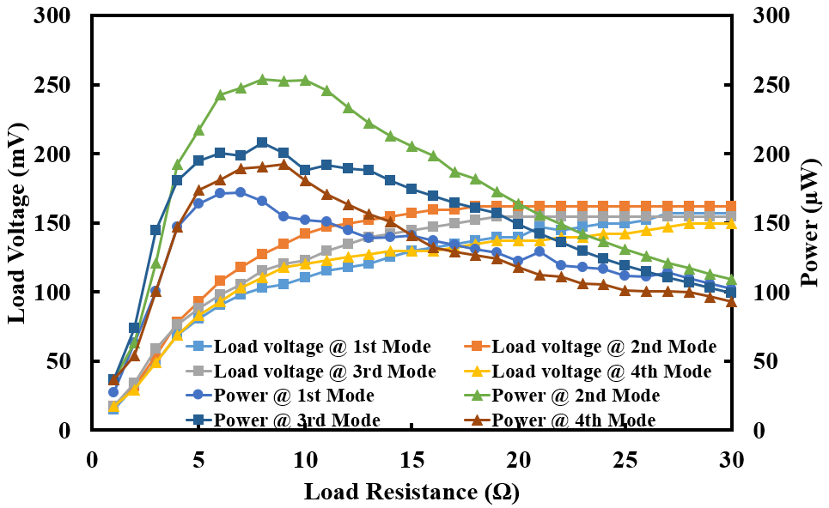
Figure ‎4.11 Load voltage and power as a function of load resistance under acoustic energy at SPL of 120 dB

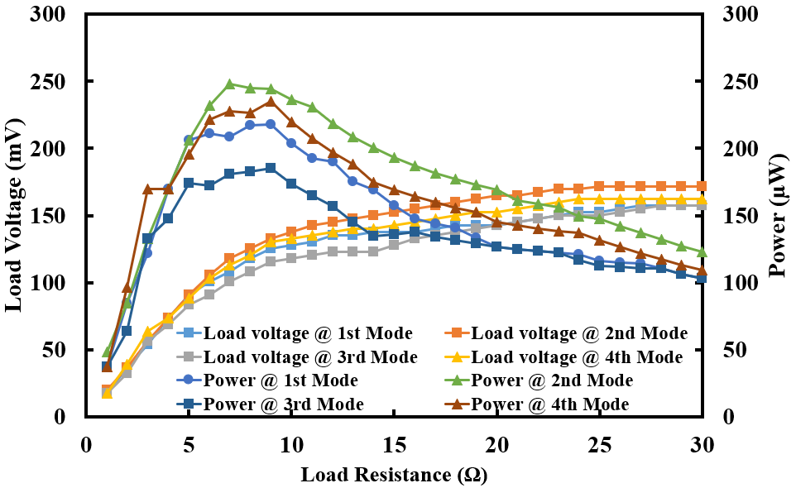
Figure ‎4.12 Load voltage and power as a function of load resistance under acoustic energy at SPL of 125 dB
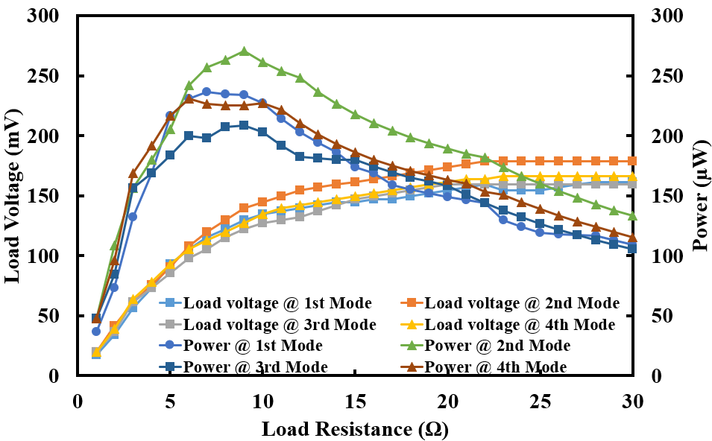
Figure ‎4.13 Load voltage and power as a function of load resistance under acoustic energy at SPL of 130 dB

Characterization of HVA-EH-1 under hybrid environment
The HVA-EH-1 was finally exposed to hybrid environment where both vibration and acoustic energies were harvested simultaneously. The data was recorded from flexible MPC as this is the only coil which experiences change in magnetic flux density at a time from both vibration and acoustic energy. The OCV versus vibration frequency responses for all four acoustic modes (340 Hz, 495 Hz, 660 Hz and 820 Hz) under various SPLs (115 dB, 120 dB, 125 dB and 130 dB) at fixed vibration levels of 0.1 g, 0.2 g and 0.3 g are shown in Figure 4.14, 4.15 and 4.16 respectively. At vibration resonant frequency, the maximum OCVs produced by HVA-EH-1 at 2nd acoustic mode under SPL of 130 dB were 353 mV, 393 mV and 540 mV at 0.1 g, 0.2 g and 0.3 g respectively. The output voltage reaches its maximum values at vibration resonance frequency and is almost constant for all acoustic modes and SPLs. This means that the vibration energy alone cannot further increase the output voltage. At higher vibration level of 0.3 g the device behaves as a broadband and can produce maximum OCV at a band of frequencies (22 to 28 Hz). It can also be seen from the same Figures that at 0 Hz of vibration frequency, the device can generate a decent OCV promising a continuous supply in the presence of even one source which is acoustic in this case.
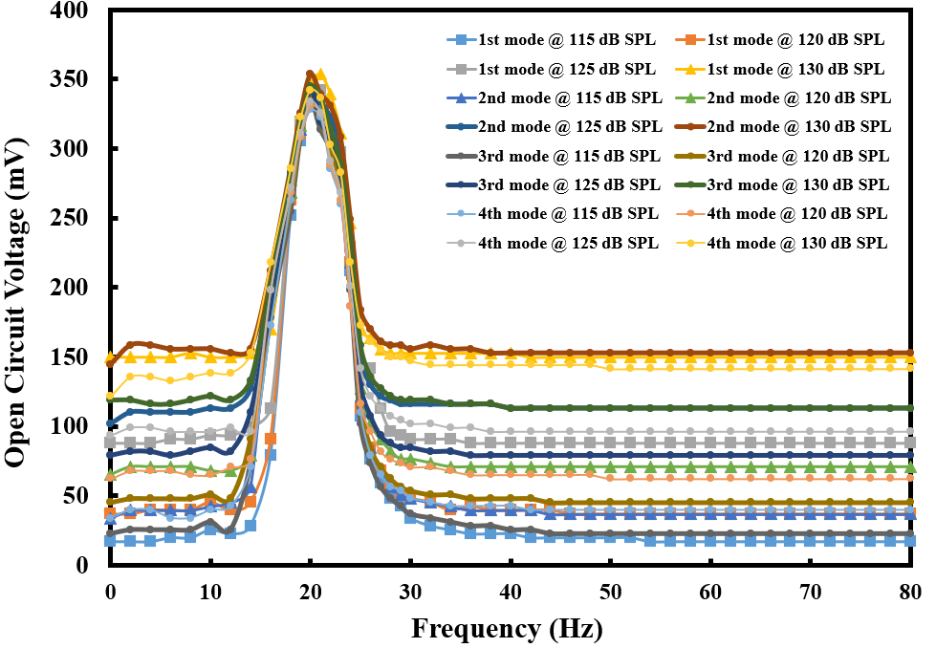
Figure ‎4.14 Open circuit voltage versus frequency of HVA-EH-1 under both vibration and acoustic energy at vibration level of 0.1 g
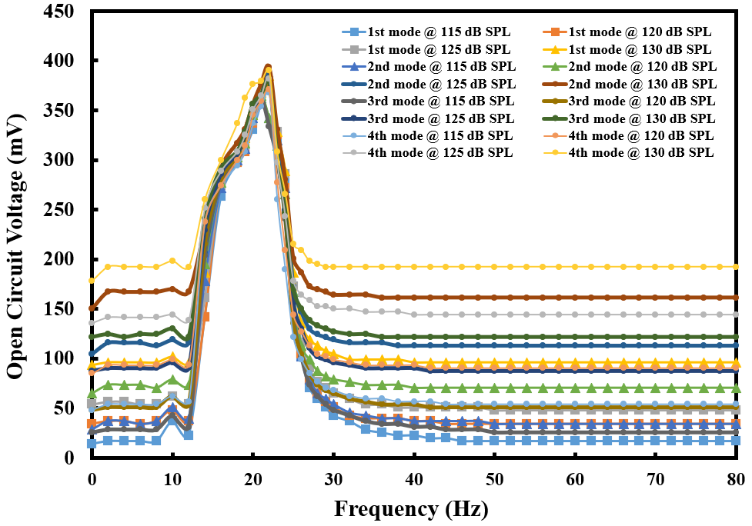
Figure ‎4.15 Open circuit voltage versus frequency of HVA-EH-1 under both vibration and acoustic energy at vibration level of 0.2 g
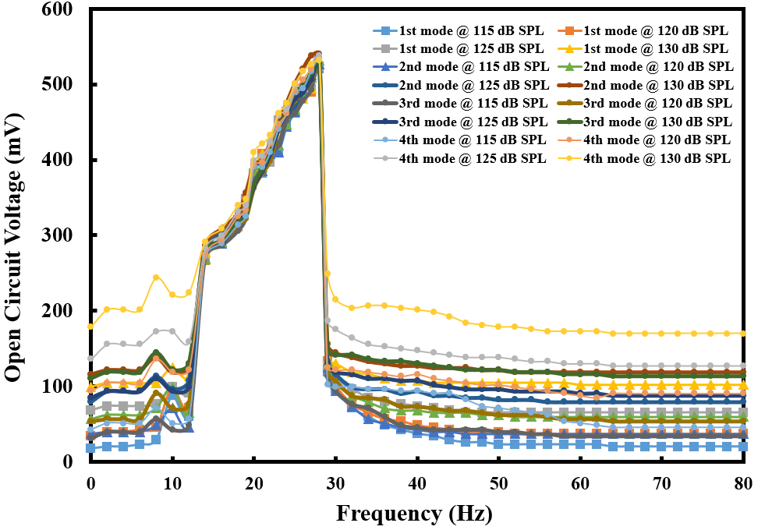
Figure ‎4.16 Open circuit voltage versus frequency of HVA-EH-1 under both vibration and acoustic energy at vibration level of 0.3 g

For the load voltages, the HVA-EH-1 was kept at vibration resonance and the data was recorded at fixed SPLs (115 dB, 120 dB, 125 dB and 130 dB) and fixed acoustic modes (340 Hz, 495 Hz, 660 Hz and 820 Hz) while the load resistance was kept on increasing. Figure 4.17, 4.18 and 4.19 shows the output load voltages at vibration levels of 0.1 g, 0.2 g and 0.3 g respectively. The maximum load voltages recorded were 147 mV, 206 mV, 297 mV at 0.1 g, 0.2 g and 0.3 g respectively at 2nd acoustic mode under SPL of 130 dB.
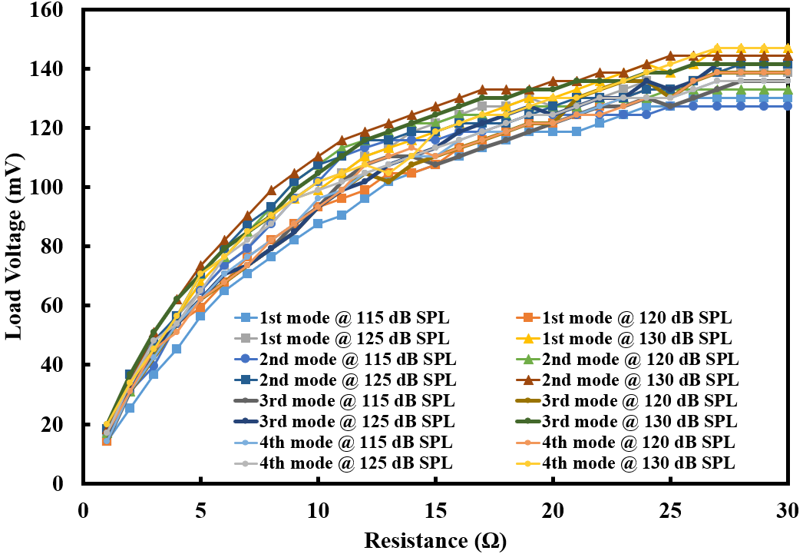
Figure ‎4.17 Load voltage as a function of load resistance of the HVA-EH-1 at 0.1 g

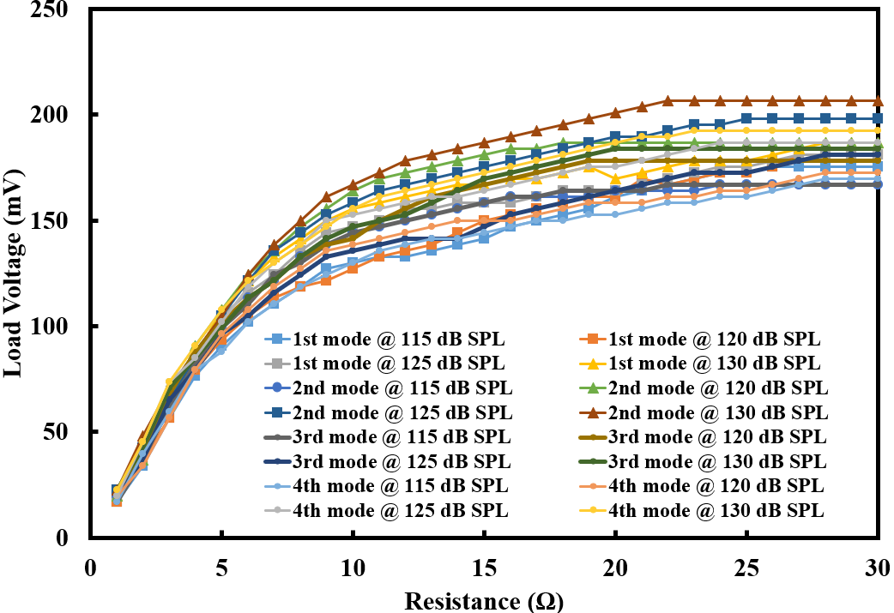
Figure ‎4.18 Load voltage as a function of load resistance of the HVA-EH-1 at 0.2 g

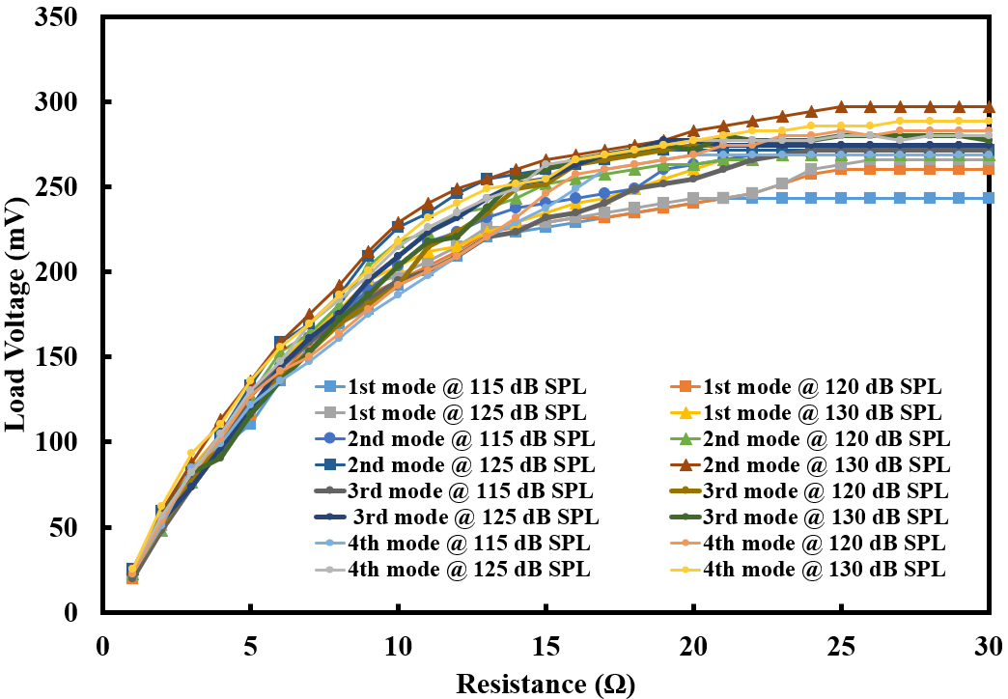
Figure ‎4.19 Load voltage as a function of load resistance of the HVA-EH-1 at 0.3 g

The output power as a functions of load resistance was also calculated and plotted for the vibration level of 0.1 g, 0.2 g and 0.3 g in Figure 4.20, 4.21, and 4.22 respectively. At matching impedance, the maximum power generated by the HVA-EH-1 in hybrid environment was 153 μW, 361 μW and 656 μW at vibration level of 0.1 g, 0.2 g and 0.3 g under SPL of 130 dB at 2nd acoustic mode. It can be observed from the results that the maximum output power generated by the HVA-EH-1 is at 0.3 g and under SPL of 130 dB. If we compare these conditions to vibration and acoustic levels shown in Table 2.2, it is very much clear that the developed HVA-EH-1 is applicable for real environment. Moreover, currently the miniaturization of electronics devices has substantially reduced the power requirements of WSNs, hence, the industrial applicability of the developed device increases.

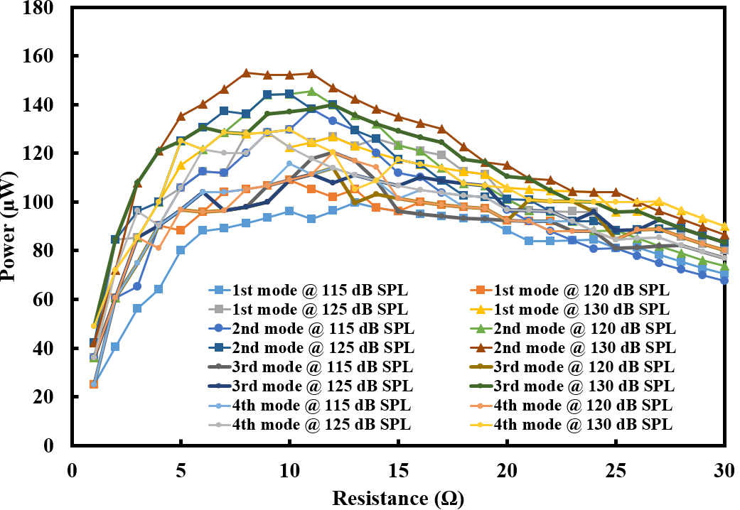
Figure ‎4.20 Output power as a function of load resistance of the HVA-EH-1 at 0.1 g

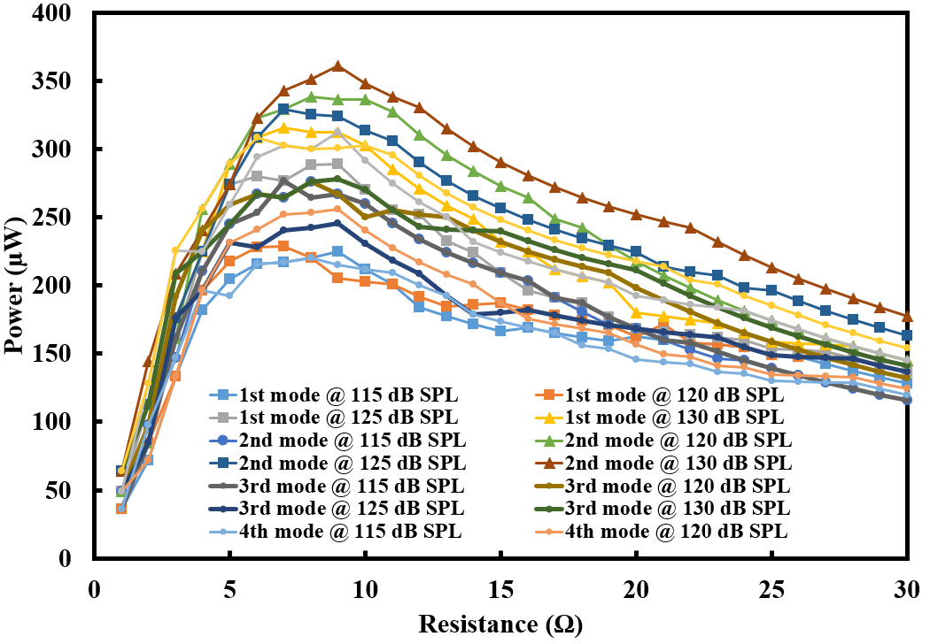
Figure ‎4.21 Output power as a function of load resistance of the HVA-EH-1 at 0.2 g
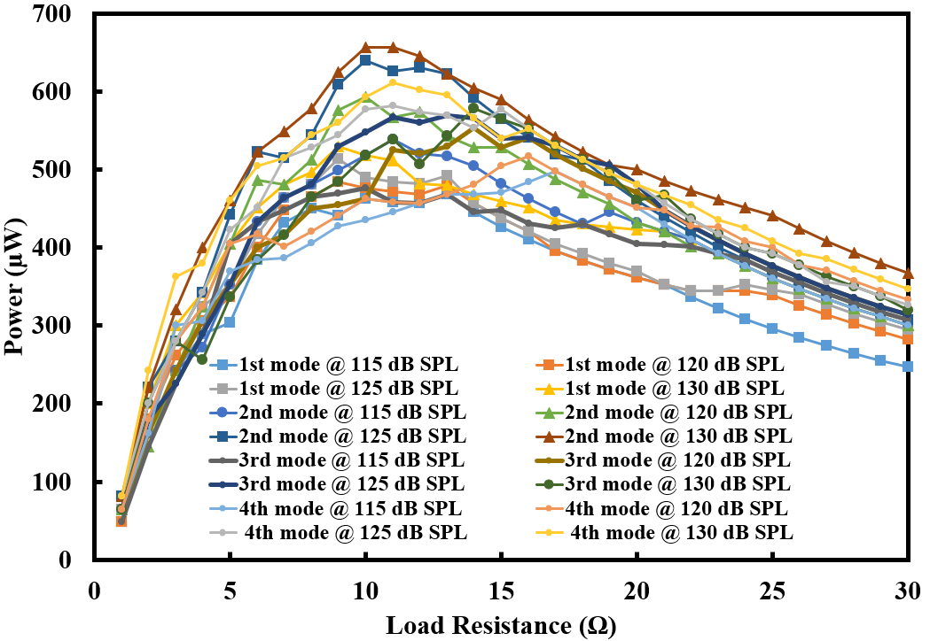
Figure ‎4.22 Output power as a function of load resistance of the HVA-EH-1 at 0.3 g

Characterization of HVA-EH-2 under vibration environment
The developed prototype of HVA-EH-2 was also initially tested under a vibration environment and was exposed to vibration levels of 0.1 g, 0.2 g and 0.3 g at a frequency range of up to 90 Hz. It was noted that the HVA-EH-2 can produce RMS open circuit voltage of 263, 350 and 374 mV under vibration levels of 0.1 g, 0.2 g and 0.3 g respectively at a resonant frequency of 29 Hz. It was also observed that the developed prototype has a second resonance frequency of 72 Hz which has been added by the spinning of the spherical magnet inside the cavity. At the second mode, the HVA-EH-2 was able to produce an RMS OCV of 144 mV, 194 mV and 220 mV under vibration levels of 0.1 g, 0.2 g and 0.3 g respectively. To record the load voltage of the HVA-EH-2, a variable resistor of 100 Ω was used. It was noted that the HVA-EH-2 is delivering maximum load voltages of 86, 88 and 103 mV under vibration levels of 0.1 g, 0.2 g and 0.3 g at the first resonant frequency. The output power was also calculated from the load voltage and the maximum output power recorded was 391, 444 and 588 μW under vibration levels of 0.1 g, 0.2 g and 0.3 g respectively at matching impedance. The RMS OCV versus frequency, RMS load voltage versus load resistance and the calculated power versus load resistance are presented in Figure 4.23, 4.24 and 4.25 respectively.
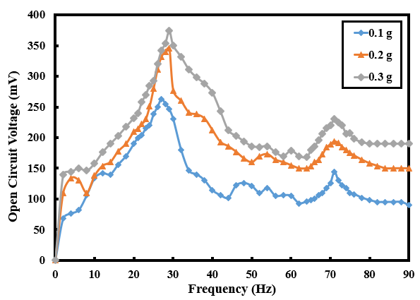
Figure ‎4.23 RMS Open circuit volatage versus frequency of HVA-EH-2 under vibration environment

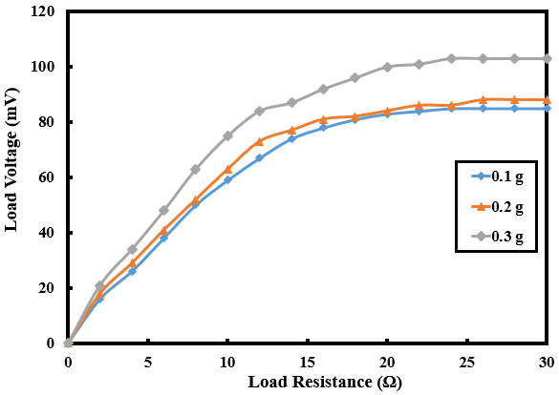
Figure ‎4.24 RMS load volatage versus load resistanceof HVA-EH-2 under vibration environment

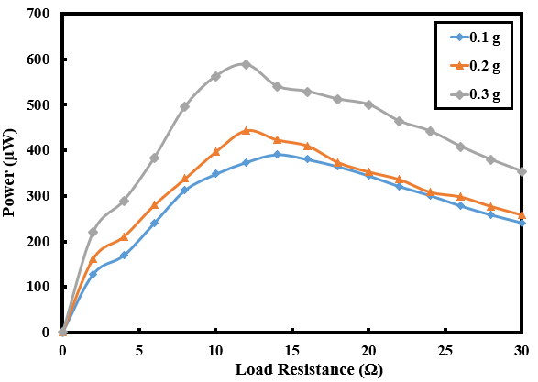
Figure ‎4.25 Calculated power versus load resistanceof HVA-EH-2 under vibration environment

Characterization of HVA-EH-2 under acoustic environment
The HVA-EH-2 was also tested under a standalone acoustic environment. The HVA-EH-2 was exposed to the acoustic frequency sweep of 1 to 1400 Hz at various SPLs of 110 dB, 120 dB, and 130 dB. The sound waves enter the HC and oscillate the flexible MPC at multiple modes. Under an acoustic environment, at 130 dB SPL, the device produces a maximum RMS OCV of 163 mV @ 130 Hz, 180 mV @ 400 Hz, 148 mV @ 740 Hz, 250 mV @ 920 Hz and 273 mV @ 1050 Hz. It can be seen from the Figure 4.26 that the RMS OCV increases with an increase in SPL. Furthermore, a variable resistor of 100 Ω was connected to the HVA-EH-2 to record the load voltage versus load resistor response. The output RMS load voltage as a function of the load resistor is shown in Figure 4.27. At SPLs of 110 dB, 120 dB and 130 dB the device was able to produce a maximum RMS load voltage of 54 mV, 68 mV and 86 mV respectively at 1050 Hz. Moreover, the output power was calculated from the load voltage at a frequency of 1050 Hz and is depicted in Figure 4.28. At matching impedance, the maximum power output achieved was 190 μW, 406 μW and 512 μW at SPLs of 110 dB, 120 dB and 130 dB respectively.
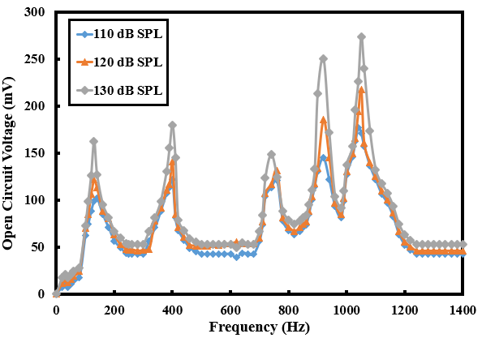
Figure ‎4.26 RMS Open circuit volatage versus frequency of HVA-EH-2 under acoustic environment
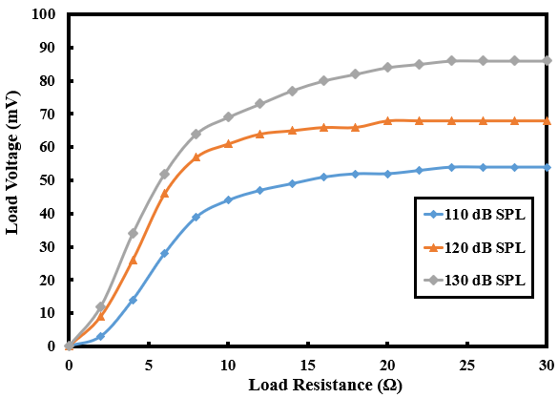
Figure ‎4.27 RMS load volatage versus load resistanceof HVA-EH-2 under acoustic environment
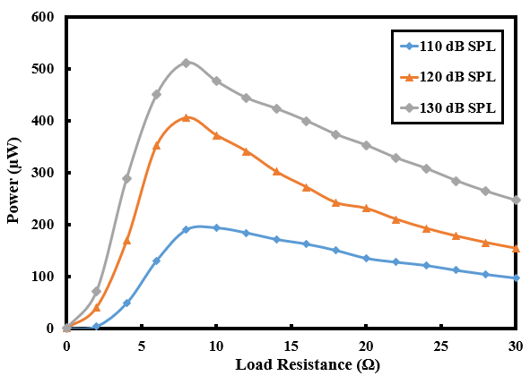
Figure ‎4.28 Calculated power versus load resistanceof HVA-EH-2 under acoustic environment

Characterization of HVA-EH-2 under hybrid environment
The performance of the HVA-EH-2 was further investigated under both acoustic and vibration environments at the same time. The developed prototype was tested under a hybrid environment and the data was recorded from flexible MPC. The RMS OCV versus vibration frequency responses under 0.1 g, 0.2 g and 0.3 g vibration levels at fixed SPLs of 110 dB, 120 dB, and 130 dB and fixed acoustic frequency of 1050 Hz are shown in Figure 4.29, 4.30 and 4.31 respectively. It was observed that at SPLs of 110 dB, 120 dB and 130 dB the HVA-EH-2 is producing maximum OCV of 323 mV, 363 mV and 409 mV respectively under 0.3 g vibration level at a first vibration frequency of 29 Hz. At a second vibration frequency of 72 Hz, the HVA-EH-2 is producing maximum OCV of 253 mV, 313 mV and 361 mV at SPLs of 110 dB, 120 dB and 130 dB respectively under 0.3 g vibration level. The OCV remains the same at vibration resonances at higher vibration level because at this stage it reaches its maximum value, and the vibration energy cannot further increase the output voltage. This effect can be seen in Figure 4.30 and Figure 4.31.
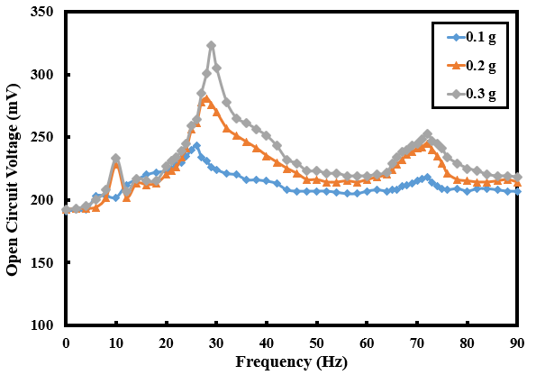
Figure ‎4.29 RMS OCV versus freqeuncy of the HVA-EH-2 under the hybrid environment at 110 dB SPL

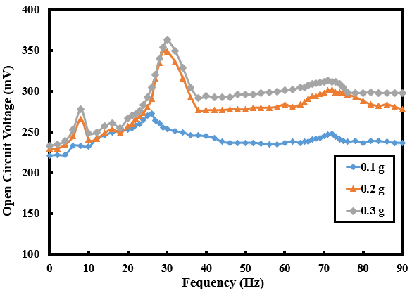
Figure ‎4.30 RMS OCV versus freqeuncy of the HVA-EH-2 under the hybrid environment at 120 dB SPL

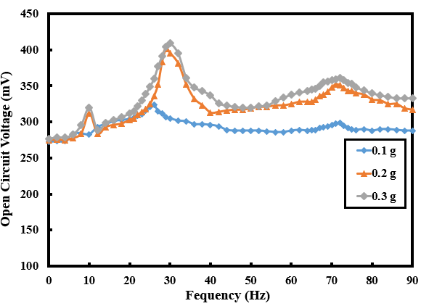
Figure ‎4.31 RMS OCV versus freqeuncy of the HVA-EH-2 under the hybrid environment at 130 dB SPL

For the RMS load voltages, the HVA-EH-2 was kept at first vibration resonance (29 Hz) and 1050 Hz acoustic frequency and the experiment was performed at SPLs (110 dB, 120 dB, and 130 dB), although the load resistance was kept on increasing. Figure 4.32, 4.33, and 4.34 shows the output RMS load voltages at SPLs of 110 dB, 120 dB, and 130 dB respectively under 0.1 g, 0.2 g and 0.3 g vibration levels. The RMS load voltages produced were 108 mV, 105 mV, and 109 mV at SPLs of 110 dB, 120 dB, and 130 dB respectively under 0.3 g vibration level.
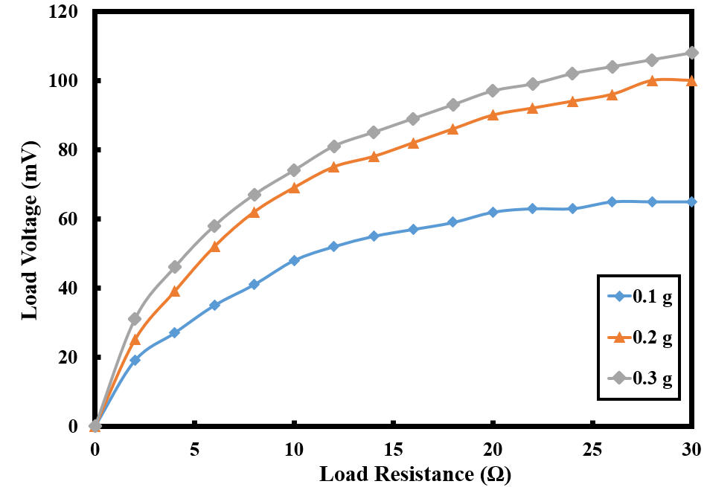
Figure ‎4.32 Load voltage versus load resistance of HVA-EH-2 under hybrid environment 110 dB SPL
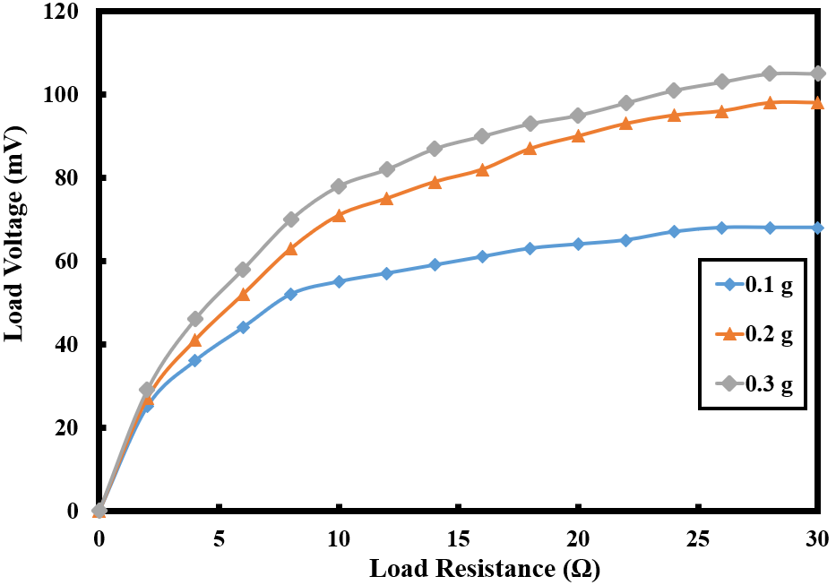
Figure ‎4.33 Load voltage versus load resistance of HVA-EH-2 under hybrid environment 120 dB SPL
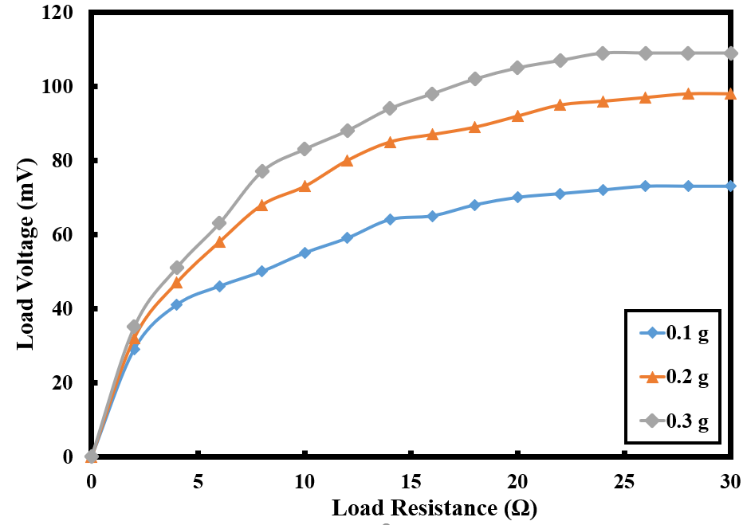
Figure ‎4.34 Load voltage versus load resistance of HVA-EH-2 under hybrid environment 130 dB SPL
The output power as a function of load resistances was also calculated and are shown in Figure 4.35, 4.36 and 4.37 for SPLs of 110 dB, 120 dB and 130 dB respectively. The maximum power produced by the developed prototype under a hybrid environment was found to be 560 μW, 612 μW, 741 μW at SPLs of 110 dB, 120 dB, and 130 dB respectively under a vibration level of 0.3 g and at vibration frequency of 29 Hz and acoustic frequency of 1050 Hz at matching impedance.
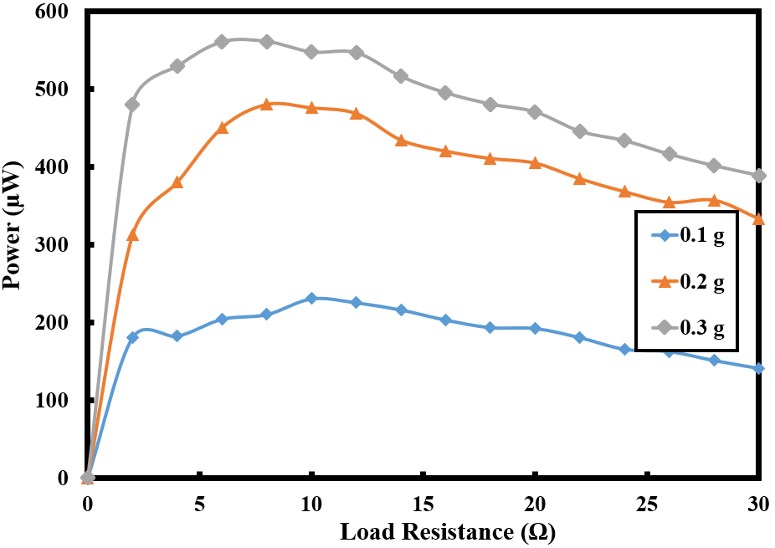
Figure ‎4.35 Power versus load resistance of HVA-EH-2 under hybrid environment 110 dB SPL
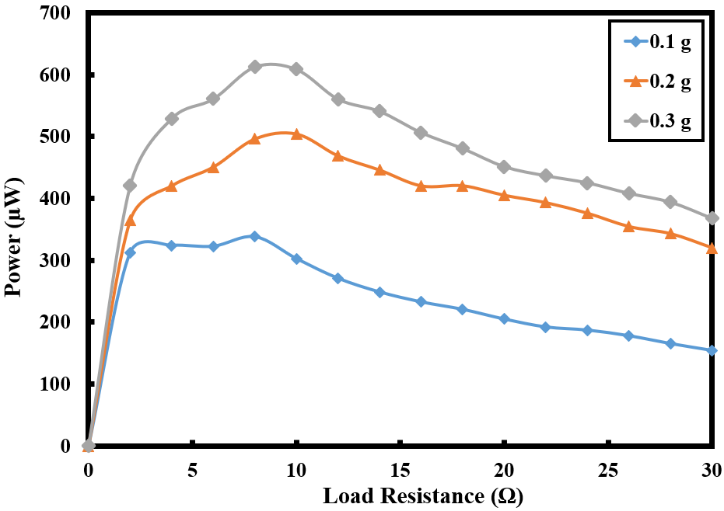
Figure ‎4.36 Power versus load resistance of HVA-EH-2 under hybrid environment 120 dB SPL
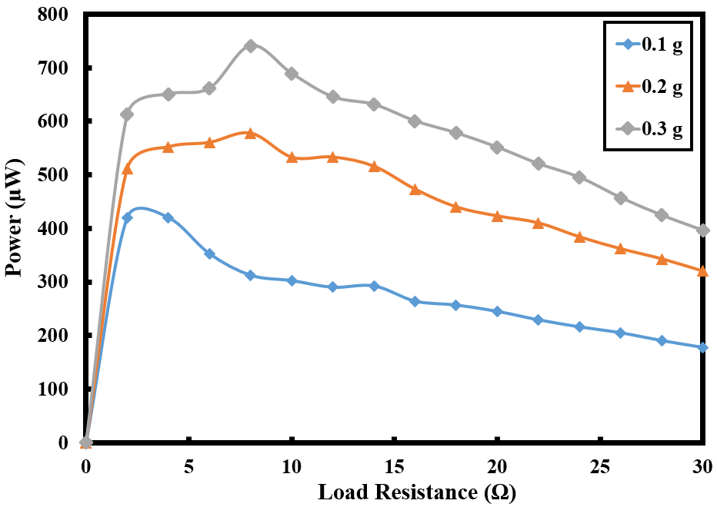
Figure ‎4.37 Power versus load resistance of HVA-EH-2 under hybrid environment 130 dB SPL

Power management
The output voltage produced by the HVA-EH-2 is relatively low and of an alternating current (AC) nature. The WSNs can only be operated continuously if the supplied energy is equal to or more than the consumption, which is challenging for most of the energy harvesters and hence ultra-low power management approaches are required to supply a reliable direct current (DC) power. The low AC voltage generated by HVA-EH-2 must be rectified and boosted into a suitable DC voltage level. In this research, a Cockcroft Walton converter (CWC) topology was used to rectify and boost the ultra-low AC voltage. The CWC can boost the low voltage without transformer which helps in reducing the device size and mass. This converter can work in low frequencies ranges, moreover, the output voltage can also be regulated by adjusting the number of stages. A CWC converts ultra-low AC voltage into high DC voltage and is capable of providing a uniform current during the operation [163]. The circuit diagram of three stage CWC is shown in Figure 4.38 (a). however, in this research different stages of the same circuit were simulated in MATLAB Simulink and the result has been plotted in Figure 4.38 (b) to see how many stages are suitable for the developed prototype. The best result was achieved from the 8 stages circuit, and it was observed that the output voltage reduces at higher stages. The 8 stages CWC was then developed on a PCB using 100 µF Tantalum capacitors and PMEG2010AEB Schottky diodes. Moreover, the power consumption of CWC is very low as mentioned by [163], for six stages CWC converter the power consumption was calculated to be 90 nW which is very low power.
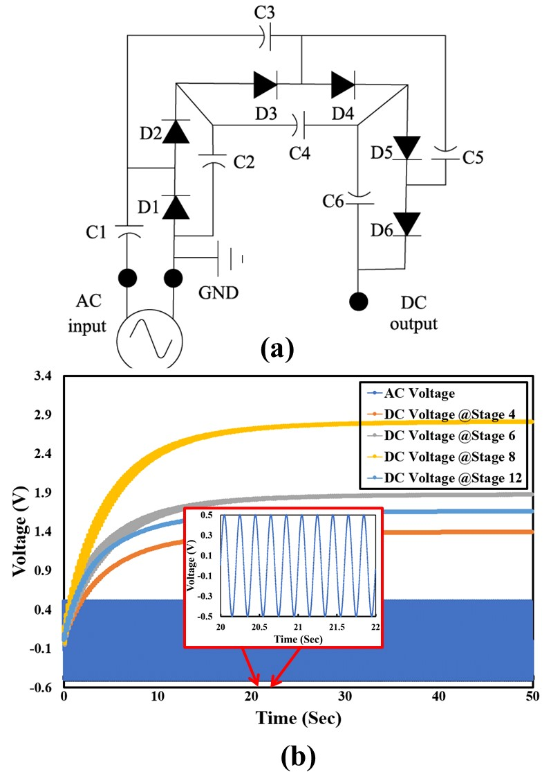
Figure ‎4.38 (a) Six stage Cockcroft Walton converter (b) MATLAB Simulation of Cockcroft Walton converter

To check the performance of the HVA-EH-2 with the power management circuit, a load resistor was used between the ULV rectifier circuit and the HVA-EH-2. This characterization was performed under a hybrid environment where the developed prototype was exposed to various vibration levels at first vibration resonance and fixed SPLs at 1050 Hz acoustic frequency. It can be seen from Figure 4.39, 4.40 and 4.41 that the maximum DC voltages produced by the HVA-EH-2 along with the power management circuit under 0.3 g vibration level are 305 mV, 371 mV and 342 mV at SPL of 110 dB, 120 dB and 130 dB respectively.
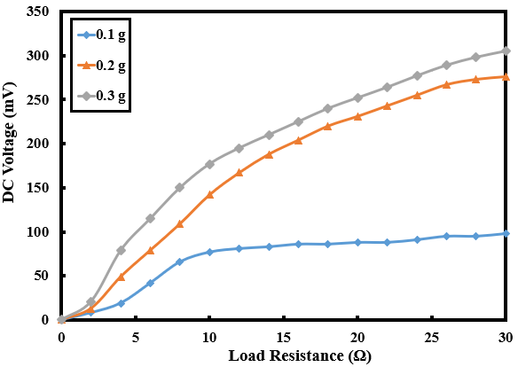
Figure ‎4.39 Characterization of HVA-EH-2 with power management circuit: DC load voltage versus load resistance at SPLs 110 dB

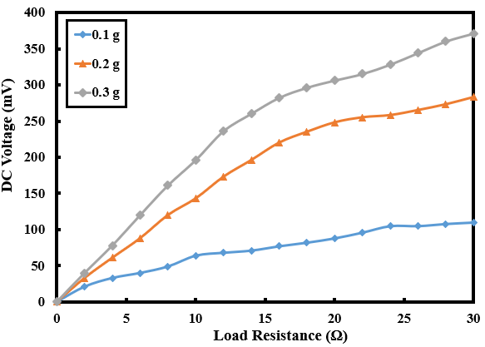
Figure ‎4.40 Characterization of HVA-EH-2 with power management circuit: DC load voltage versus load resistance at SPLs 120 dB

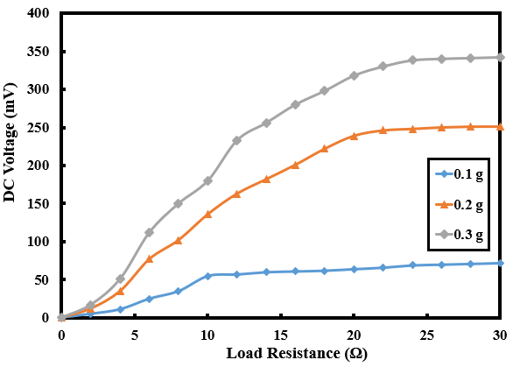
Figure ‎4.41 Characterization of HVA-EH-2 with power management circuit: DC load voltage versus load resistance at SPLs 130 dB

The power was also calculated from the DC load voltage and it was observed that under 0.3 g vibration levels the HVA-EH-2 is capable of generating maximum power of 3168 µW, 4970 µW and 5056 µW at 110 dB, 120 dB and 130 dB SPLs respectively. The DC power versus load resistance of the HVA-EH-2 under various vibration level at SPLs of 110 dB, 120 dB and 130 dB are shown in Figure 4.42, 4.43, and 4.44 respectively.

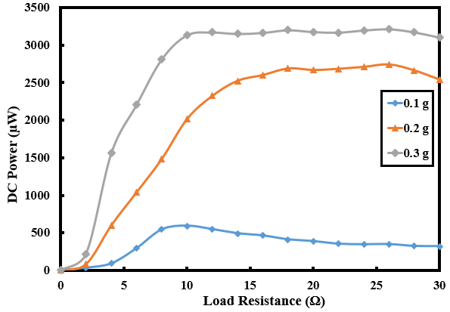
Figure ‎4.42 Characterization of HVA-EH-2 with power management circuit: DC power versus load resistance at SPLs 110 dB

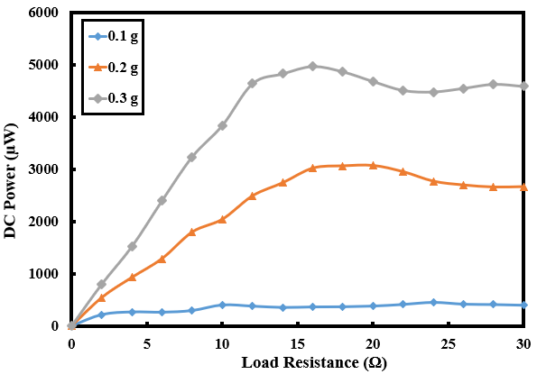
Figure ‎4.43 Characterization of HVA-EH-2 with power management circuit: DC power versus load resistance at SPLs 120 dB

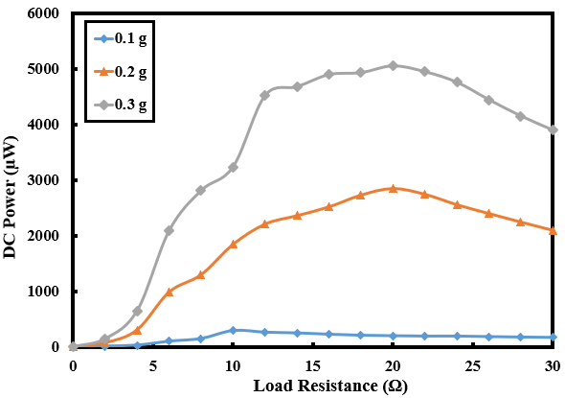
Figure ‎4.44 Characterization of HVA-EH-2 with power management circuit: DC power versus load resistance at SPLs 130 dB
The HVA-EH-2 was then connected to the battery to see the charging capabilities of the developed device. The block diagram of the charging setup is shown in Figure 4.45. The same power management circuit was used to charge AAA 1.5 V battery. Initially, a load resistor was used to discharge the battery up to 0.6 V and then it was connected to the power management system for charging. It was noted that the HVA-EH-2 along with the power management circuit is able to charge the battery completely in an hour’s time under hybrid environment. Figure 4.46 shows the battery charging.
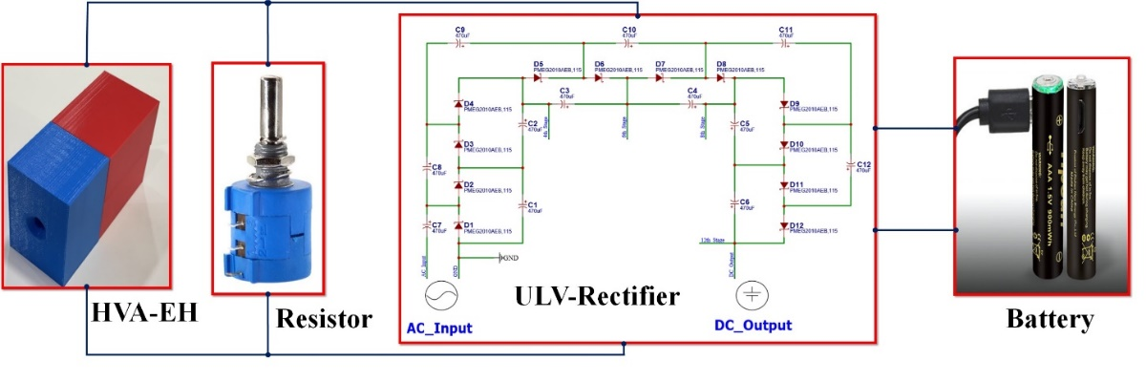
Figure ‎4.45 Block diagram of battery charging

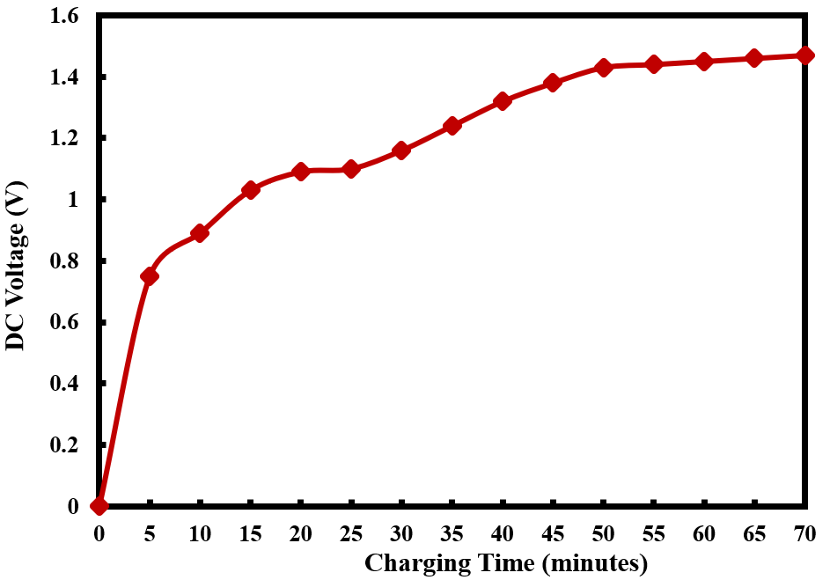
Figure ‎4.46 Battery charging at 0.3 g, 130 dB SPL under both resonances

Discussion and comparison
Most of the recently developed energy harvesters for WSNs in literature are compared with both the prototypes of HVA-EH based on various parameters like transduction mechanism, device volume, internal resistance, SPLs, vibration levels, natural frequencies, voltage produced, output power and power density. For WSNs applications, the piezoelectric transduction mechanism is used in majority of the acoustic energy harvesters while, in vibration energy harvesters both electromagnetic and piezoelectric transduction mechanisms are used. The devices developed in literature are only relying on single source either vibration or acoustic and mostly the architecture does not allow to accommodate more sources. Because of the high resonant frequencies and high internal impedance of piezoelectric devices, the electromagnetic transduction was preferred, moreover, the electrostatic was not selected as it requires the initial power signal for start-up. The resonant frequencies of the electromagnetic type of vibration and acoustic energy harvesters reported in literature ranges from 20 to 1332 Hz, while for piezoelectric energy harvester it ranges from 50 to 2100 Hz. The resonant frequencies are mostly dependant on the architecture of the devices which can be tune accordingly with modification in architectures. The vibration and sound pressure levels to which these harvesters were subjected are from 0.06 g to 2.5 g and 100 dB to 130 dB respectively. The voltage produced by the vibration energy harvester in both piezoelectric and electromagnetic transduction is higher (33 to 25000 mV) than the acoustic energy harvesters (110 to 3200 mV). Similarly, the power output of the reported vibration energy harvesters is more (16 to 630 μW) than the acoustic energy harvesters (2.4 to 212 μW).
The HVA-EH-1 developed in this work is the first electromagnetic type of hybrid environment-based energy harvester which is capable of scavenging both vibration and acoustic energies simultaneously with its unique architecture. The device is demonstrated to be capable of harvesting energy at low vibration (26 Hz) and acoustic (<1000 Hz) frequency as compared to the ones reported in literature, which shows the suitability of the device for WSNs in real environment. The HVA-EH-1 is also compared with the reported standalone vibration and acoustic energy harvester. The output power of the HVA-EH-1 under vibration energy is 372 μW which is the highest among the vibration devices except [44] which was characterized at higher vibration level of 1 g, moreover, the device reported in [44] has comparatively high resonant frequency of 100 Hz. The vibration level at which the device is tested is suitable for the real-life vibration shown in Table 2.2. Under acoustic energy the HVA-EH-1 generates a maximum output power of 271 μW which is the highest among the acoustic devices reported in literature (2.4 to 212 μW). The applicability of the device in acoustic mode can also be seen from the SPLs of different devices in Table 2.2 and the one at which the device is tested. Apart from the standalone comparison, the HVA-EH-1 generates the output power 656 μW at low vibration and acoustic frequencies, under low vibration level and at comparable SPLs. The ability of harvesting low frequency sound and vibration simultaneously with its unique architecture makes the HVA-EH-1 an energy eﬃcient and more applicable system for WSNs amongst the reported energy harvesters listed in Table 4.1.
The performance of the HVA-EH-2 where flexible coil along with spinning spherical magnet is used in its architecture, is also compared with previously developed (mostly in the last five years) vibration, acoustic and vibro-acoustic energy harvesters. The HVA-EH-2 is also verified to be capable of scavenging ambient energy at low vibration (29 Hz) and acoustic (<1400 Hz) frequencies as compared to the ones stated in the literature. Like HVA-EH-1, the HVA-EH-2 is also benched marked with the reported separate vibration and acoustic energy harvesters and then it is being compared with the hybrid vibro-acoustic energy harvesters. The maximum output RMS voltage and power of the developed prototype under standalone vibration environment at 0.3 g and at resonant frequency of 29 Hz is 374 mV and 588 μW respectively which is higher than the reported work. The comparison was also performed under a standalone acoustic environment with the reported acoustic energy harvesters. The output voltages and power production of the reported acoustic energy harvesters lies in the range of 38 mV to 1365 mV and 3.16 μW to 271 μW respectively, while the output voltage and power produced by the developed HVA-EH-2 under standalone acoustic environment are 273 mV and 512 μW, respectively. This is the highest amongst the reported acoustic energy harvesters except [146] , because of its large volume of 6141.3 cm³. The HVA-EH-2 was also compared with the previous prototype developed in this work (HVA-EH-1). The output power produced by the HVA-EH-2 is higher (741 μW) than the HVA-EH-1 (656 μW). It is clear from the comparison that the second prototypes developed in this work can produce higher voltage and higher power levels than the harvesters developed earlier. This is because of the changes in its architecture by spinning of spherical magnet which has been added to this prototype. The results of the developed prototypes show the same behaviour as of the already verified models of the vibration and acoustic energy harvesters. Moreover, the developed HVA-EH-2 has the highest power density (9.2 μW/cm³) amongst the reported vibration, acoustic and vibroacoustic energy harvesters except [49], which is a piezoelectric device with low output power and extremely small size. Furthermore, the HVA-EH-2 when connected to the newly developed power management circuit, it was able to produce a maximum output DC power of 5056 μW and it was able to fully charge 1.5 V AAA battery in almost a duration of an hour time. The capability of harvesting low-frequency vibration and sound at the same time makes the HVA-EH-2 an energy eﬃcient system for WSNs.
With the recent advancement of microfabrication technology, the power requirement of different sensors (pressure, acceleration, and temperature) has reduced and is in the range of 1.8 to 324 μW [161]. It can be seen that the developed prototype is able to power these types of WSNs. Moreover, vibration and acoustic are simultaneously available in many environments like: the industrial machines in running condition produce noise and vibrate at the same time [4]. Moreover, there are a lot of WSNs used for the health monitoring of machines as well as for the internet of things (IoT) in the industrial environment [4]. This research will also help in achieving self-sustained long-term operation of those WSNs and will eventually makes the deployment of WSNs easy. This research will help in other advanced technologies where WSNs are the key components of the system like internet of things, remote condition monitoring, tele health diagnosing and monitoring, global positioning systems and structural health monitoring.
Table 4.1 Comparison of acoustic and vibration energy harvesters with HVA-EH-1 and HVA-EH-2
Type | Transduction Mechanism | Device volume (cm³) | Resistance (Ω) | Input Acceleration (g)/SPL (dB) | Frequency (Hz) | Voltage (mV) | Power (μW) | Power density(μW/cm³) | Ref./Year
Vibration | Electromagnetic | 0.15 | 2323 | 0.06 g | 52 | 1141 | 58 | ¯¯¯ | [40] 2008
Vibration | Electromagnetic | 29.03 | ¯¯¯ | 2 g | 82 | 33 | 68.4 | 2.35 | [34] 2018
Vibration | Piezoelectric | ¯¯¯ | 900000 | ¯¯¯ | 20 | 25000 | 60–131 | ¯¯¯ | [41] 2022
Vibration | Piezoelectric | 4.03 | ¯¯¯ | 0.45 g | 40.8 | 4800^{b} | 100ª | ¯¯¯ | [43] 2013
Vibration | Piezoelectric | ¯¯¯ | 100000 | 1 g | 100 | 8000 | 630 | ¯¯¯ | [44] 2017
Vibration | Piezoelectric | ¯¯¯ | 1000000 | 2.5 g | 50 | ¯¯¯ | 16 | ¯¯¯ | [45] 2020
Vibration | Electromagnetic | 67.20 | 8 | 0.3 g | 26 | 852 | 372 | 5.53 | [This Work, HVA-EH-1]
Acoustic | Piezoelectric | ¯¯¯ | ¯¯¯ | 100 dB | 138 |  | 15.3 | ¯¯¯ | [46] 2020
Acoustic | Electromagnetic | ¯¯¯ | ¯¯¯ | 100 dB | <1332 | 110 | 212 | ¯¯¯ | [147] 2018
Acoustic | Electromagnetic | 6141.3 | 160000 | 110 dB | 140 | 1365 | 625 | 0.10 | [146] 2020
Acoustic | Piezoelectric | 21.20 | 114 | 130 dB | 2100 | 38 | 3.16 | 2.45 | [47] 2016

Table 4.1 Comparison of acoustic and vibration energy harvesters with HVA-EH-1 and HVA-EH-2 (Continued)

Type | Transduction Mechanism | Device volume (cm³) | Resistance (Ω) | Input Acceleration (g)/SPL (dB) | Frequency (Hz) | Voltage (mV) | Power (μW) | Power density(μW/cm³) | Ref./Year
Acoustic | Piezoelectric | ¯¯¯ | 22000 | 100 dB | ¯¯¯ | ¯¯¯ | 2.4 | ¯¯¯ | [48] 2018
Acoustic | Piezoelectric | 1.22 | 12000 | 130 dB | 1350 | 558 | 40 | 32.70 | [49] 2019
Acoustic | Piezoelectric | ¯¯¯ | ¯¯¯ | 123.8 dB | 391 | 3200 | 130 | ¯¯¯ | [148] 2021
Acoustic | Piezoelectric | ¯¯¯ | 10000 | 114 dB | 155 |  | 210 | ¯¯¯ | [149] 2018
Acoustic | Electromagnetic | 64.00 | 9 | 130 dB | <1000 | 448 | 271 | 4.23 | [This Work, HVA-EH-1]
Vibro-Acoustic | Electromagnetic | 131.20 | 9 | 0.3 g and 130 dB | 14-28 at acoustic frequency of 495 Hz | 540 | 656 | 5.00 | [This Work, HVA-EH-1]
Vibro-Acoustic | Electromagnetic | 550 | 9 | 0.3 g and 130 dB | 29 at acoustic frequency of 1050 Hz | 409 | 5056 | 9.20 | [This Work, HVA-EH-2]
ªAverage power ^{c}Rotary frequency
^{b}Rectified voltage ^{d}calculated value

CONCLUSION AND RECOMMENDATIONS

Overview
The conclusion of the research is presented in this chapter and the proposed future recommendations have also been provided at the end of this chapter.

Conclusion
A novel hybrid vibro-acoustic energy harvester (HVA-EH) using flexible coil and spinning spherical magnet is designed and developed in this work to build a self-powered wireless sensor network through electromagnetic transduction. Two prototypes (HVA-EH-1 and HVA-EH-2) were developed which are capable of harvesting vibration and acoustic energies simultaneously using single flexible coil. The spinning spherical magnet was used to enable the second resonance in the vibration part and increase the power output. The HVA-EH-1 was composed of a cantilever beam having a cube magnet at its tip and a Helmholtz Cavity (HC) with a flexible micro planar coil in its backside. The cantilever beam contributes to the vibration energy harvesting while the HC contributes to the acoustic energy harvester. During characterization, under vibration energy, at matching impedance of 24 Ω, the combined coils of HVA-EH-1 generate an output power of 372 μW at an acceleration level of 0.3 g and at the resonant frequency of 26 Hz which is highest among the reported vibration energy harvesters. Furthermore, under acoustic energy, it was observed that at 2nd mode the device can generate a maximum output power of 271 μW under SPLs of 130 dB at matching impedance which is highest among the reported acoustic energy harvesters, while, under a hybrid environment, where the HVA-EH-1 was exposed to vibration and acoustic energies at the same time, at matching impedance, the maximum power generated was 656 μW at vibration resonance and acceleration level of 0.3 g under SPL of 130 dB at 2nd acoustic mode which is the highest among all reported energy harvesters.
To enhance the conversion efficiency and manage the output power properly, another prototype (HVA-EH-2) with a unique architecture was designed and developed utilizing a spinning spherical magnet along with the flexible coil. The HVA-EH-2 is composed of a cantilever beam having a spherical magnet at its tip and a HC with a flexible micro planar coil in its backside like HVA-EH-1. The spherical magnet at the tip of the cantilever beam is free to move which adds vibration resonance to the device. The novel harvester has the capability to convert vibration and acoustic energies simultaneously in a more efficient way to useful electrical energy. The developed HVA-EH-2, when exposed to hybrid environment of vibration level of 0.3 g and sound pressure level of 130 dB, a maximum root mean square open circuit voltage and load power of 409 mV and 741 μW respectively were achieved at 29 Hz vibration and 1050 Hz acoustic frequency during in-lab characterization. The spinning spherical magnet architecture in HVA-EH-2 has increased the output power by 11.47 % compared to HVA-EH-1. Moreover, the simulation of the Cockcroft Walton converter was performed in MATLAB to select suitable number of stages for the developed prototype, and it was concluded that 8 stages of Cockcroft Walton converter will gives best result. When the HVA-EH-2 was connected with the developed power management circuit, a DC output power of 5056 μW was achieved at optimum load resistance under vibration and sound pressure level of 0.3 g and 130 dB respectively. With the help of the power management circuit, the HVA-EH-2 was able to fully charge a 1.5 V AAA battery in an hour’s time duration. Furthermore, the performance of a developed prototypes was also compared with the vibration, acoustic and vibro-acoustic energy harvesters in the literature and it was found that the power (5056 μW) and power density (9.2 μW/cm³) for the developed HVA-EH-2 is considerably better than the reported energy harvesters in literature and the energy production levels are quite satisfactory and can be used to attain self-sustained long-standing operation of WSNs.
The HVA-EH-1 and HVA-EH-2 exhibit advantages of high output power and multiple modes at low frequency and low acceleration and SPL, which inform new solutions to the battery problems of WSNs. The flexible coil in the acoustic part of the harvester and spinning of the spherical magnet in the vibration part contributes to multiple natural frequencies because of which the device provides a continuous voltage at a wideband, hence, the applicability of the developed HVA-EH-2 increases. The devices are demonstrated to be capable of harvesting energy at low vibration and acoustic frequency as compared to the ones reported in literature, which shows the suitability of the developed harvester for the real environment. The capability of harvesting low-frequency vibration and sound at the same time using single flexible coil makes the developed prototypes an energy efficient system to operate the WSNs.

Proposed future work and recommendations
Further enhancement of the system can be achieved by improving the efficiencies of the developed prototypes. Overall, system performance can be improved in serval areas such as the flexible micro planar coil can be fabricated in a more sophisticated way to increase the flexibility and also increase the number of turns which will increase the output power. The acoustic energy is available in all four sides of the device, so multiple HCs can be used in different directions to harvest every joule of acoustic energy. A major area for the improvement is the power management system, new techniques need to be researched to avoid power losses in the circuitry and decrease the charging time.
As a future design thought, along with vibration and acoustic, others energy sources like solar and thermal can be harvested simultaneously. These sources will not add a lot to the size of the device but will provide a decent increase to the efficiency. To increase the efficiency of the vibration part, a piezoelectric material can be added to the cantilever beam which will increase the output power. The flexible micro planar coils can be manufactured from a piezoelectric material which will increase the efficiency of both vibration and acoustic energy harvesters.
Real-time vibration is random in nature and very little research has been reported with regard to the response of harvesters under random vibrations, moreover the research which has been conducted in this work, is for uniaxial vibration. However, real vibrations are more of tri-axial nature and relevant research can be conducted in modelling, fabrication, and characterization of suitable harvesters. Furthermore, the fatigue analysis of the cantilever beam can be considered to estimate the life cycle and endurance limit of the beam.

REFERENCES
[1] F. Almalki et al., “Green IoT for eco-friendly and sustainable smart cities: future directions and opportunities,” Mob. Networks Appl., pp. 1–25, 2021.
[2] J. Singh, R. Kaur, and D. Singh, “Energy harvesting in wireless sensor networks: A taxonomic survey,” Int. J. Energy Res., vol. 45, no. 1, pp. 118–140, 2021.
[3] G. Hossain, I. Z. Hossain, and G. Grabher, “Piezoresistive smart-textile sensor for inventory management record,” Sensors Actuators A Phys., vol. 315, p. 112300, 2020, doi: https://doi.org/10.1016/j.sna.2020.112300.
[4] I. Ahmad, L. M. Hee, A. M. Abdelrhman, S. A. Imam, and M. S. Leong, “Scopes, challenges and approaches of energy harvesting for wireless sensor nodes in machine condition monitoring systems: A review,” Measurement, p. 109856, 2021.
[5] M. R. Miah, M. Yang, M. M. Hossain, S. Khandaker, and M. R. Awual, “Textile-based flexible and printable sensors for next generation uses and their contemporary challenges: A critical review,” Sensors Actuators A Phys., vol. 344, p. 113696, 2022, doi: https://doi.org/10.1016/j.sna.2022.113696.
[6] M. Bengtsson, E. Olsson, P. Funk, and M. Jackson, “Design of condition based maintenance system—A case study using sound analysis and case-based reasoning,” Cond. Based Maint. Syst. Investig. Tech. Const. Organ. Asp. Malardalen Univ. Eskilstuna, Sweden, p. 57, 2004.
[7] S. M. Lee, D. Lee, and Y. S. Kim, “The quality management ecosystem for predictive maintenance in the Industry 4.0 era,” Int. J. Qual. Innov., vol. 5, no. 1, p. 4, 2019.
[8] P. A. Delgado-Arredondo, D. Morinigo-Sotelo, R. A. Osornio-Rios, J. G. Avina-Cervantes, H. Rostro-Gonzalez, and R. de Jesus Romero-Troncoso, “Methodology for fault detection in induction motors via sound and vibration signals,” Mech. Syst. Signal Process., vol. 83, pp. 568–589, 2017.
[9] H. Chelladurai, V. K. Jain, and N. S. Vyas, “Development of a cutting tool condition monitoring system for high speed turning operation by vibration and strain analysis,” Int. J. Adv. Manuf. Technol., vol. 37, no. 5–6, pp. 471–485, 2008, doi: 10.1007/s00170-007-0986-z.
[10] C. Malla and I. Panigrahi, “Review of Condition Monitoring of Rolling Element Bearing Using Vibration Analysis and Other Techniques,” J. Vib. Eng. Technol., vol. 7, no. 4, pp. 407–414, 2019, doi: 10.1007/s42417-019-00119-y.
[11] P. Guo, D. Infield, and X. Yang, “Wind turbine generator condition-monitoring using temperature trend analysis,” IEEE Trans. Sustain. energy, vol. 3, no. 1, pp. 124–133, 2011.
[12] M. Kuntoğlu and H. Sağlam, “Investigation of signal behaviors for sensor fusion with tool condition monitoring system in turning,” Measurement, vol. 173, p. 108582, 2021.
[13] S. Offenbacher, B. Antony, O. Barbir, F. Auer, and M. Landgraf, “Evaluating the applicability of multi-sensor equipped tamping machines for ballast condition monitoring,” Measurement, vol. 172, p. 108881, 2021.
[14] C. Cepnik, R. Lausecker, and U. Wallrabe, “Review on electrodynamic energy harvesters-a classification approach,” Micromachines, vol. 4, no. 2, pp. 168–196, 2013, doi: 10.3390/mi4020168.
[15] H. Alawad and S. Kaewunruen, “Wireless sensor networks: Toward smarter railway stations,” Infrastructures, vol. 3, no. 3, p. 24, 2018.
[16] B. Bengherbia, R. Kara, A. Toubal, M. O. Zmirli, S. Chadli, and P. Wira, “FPGA implementation of a wireless sensor node with a built-in ADALINE neural network coprocessor for vibration analysis and fault diagnosis in machine condition monitoring,” Measurement, vol. 163, p. 107960, 2020.
[17] A. A. Jaber and R. Bicker, “Design of a wireless sensor node for vibration monitoring of industrial machinery,” Int. J. Electr. Comput. Eng., vol. 6, no. 2, p. 639, 2016.
[18] Q. Huang, B. Tang, and L. Deng, “Development of high synchronous acquisition accuracy wireless sensor network for machine vibration monitoring,” Measurement, vol. 66, pp. 35–44, 2015.
[19] F. U. Khan and I. Ahmad, “Review of energy harvesters utilizing bridge vibrations,” Shock Vib., vol. 2016, 2016.
[20] Z. Wang et al., “On-rotor electromagnetic energy harvester for powering a wireless condition monitoring system on bogie frames,” Energy Convers. Manag., vol. 243, p. 114413, 2021.
[21] M. Iqbal and F. U. Khan, “Hybrid vibration and wind energy harvesting using combined piezoelectric and electromagnetic conversion for bridge health monitoring applications,” Energy Convers. Manag., vol. 172, pp. 611–618, 2018.
[22] B. K. N. Rao, Handbook of condition monitoring. Elsevier, 1996.
[23] S. Sony, S. Laventure, and A. Sadhu, “A literature review of next‐generation smart sensing technology in structural health monitoring,” Struct. Control Heal. Monit., vol. 26, no. 3, p. e2321, 2019.
[24] M. Chen, X. Zhang, D. Zhou, and Y. Wang, “Design of Remote Condition Monitoring System for Armored Vehicles Based on Beidou,” in Recent Trends in Intelligent Computing, Communication and Devices, Springer, 2020, pp. 935–942.
[25] P. Verma and S. K. Sood, “Fog assisted-IoT enabled patient health monitoring in smart homes,” IEEE Internet Things J., vol. 5, no. 3, pp. 1789–1796, 2018.
[26] M. A. Ma’Sum et al., “Simulation of intelligent unmanned aerial vehicle (uav) for military surveillance,” in 2013 International Conference on Advanced Computer Science and Information Systems (ICACSIS), 2013, pp. 161–166.
[27] R. Groves and S. Watson, “32–Remote structural health and condition monitoring and diagnostics for turbines,” Netherlands’ Long-Term Offshore Wind R&D Agenda, vol. 46, pp. 169–178, 2019.
[28] F. Bibi, C. Guillaume, N. Gontard, and B. Sorli, “A review: RFID technology having sensing aptitudes for food industry and their contribution to tracking and monitoring of food products,” Trends Food Sci. Technol., vol. 62, pp. 91–103, 2017.
[29] A. Das, P. Dash, and B. K. Mishra, “An innovation model for smart traffic management system using internet of things (IoT),” in Cognitive Computing for Big Data Systems Over IoT, Springer, 2018, pp. 355–370.
[30] P. Sethi and S. R. Sarangi, “Internet of things: architectures, protocols, and applications,” J. Electr. Comput. Eng., vol. 2017, 2017.
[31] X. Tang, X. Wang, R. Cattley, F. Gu, and A. D. Ball, “Energy harvesting technologies for achieving self-powered wireless sensor networks in machine condition monitoring: A review,” Sensors, vol. 18, no. 12, p. 4113, 2018.
[32] J. Siang, M. H. Lim, and M. Salman Leong, “Review of vibration-based energy harvesting technology: Mechanism and architectural approach,” Int. J. Energy Res., vol. 42, no. 5, pp. 1866–1893, 2018, doi: 10.1002/er.3986.
[33] M. Guan, K. Wang, D. Xu, and W.-H. Liao, “Design and experimental investigation of a low-voltage thermoelectric energy harvesting system for wireless sensor nodes,” Energy Convers. Manag., vol. 138, pp. 30–37, 2017.
[34] I. Ahmad and F. U. Khan, “Multi-mode vibration based electromagnetic type micro power generator for structural health monitoring of bridges,” Sensors Actuators A Phys., vol. 275, pp. 154–161, 2018.
[35] J. Siang, M. H. Lim, and M. Salman Leong, “Review of vibration‐based energy harvesting technology: Mechanism and architectural approach,” Int. J. Energy Res., vol. 42, no. 5, pp. 1866–1893, 2018.
[36] I. Ahmad, M. M. Ur Rehman, M. Khan, A. Abbas, S. Ishfaq, and S. Malik, “Flow‐based electromagnetic‐type energy harvester using microplanar coil for IoT sensors application,” Int. J. Energy Res., vol. 43, no. 10, pp. 5384–5391, 2019.
[37] A. S. Spanias, “Solar energy management as an Internet of Things (IoT) application,” in 2017 8th International Conference on Information, Intelligence, Systems & Applications (IISA), 2017, pp. 1–4.
[38] Y. Wu, H. Zhang, and L. Zuo, “Thermoelectric energy harvesting for the gas turbine sensing and monitoring system,” Energy Convers. Manag., vol. 157, pp. 215–223, 2018.
[39] Z. Zhou, W. Qin, and P. Zhu, “Harvesting acoustic energy by coherence resonance of a bi-stable piezoelectric harvester,” Energy, vol. 126, pp. 527–534, 2017.
[40] R. Torah, P. Glynne-Jones, M. Tudor, T. O’Donnell, S. Roy, and S. Beeby, “Self-powered autonomous wireless sensor node using vibration energy harvesting,” Meas. Sci. Technol., vol. 19, no. 12, 2008, doi: 10.1088/0957-0233/19/12/125202.
[41] L. Zhang, F. Zhang, Z. Qin, Q. Han, T. Wang, and F. Chu, “Piezoelectric energy harvester for rolling bearings with capability of self-powered condition monitoring,” Energy, vol. 238, p. 121770, 2022.
[42] F. Yang, L. Du, W. Chen, J. Li, Y. Wang, and D. Wang, “Hybrid energy harvesting for condition monitoring sensors in power grids,” Energy, vol. 118, pp. 435–445, 2017.
[43] J. Jang, D. Berdy, J. Lee, D. Peroulis, and B. Jung, “A wireless condition monitoring system powered by a sub-100/spl mu/W vibration energy harvester,” IEEE Trans. Circuits Syst. I Regul. Pap., vol. 60, no. 4, pp. 1082–1093, 2012.
[44] F. Yang, L. Du, W. Chen, J. Li, Y. Wang, and D. Wang, “Hybrid energy harvesting for condition monitoring sensors in power grids,” Energy, vol. 118, pp. 435–445, 2017, doi: 10.1016/j.energy.2016.11.037.
[45] H. Fu, W. Song, Y. Qin, and E. M. Yeatman, “Broadband Vibration Energy Harvesting from Underground Trains for Self-Powered Condition Monitoring,” vol. 2, no. d, pp. 1–5, 2020, doi: 10.1109/powermems49317.2019.93285904627.
[46] P. Eghbali, D. Younesian, and S. Farhangdoust, “Enhancement of the low-frequency acoustic energy harvesting with auxetic resonators,” Appl. Energy, vol. 270, p. 115217, 2020.
[47] F. U. Khan and Izhar, “Hybrid acoustic energy harvesting using combined electromagnetic and piezoelectric conversion,” Rev. Sci. Instrum., vol. 87, no. 2, p. 25003, 2016.
[48] M. Yuan, X. Wang, and Z. Ding, “Low frequency acoustic energy harvesting adopting slit helmholtz resonator,” Vibroengineering Procedia, vol. 20, pp. 151–155, 2018, doi: 10.21595/vp.2018.20245.
[49] I. Ahmad, A. Hassan, M. Ullah, S. Malik, and T. Ali, “Ambient Acoustic Energy Harvesting using Two Connected Resonators with Piezoelement for Wireless Distributed Sensor Network,” vol. 65, no. 5, pp. 471–477, 2019, doi: 10.1134/S1063771019050014.
[50] J. M. Rabaey, M. J. Ammer, J. L. Da Silva, D. Patel, and S. Roundy, “PicoRadio supports ad hoc ultra-low power wireless networking,” Computer (Long. Beach. Calif)., vol. 33, no. 7, pp. 42–48, 2000, doi: 10.1109/2.869369.
[51] F. U. Khan and E. Izhar, “Acoustic-based electrodynamic energy harvester for wireless sensor nodes application,” Int. J. Mater. Sci. Eng, vol. 1, no. 2, pp. 72–78, 2013.
[52] V. Bhatnagar and P. Owende, “Energy harvesting for assistive and mobile applications,” Energy Sci. Eng., vol. 3, no. 3, pp. 153–173, 2015, doi: 10.1002/ese3.63.
[53] M. Renaud et al., “a high performance electrostatic mems vibration energy harvester with corrugated inorganic sio 2 -Si 3 N 4 electrict Imec / Holst Centre , Eindhoven , The Netherlands Panasonic Corporation , Osaka , JAPAN,” no. June, pp. 693–696, 2013.
[54] R. J. M. Vullers, R. Van Schaijk, I. Doms, C. Van Hoof, and R. Mertens, “Solid-State Electronics Micropower energy harvesting,” Solid State Electron., vol. 53, no. 7, pp. 684–693, 2009, doi: 10.1016/j.sse.2008.12.011.
[55] I. Ahmad and F. Ullah, “Sensors and Actuators A : Physical Multi-mode vibration based electromagnetic type micro power generator for structural health monitoring of bridges,” vol. 275, pp. 154–161, 2018.
[56] Y. Wang, Z. Yang, P. Li, D. Cao, W. Huang, and D. J. Inman, “Energy harvesting for jet engine monitoring,” Nano Energy, p. 104853, 2020, doi: 10.1016/j.nanoen.2020.104853.
[57] I. D. Hamani, R. Tikani, H. Assadi, and S. Ziaei-Rad, “Energy harvesting from moving harmonic and moving continuous mass traversing on a simply supported beam,” Measurement, vol. 150, p. 107080, 2020.
[58] A. Rajanbabu, C. Thangamuniyandi, and J. Ganesan, “Energy Harvesting Technology and its Potential applications–A Mini Review,” J. Nucl. Eng. Technol., vol. 9, no. 3, pp. 33–43, 2020.
[59] C. Cepnik, R. Lausecker, and U. Wallrabe, “Review on electrodynamic energy harvesters—a classification approach,” Micromachines, vol. 4, no. 2, pp. 168–196, 2013.
[60] D. Lisbona and T. Snee, “A review of hazards associated with primary lithium and lithium-ion batteries,” Process Saf. Environ. Prot., vol. 89, no. 6, pp. 434–442, 2011.
[61] B. Bao, Q. Wang, N. Wu, and S. Zhou, “Hand-held piezoelectric energy harvesting structure: Design, dynamic analysis, and experimental validation,” Measurement, vol. 174, p. 109011, 2021.
[62] S. Bradai, S. Naifar, C. Trigona, S. Baglio, and O. Kanoun, “An electromagnetic/magnetoelectric transducer based on nonlinear RMSHI circuit for power harvesting and sensing,” Measurement, p. 109307, 2021.
[63] S. Ahmad, M. Abdul Mujeebu, and M. A. Farooqi, “Energy harvesting from pavements and roadways: A comprehensive review of technologies, materials, and challenges,” Int. J. Energy Res., vol. 43, no. 6, pp. 1974–2015, 2019.
[64] P. Eghbali, D. Younesian, and S. Farhangdoust, “Enhancement of piezoelectric vibration energy harvesting with auxetic boosters,” Int. J. Energy Res., vol. 44, no. 2, pp. 1179–1190, 2020.
[65] A. Nozariasbmarz et al., “Review of wearable thermoelectric energy harvesting: From body temperature to electronic systems,” Appl. Energy, vol. 258, p. 114069, 2020.
[66] C. L. Izidoro, O. H. A. Junior, J. P. Carmo, and L. Schaeffer, “Characterization of thermoelectric generator for energy harvesting,” Measurement, vol. 106, pp. 283–290, 2017.
[67] G. Hassan, B. S. Yilbas, A. Al‐Sharafi, A. Z. Sahin, and H. Al‐Qahtani, “Solar energy harvesting and self‐cleaning of surfaces by an impacting water droplet,” Int. J. Energy Res., vol. 44, no. 1, pp. 388–401, 2020.
[68] A. D. Ball, F. Gu, R. Cattley, X. Wang, and X. Tang, “Energy harvesting technologies for achieving self-powered wireless sensor networks in machine condition monitoring: A review,” Sensors (Switzerland), vol. 18, no. 12, 2018, doi: 10.3390/s18124113.
[69] R. Shen, X. Gou, H. Xu, and K. Qiu, “A cascaded thermoelectric generation system for low‐grade heat harvesting,” Int. J. Energy Res., 2020.
[70] N. M. Monroe and J. H. Lang, “Broadband, large scale acoustic energy harvesting via synthesized electrical load: I. Harvester design and model,” Smart Mater. Struct., vol. 28, no. 5, p. 55032, 2019.
[71] F. U. Khan and T. Ali, “A piezoelectric based energy harvester for simultaneous energy generation and vibration isolation,” Int. J. Energy Res., vol. 43, no. 11, pp. 5922–5931, 2019.
[72] G. Singh, R. Ponnaganti, T. V. Prabhakar, and K. J. Vinoy, “A tuned rectifier for RF energy harvesting from ambient radiations,” AEU - Int. J. Electron. Commun., vol. 67, no. 7, pp. 564–569, 2013, doi: 10.1016/j.aeue.2012.12.004.
[73] N. W. Based and G. Energy, “Ambient Energy Sources : Mechanical , Light , and Thermal,” pp. 1–15, 2013.
[74] R. J. M. Vullers, R. Van Schaijk, I. Doms, C. Van Hoof, and R. Mertens, “Solid-State Electronics Micropower energy harvesting,” Solid State Electron., vol. 53, no. 7, pp. 684–693, 2009, doi: 10.1016/j.sse.2008.12.011.
[75] F. U. Khan, “State of the art in acoustic energy harvesting,” J. Micromechanics Microengineering, vol. 25, no. 2, p. 23001, 2015.
[76] S. Roundy, P. K. Wright, and J. Rabaey, “A study of low level vibrations as a power source for wireless sensor nodes,” Comput. Commun., vol. 26, no. 11, pp. 1131–1144, 2003.
[77] S. B. Horowitz, M. Sheplak, L. N. Cattafesta, and T. Nishida, “A MEMS acoustic energy harvester,” J. Micromechanics Microengineering, vol. 16, no. 9, p. S174, 2006.
[78] A. A. Myrberg Jr, “The effects of man-made noise on the behavior of marine animals,” Environ. Int., vol. 16, no. 4–6, pp. 575–586, 1990.
[79] E. K. Reilly, L. M. Miller, R. Fain, and P. Wright, “A study of ambient vibrations for piezoelectric energy conversion,” Proc. PowerMEMS, vol. 2009, pp. 312–315, 2009.
[80] F. U. Khan, “Three degree of freedom acoustic energy harvester using improved Helmholtz resonator,” Int. J. Precis. Eng. Manuf., vol. 19, no. 1, pp. 143–154, 2018.
[81] M. L. Barlett and G. R. Wilson, “Characteristics of small boat signatures,” J. Acoust. Soc. Am., vol. 112, no. 5, p. 2221, 2002.
[82] Z. C. Ong, Y. X. Ooi, S. Y. Khoo, and Y. H. Huang, “Two-stage multi-modal system for low frequency and wide bandwidth vibration energy harvesting,” Measurement, vol. 149, p. 106981, 2020.
[83] U. Erturun, A. A. Eisape, and J. E. West, “Design and analysis of a vibration energy harvester using push-pull electrostatic conversion,” Smart Mater. Struct., 2020.
[84] C. Zhao, Y. Yang, D. Upadrashta, and L. Zhao, “Design, modeling and experimental validation of a low-frequency cantilever triboelectric energy harvester,” Energy, vol. 214, p. 118885, 2021.
[85] S. R. Ganapathy, H. Salleh, and M. K. A. Azhar, “Design and optimisation of magnetically-tunable hybrid piezoelectric-triboelectric energy harvester,” Sci. Rep., vol. 11, no. 1, pp. 1–13, 2021.
[86] S. Naifar, S. Bradai, C. Viehweger, and O. Kanoun, “Survey of electromagnetic and magnetoelectric vibration energy harvesters for low frequency excitation,” Measurement, vol. 106, pp. 251–263, 2017.
[87] I. Ahmad, A. Abdelrhman, C. Georgantopoulou, S. A. Imam, and S. Najat, “Wearable vibration based hybrid energy harvester for wearable devices,” 2019 8th Int. Conf. Model. Simul. Appl. Optim. ICMSAO 2019, pp. 1–4, 2019, doi: 10.1109/ICMSAO.2019.8880423.
[88] F. U. Khan and M. U. Qadir, “State-of-the-art in vibration-based electrostatic energy harvesting,” J. Micromechanics Microengineering, vol. 26, no. 10, p. 103001, 2016, doi: 10.1088/0960-1317/26/10/103001.
[89] A. Ibrahim, A. Ramini, and S. Towfighian, “Triboelectric energy harvester with large bandwidth under harmonic and random excitations,” Energy Reports, vol. 6, pp. 2490–2502, 2020.
[90] P. Thainiramit, P. Yingyong, and D. Isarakorn, “Impact-Driven Energy Harvesting: Piezoelectric Versus Triboelectric Energy Harvesters,” Sensors, vol. 20, no. 20, p. 5828, 2020.
[91] F. U. Khan and I. Ahmad, “Vibration-based electromagnetic type energy harvester for bridge monitoring sensor application,” in 2014 International Conference on Emerging Technologies (ICET), 2014, pp. 125–129.
[92] S. Roundy, P. K. Wright, and J. M. Rabaey, “Energy scavenging for wireless sensor networks,” in Norwell, Springer, 2003, pp. 45–47.
[93] P. Miao, P. D. Mitcheson, A. S. Holmes, E. M. Yeatman, T. C. Green, and B. H. Stark, “MEMS inertial power generators for biomedical applications,” Microsyst. Technol., vol. 12, no. 10, pp. 1079–1083, 2006.
[94] M. G. Cain, M. Stewart, and M. G. Gee, “Degradation of piezoelectric materials.,” 1999.
[95] Z. L. Wang, J. Chen, and L. Lin, “Progress in triboelectric nanogenerators as a new energy technology and self-powered sensors,” Energy Environ. Sci., vol. 8, no. 8, pp. 2250–2282, 2015.
[96] F. Khan, F. Sassani, and B. Stoeber, “Nonlinear behaviour of membrane type electromagnetic energy harvester under harmonic and random vibrations,” Microsyst. Technol., vol. 20, no. 7, pp. 1323–1335, 2014.
[97] P. Miao, A. S. Holmes, E. M. Yeatman, T. C. Green, and P. D. Mitcheson, “Micro-machined variable capacitors for power generation,” 2003.
[98] V. Škobić, B. Dokić, and Ž. Ivanović, “Solar Energy Harvesting for Wireless Sensor Nodes”.
[99] W. Lai, W. Chen, J. Li, X. Zhang, Z. Lin, and H. Li, “Nonlinear adaptive control of PV inverter for maximum solar energy harvesting using democratic joint,” IOP Conf. Ser. Earth Environ. Sci., vol. 467, p. 12068, 2020, doi: 10.1088/1755-1315/467/1/012068.
[100] M. Sheikholeslami, S. A. Farshad, A. Shafee, and H. Babazadeh, “Performance of solar collector with turbulator involving nanomaterial turbulent regime,” Renew. Energy, vol. 163, pp. 1222–1237, 2021.
[101] P. Choudhary, L. Bhargava, V. Singh, M. Choudhary, and A. kumar Suhag, “A survey–Energy harvesting sources and techniques for internet of things devices,” Mater. Today Proc., vol. 30, pp. 52–56, 2020.
[102] M. H. Rahman and S. Yamashiro, “Novel distributed power generating system of PV-ECaSS using solar energy estimation,” IEEE Trans. Energy Convers., vol. 22, no. 2, pp. 358–367, 2007.
[103] G. J. Snyder, “Thermoelectric Energy Harvesting BT - Energy Harvesting Technologies,” S. Priya and D. J. Inman, Eds. Boston, MA: Springer US, 2009, pp. 325–336. doi: 10.1007/978-0-387-76464-1_11.
[104] S. Rana, B. Orr, A. Iqbal, L. C. Ding, A. Akbarzadeh, and A. Date, “Modelling and optimization of low-temperature waste heat thermoelectric generator system,” Energy Procedia, vol. 110, pp. 196–201, 2017.
[105] D. Enescu, “Thermoelectric energy harvesting: basic principles and applications,” Green energy Adv., p. 1, 2019.
[106] L. C. Chuan, H. Wahid, H. A. Rahim, and R. A. Rahim, “A Review of Thermoelectric Energy Harvester and Its Power Management Approach in Electronic Applications,” J. Teknol., vol. 73, no. 3, 2015.
[107] M. Q. Le et al., “Review on energy harvesting for structural health monitoring in aeronautical applications,” Prog. Aerosp. Sci., vol. 79, pp. 147–157, 2015.
[108] M. Yuan, Z. Cao, J. Luo, and X. Chou, “Recent developments of acoustic energy harvesting: A review,” Micromachines, vol. 10, no. 1, 2019, doi: 10.3390/mi10010048.
[109] M. A. Pillai and E. Deenadayalan, “A review of acoustic energy harvesting,” Int. J. Precis. Eng. Manuf., vol. 15, no. 5, pp. 949–965, 2014.
[110] L.-G. Tran, H.-K. Cha, and W.-T. Park, “RF power harvesting: a review on designing methodologies and applications,” Micro Nano Syst. Lett., vol. 5, no. 1, p. 14, 2017, doi: 10.1186/s40486-017-0051-0.
[111] D. Colaiuda, I. Ulisse, and G. Ferri, “Rectifiers’ design and optimization for a dual-channel RF energy harvester,” J. Low Power Electron. Appl., vol. 10, no. 2, 2020, doi: 10.3390/jlpea10020011.
[112] M. Cansiz, D. Altinel, and G. K. Kurt, “Efficiency in RF energy harvesting systems: A comprehensive review,” Energy, vol. 174, pp. 292–309, 2019.
[113] X. Lu, P. Wang, D. Niyato, D. I. Kim, and Z. Han, “Wireless networks with RF energy harvesting: A contemporary survey,” IEEE Commun. Surv. Tutorials, vol. 17, no. 2, pp. 757–789, 2014.
[114] B. Zaghari, A. Weddell, and N. White, “Poster Abstract: Opportunities and challenges for energy harvesting sensor systems for harsh environments,” ENSsys 2017 - Proc. 5th Int. Work. Energy Harvest. Energy-Neutral Sens. Syst. Part SenSys 2017, no. January, pp. 40–42, 2017, doi: 10.1145/3142992.3143001.
[115] A. C. Waterbury and P. K. Wright, “Vibration energy harvesting to power condition monitoring sensors for industrial and manufacturing equipment,” Proc. Inst. Mech. Eng. Part C J. Mech. Eng. Sci., vol. 227, no. 6, pp. 1187–1202, 2013, doi: 10.1177/0954406212457895.
[116] F. M. Discenzo, D. Chung, R. Automation, M. Heights, K. A. Loparo, and C. Western, “Self-Powered Wireless Sensors,” no. May, pp. 12–15, 2006.
[117] M. Gao, Y. Li, J. Lu, Y. Wang, P. Wang, and L. Wang, “Condition monitoring of urban rail transit by local energy harvesting,” vol. 14, no. 11, 2018, doi: 10.1177/1550147718814469.
[118] J. Jang, D. F. Berdy, J. Lee, D. Peroulis, and B. Jung, “A wireless condition monitoring system powered by a sub-100 μ W vibration energy harvester,” IEEE Trans. Circuits Syst. I Regul. Pap., vol. 60, no. 4, pp. 1082–1093, 2013, doi: 10.1109/TCSI.2012.2215395.
[119] R. Ibrahim, T. D. Chung, S. M. Hassan, K. Bingi, and S. K. B. Salahuddin, “Solar Energy Harvester for Industrial Wireless Sensor Nodes,” Procedia Comput. Sci., vol. 105, no. December 2016, pp. 111–118, 2017, doi: 10.1016/j.procs.2017.01.184.
[120] B. Pozo, J. I. Garate, J. Á. Araujo, and S. Ferreiro, “Photovoltaic energy harvesting system adapted for different environmental operation conditions: Analysis, modeling, simulation and selection of devices,” Sensors (Switzerland), vol. 19, no. 7, 2019, doi: 10.3390/s19071578.
[121] N. Jaziri, A. Boughamoura, J. Müller, B. Mezghani, F. Tounsi, and M. Ismail, “A comprehensive review of Thermoelectric Generators: Technologies and common applications,” Energy Reports, no. xxxx, 2019, doi: 10.1016/j.egyr.2019.12.011.
[122] L. Francioso et al., “Flexible thermoelectric generator for wearable biometric sensors,” Proc. IEEE Sensors, pp. 747–750, 2010, doi: 10.1109/ICSENS.2010.5690757.
[123] J.-M. Dilhac, R. Monthéard, M. Bafleur, V. Boitier, P. Durand-Estèbe, and P. Tounsi, “Implementation of thermoelectric generators in airliners for powering battery-free wireless sensor networks,” J. Electron. Mater., vol. 43, no. 6, pp. 2444–2451, 2014.
[124] S. Schirrmacher, G. Ullmann, and L. Overmeyer, “Thermoelectric power supply of wireless sensor nodes in marine gearboxes,” Energy Harvest. Syst., vol. 2, no. 1, pp. 81–93, 2015.
[125] S. Iizumi et al., “Lead zirconate titanate acoustic energy harvesters utilizing different polarizations on diaphragm,” Procedia Eng., vol. 25, pp. 187–190, 2011, doi: 10.1016/j.proeng.2011.12.046.
[126] F. Khan and Izhar, “Piezoelectric type acoustic energy harvester with a tapered Helmholtz cavity for improved performance,” J. Renew. Sustain. Energy, vol. 8, no. 5, 2016, doi: 10.1063/1.4962027.
[127] H. Liu, H. Fu, L. Sun, C. Lee, and E. M. Yeatman, “Hybrid energy harvesting technology: From materials, structural design, system integration to applications,” Renew. Sustain. Energy Rev., p. 110473, 2020.
[128] Y. Bai, H. Jantunen, and J. Juuti, “Energy harvesting research: the road from single source to multisource,” Adv. Mater., vol. 30, no. 34, p. 1707271, 2018.
[129] M. Iqbal et al., “Vibration-based piezoelectric, electromagnetic, and hybrid energy harvesters for microsystems applications: A contributed review,” Int. J. Energy Res., no. May, 2020, doi: 10.1002/er.5643.
[130] H. Ryu, H. J. Yoon, and S. W. Kim, “Hybrid Energy Harvesters: Toward Sustainable Energy Harvesting,” Adv. Mater., vol. 31, no. 34, pp. 1–19, 2019, doi: 10.1002/adma.201802898.
[131] O. B. Akan, O. Cetinkaya, C. Koca, and M. Ozger, “Internet of Hybrid Energy Harvesting Things,” IEEE Internet Things J., vol. 5, no. 2, pp. 736–746, 2018, doi: 10.1109/JIOT.2017.2742663.
[132] Y. Bai, H. Jantunen, and J. Juuti, “Hybrid, Multi-Source, and Integrated Energy Harvesters ,” Frontiers in Materials , vol. 5. p. 65, 2018. [Online]. Available: https://www.frontiersin.org/article/10.3389/fmats.2018.00065
[133] S. Khalid, I. Raouf, A. Khan, N. Kim, and H. S. Kim, A Review of Human-Powered Energy Harvesting for Smart Electronics: Recent Progress and Challenges, vol. 6, no. 4. Korean Society for Precision Engineering, 2019. doi: 10.1007/s40684-019-00144-y.
[134] S. Bright, P. Examiner, and D. S. Larkin, “(12) United States Patent,” vol. 2, no. 12, 2009.
[135] M. S. Rahman and U. K. Chakravarty, “Design and Analysis of a Hybrid Solar and Vibration Energy Harvester,” Energy Harvest. Syst., no. 0, 2019, doi: https://doi.org/10.1515/ehs-2019-0006.
[136] X. Zhou, S. Gao, H. Liu, and L. Jin, “Nonlinear hybrid piezoelectric and electromagnetic energy harvesting driven by colored excitation,” Energies, vol. 11, no. 3, 2018, doi: 10.3390/en11030498.
[137] J. He et al., “Triboelectric-piezoelectric-electromagnetic hybrid nanogenerator for high-efficient vibration energy harvesting and self-powered wireless monitoring system,” Nano Energy, vol. 43, no. November 2017, pp. 326–339, 2018, doi: 10.1016/j.nanoen.2017.11.039.
[138] Y. Eun et al., “A flexible hybrid strain energy harvester using piezoelectric and electrostatic conversion,” Smart Mater. Struct., vol. 23, no. 4, 2014, doi: 10.1088/0964-1726/23/4/045040.
[139] D. J. De Villiers, S. Kaplan, and R. H. Wilkinson, “Energy harvesting for a condition monitoring mote,” IECON Proc. (Industrial Electron. Conf., pp. 2161–2166, 2008, doi: 10.1109/IECON.2008.4758291.
[140] W. Wang, A. M. Ortiz, N. Wang, M. Hayes, B. O’Flynn, and C. O’Mathuna, “Multi-source energy harvesting powered acoustic emission sensing system for rotating machinery condition monitoring applications,” ICINCO 2013 - Proc. 10th Int. Conf. Informatics Control. Autom. Robot., vol. 1, pp. 492–499, 2013, doi: 10.5220/0004593804920499.
[141] S. Wu, S. Wang, C. Yang, and K. Xie, “Energy management for thermoelectric generators based on maximum power point and load power tracking,” Energy Convers. Manag., vol. 177, pp. 55–63, 2018, doi: https://doi.org/10.1016/j.enconman.2018.09.040.
[142] Y. Zhang et al., “A Batteryless 19 $\mu$W MICS/ISM-Band Energy Harvesting Body Sensor Node SoC for ExG Applications,” IEEE J. Solid-State Circuits, vol. 48, no. 1, pp. 199–213, 2013, doi: 10.1109/JSSC.2012.2221217.
[143] K. Kadirvel et al., “A 330nA energy-harvesting charger with battery management for solar and thermoelectric energy harvesting,” in 2012 IEEE International Solid-State Circuits Conference, 2012, pp. 106–108. doi: 10.1109/ISSCC.2012.6176896.
[144] J. C. Rodriguez, V. Nico, and J. Punch, “A Vibration Energy Harvester and Power Management Solution for Battery-Free Operation of Wireless Sensor Nodes,” Sensors, vol. 19, no. 17. 2019. doi: 10.3390/s19173776.
[145] M. S. M. Resali and H. Salleh, “Comparison of energy harvesting power management techniques and application,” in 2010 34th IEEE/CPMT International Electronic Manufacturing Technology Symposium (IEMT), 2010, pp. 1–5. doi: 10.1109/IEMT.2010.5746768.
[146] C. Gu, Y. Chen, W. Chen, and P. Zhao, “Acoustic Energy Harvester by Electromagnetic Mechanisms and Helmholtz Resonator,” in IOP Conference Series: Earth and Environmental Science, 2020, vol. 617, no. 1, p. 12038.
[147] F. U. Khan, “Electromagnetic based acoustic energy harvester for low power wireless autonomous sensor applications,” Sens. Rev., 2018.
[148] T. Li, Z. Wang, H. Xiao, Z. Yan, C. Yang, and T. Tan, “Dual-band piezoelectric acoustic energy harvesting by structural and local resonances of Helmholtz metamaterial,” Nano Energy, vol. 90, p. 106523, 2021.
[149] M. Yuan, Z. Cao, J. Luo, and R. Ohayon, “Acoustic metastructure for effective low-frequency acoustic energy harvesting,” J. Low Freq. Noise, Vib. Act. Control, vol. 37, no. 4, pp. 1015–1029, 2018.
[150] C. Kumar, A. K. Singh, N. Kumar, and A. Kumar, “Cantilever Beam with Tip Mass At Free End Analysis By FEM,” Int. J. Sci. Res. Educ. 2, pp. 1077–1090, 2014.
[151] C. Wei and X. Jing, “A comprehensive review on vibration energy harvesting: Modelling and realization,” Renew. Sustain. Energy Rev., vol. 74, pp. 1–18, 2017.
[152] I. Sari, T. Balkan, and H. Kulah, “An electromagnetic micro power generator for wideband environmental vibrations,” Sensors Actuators A Phys., vol. 145, pp. 405–413, 2008.
[153] I. Sari, T. Balkan, and H. Kulah, “A wideband electromagnetic micro power generator for wireless microsystems,” in TRANSDUCERS 2007-2007 International Solid-State Sensors, Actuators and Microsystems Conference, 2007, pp. 275–278.
[154] M. Yuan, Z. Cao, J. Luo, and X. Chou, “Recent developments of acoustic energy harvesting: A review,” Micromachines, vol. 10, no. 1, p. 48, 2019.
[155] F. U. Khan, “An improved design of Helmholtz resonator for acoustic energy harvesting devices,” in 2016 International Conference on Intelligent Systems Engineering (ICISE), 2016, pp. 283–288.
[156] A. W. Nolle, “Small‐Signal Impedance of Short Tubes,” J. Acoust. Soc. Am., vol. 25, no. 1, pp. 32–39, 1953.
[157] S. B. Horowitz, Development of a MEMS-based acoustic energy harvester. University of Florida, 2004.
[158] I. A. Khan and G. K. Awari, “Analysis of natural frequency and mode shape of all edge fixed condition plate with uncertain parameters,” Int. J. Innov. Res. Sci. Eng. Technol, vol. 3, no. 2, pp. 9277–9284, 2014.
[159] M. B. Ozer and T. J. Royston, “Application of Sherman–Morrison matrix inversion formula to damped vibration absorbers attached to multi-degree of freedom systems,” J. Sound Vib., vol. 283, no. 3, pp. 1235–1249, 2005, doi: https://doi.org/10.1016/j.jsv.2004.07.019.
[160] Vlab.amrita., “Free Vibration of a Cantilever Beam with a Lumped Mass at Free End,” web page, 2011. https://vlab.amrita.edu/?sub=3&brch=175&sim=1078&cnt=1 (accessed Dec. 03, 2022).
[161] I. Ahmad, L. M. Hee, A. M. Abdelrhman, S. A. Imam, and M. S. Leong, “Hybrid vibro-acoustic energy harvesting using electromagnetic transduction for autonomous condition monitoring system,” Energy Convers. Manag., vol. 258, p. 115443, 2022.
[162] Izhar, M. Iqbal, and F. Khan, “Hybrid acoustic, vibration, and wind energy harvester using piezoelectric transduction for self-powered wireless sensor node applications,” Energy Convers. Manag., vol. 277, p. 116635, 2023, doi: https://doi.org/10.1016/j.enconman.2022.116635.
[163] F. U. Khan, T. Ali, and K. Jamil, “Development of a low voltage AC to DC converter for meso and micro energy harvesters,” J. Eng. Appl. Sci., vol. 34, no. 2, pp. 35–46, 2015.

APPENDIX
- Simulink block diagram of the power management circuit
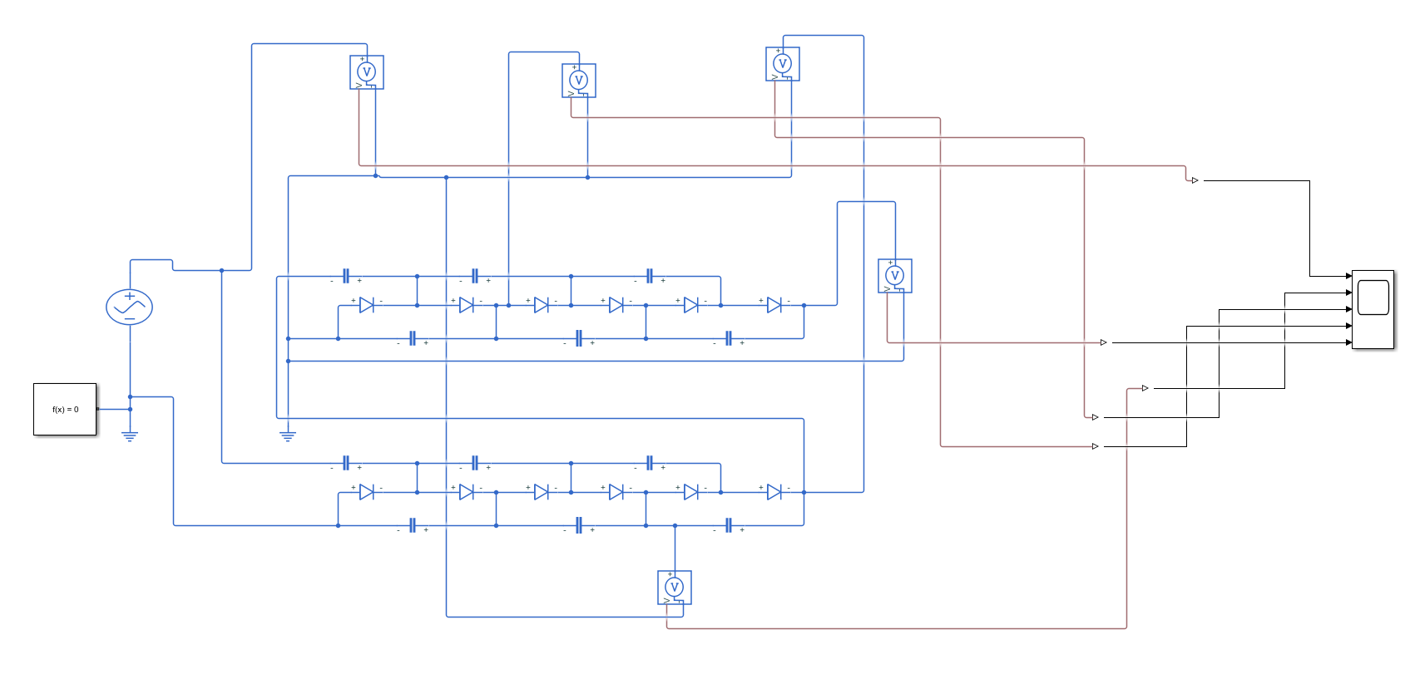
- Article 1

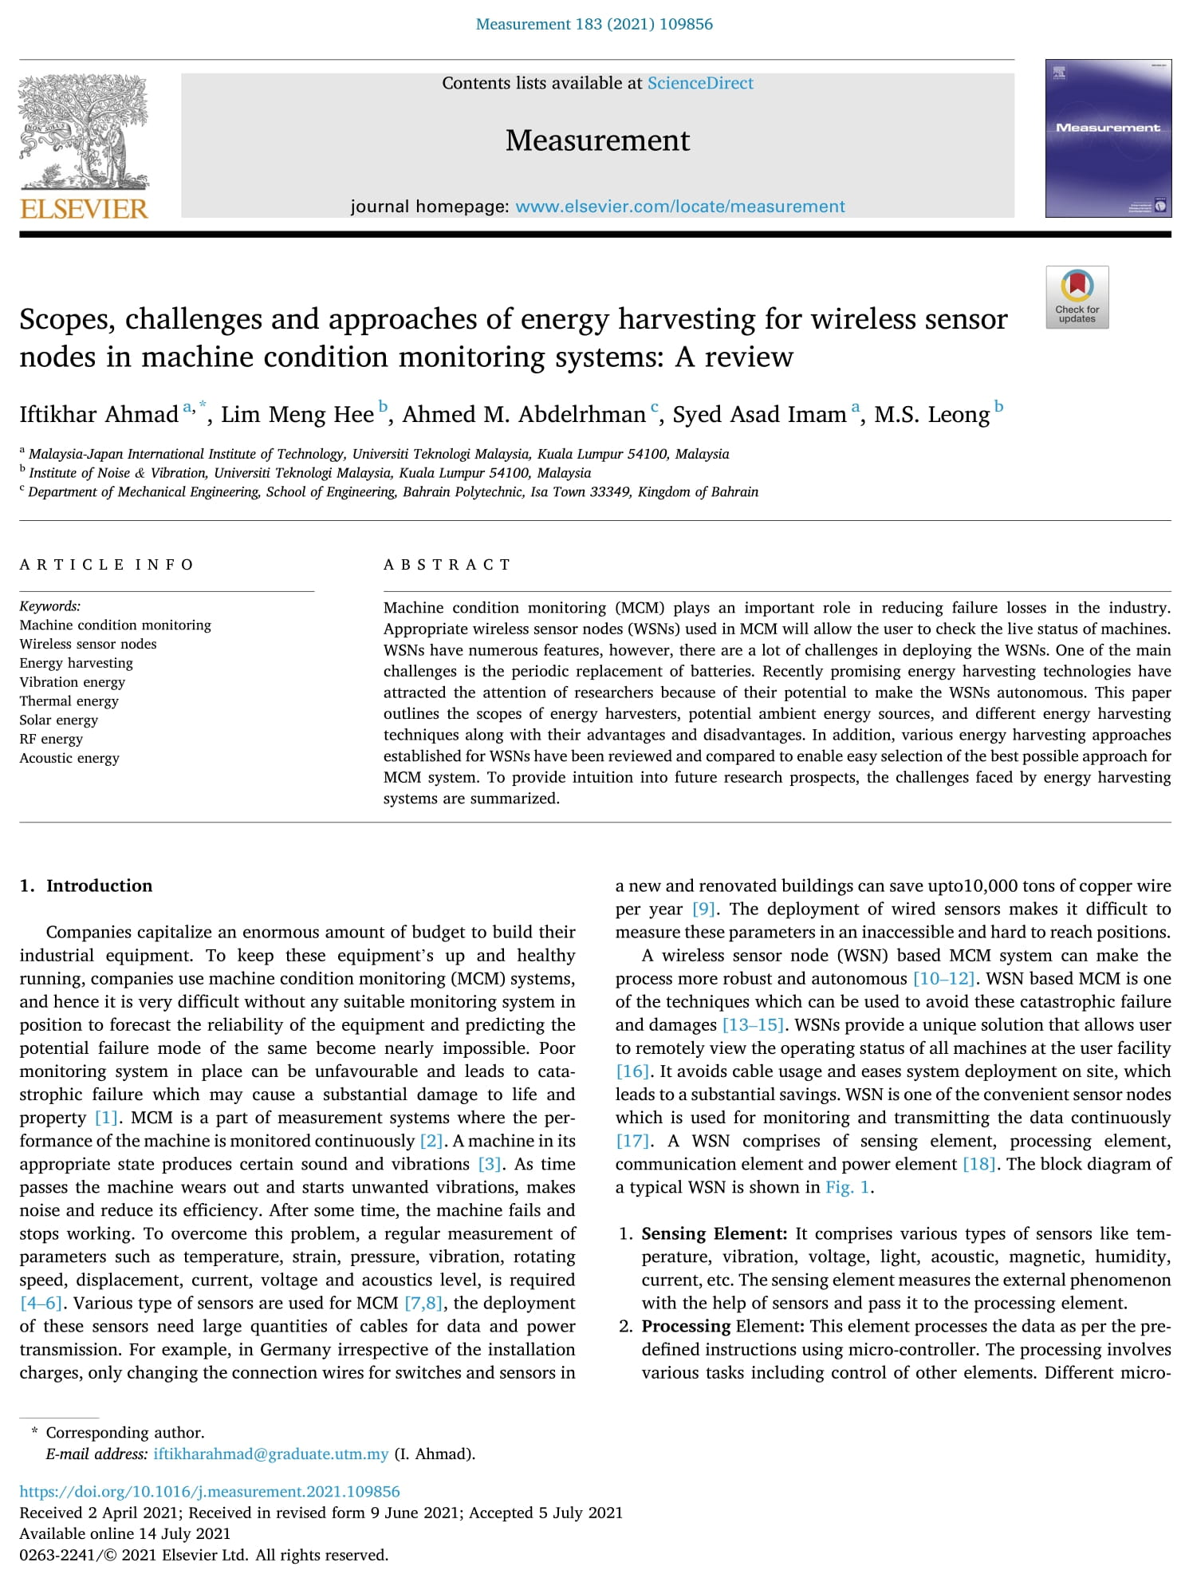

- Article 2
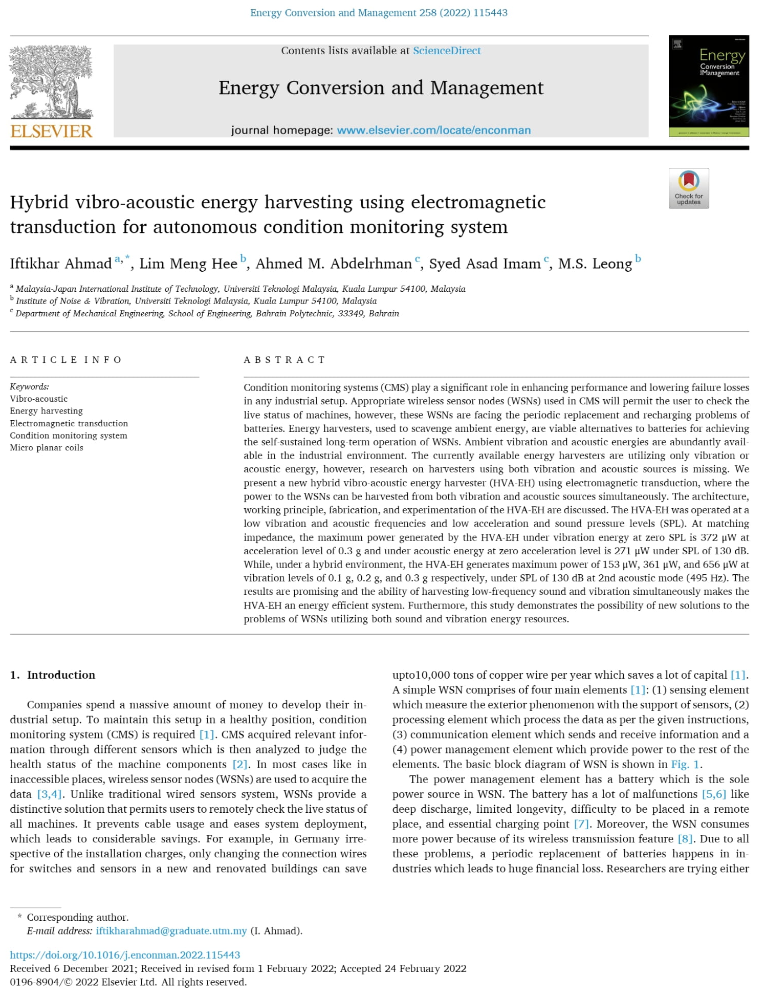

- Article 3
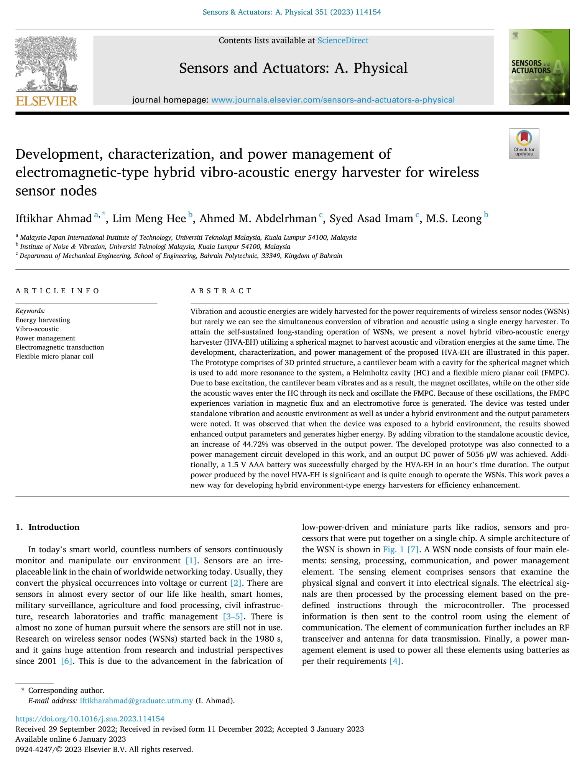

LIST OF PUBLICATIONS
1. Ahmad, I., Hee, L. M., Abdelrhman, A. M., Imam, S. A., & Leong, M. S. (2021). Scopes, challenges, and approaches of energy harvesting for wireless sensor nodes in machine condition monitoring systems: A review. Measurement, 183, 109856. https://doi.org/10.1016/j.measurement.2021.109856 (Q1. IF: 5.13)
2. Ahmad, I., Hee, L. M., Abdelrhman, A. M., Imam, S. A., & Leong, M. S. (2022). Hybrid vibro-acoustic energy harvesting using electromagnetic transduction for autonomous condition monitoring system. Energy Conversion and Management, 258, 115443. https://doi.org/10.1016/j.enconman.2022.115443 (Q1. IF: 11.53)
3. Ahmad, I., Hee, L. M., Abdelrhman, A. M., Imam, S. A., & Leong, M. S. (2023). Development, characterization, and power management of electromagnetic-type hybrid vibro-acoustic energy harvester for wireless sensor nodes. Sensors and Actuators A: Physical. 351, 114154. https://doi.org/10.1016/j.sna.2023.114154 (Q1. IF: 4.29)

